Locational knowledge: extend their locational knowledge and deepen their spatial awareness of the world’s countries using maps of the world to focus on Africa, Russia, Asia (including China and India), and the Middle East, focusing on their environmental regions, including polar and hot deserts, key physical and human characteristics, countries and major cities
KEY STAGE THREE ATTAINMENT TARGETS
Geography Learning Journey: Key Stages 3 and 4 (G.C.S.E.)
Human and physical geography: understand, through the use of detailed place-based exemplars at a variety of scales, the key processes in: physical geography relating to: geological timescales and plate tectonics; rocks, weathering and soils; weather and climate, including the change in climate from the Ice Age to the present; and glaciation, hydrology and coasts AND human geography relating to: population and urbanisation; international development; economic activity in the primary, secondary, tertiary and quaternary sectors; and the use of natural resources. Understand how human and physical processes interact to influence, and change landscapes, environments and the climate; and how human activity relies on effective functioning of natural systems

Place Knowledge: understand geographical similarities, differences and links between places through the study of human and physical geography of a region within Africa, and of a region within Asia

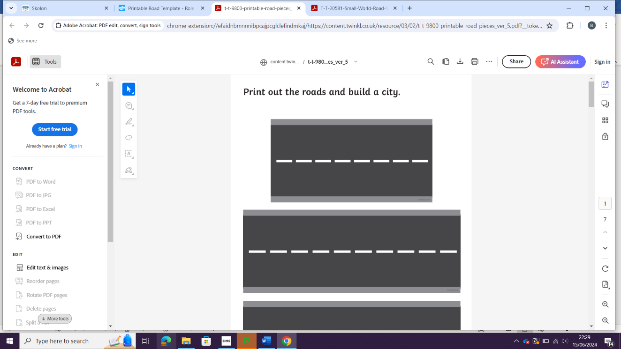
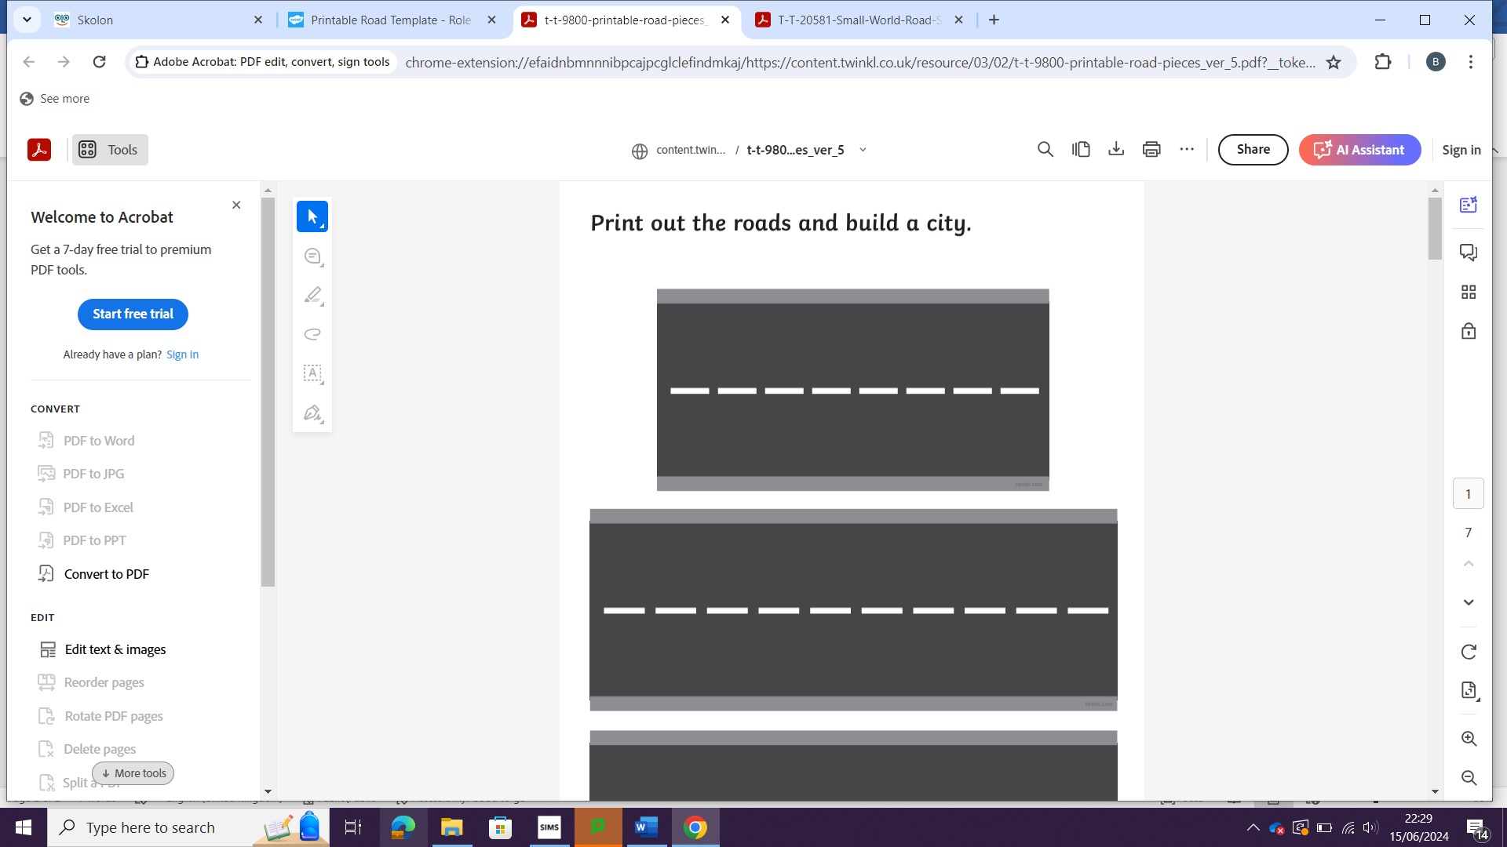
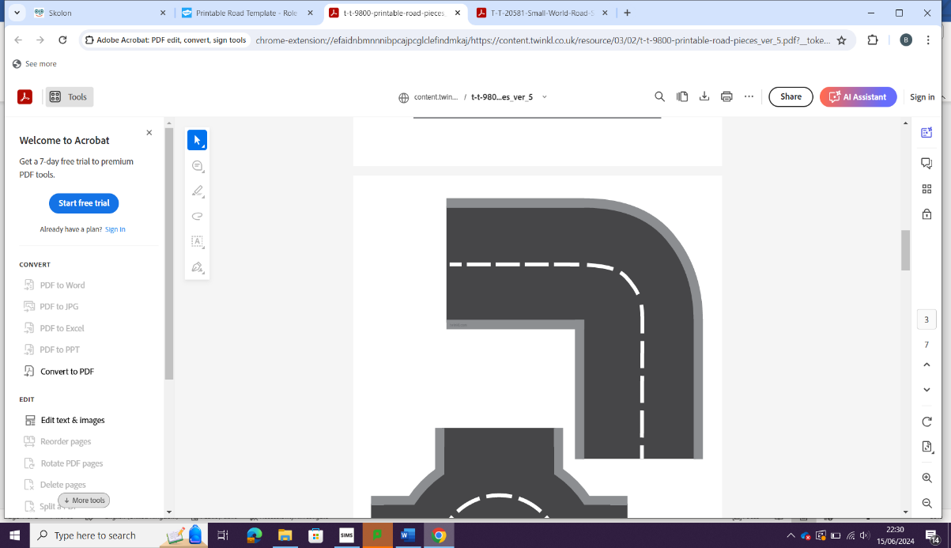
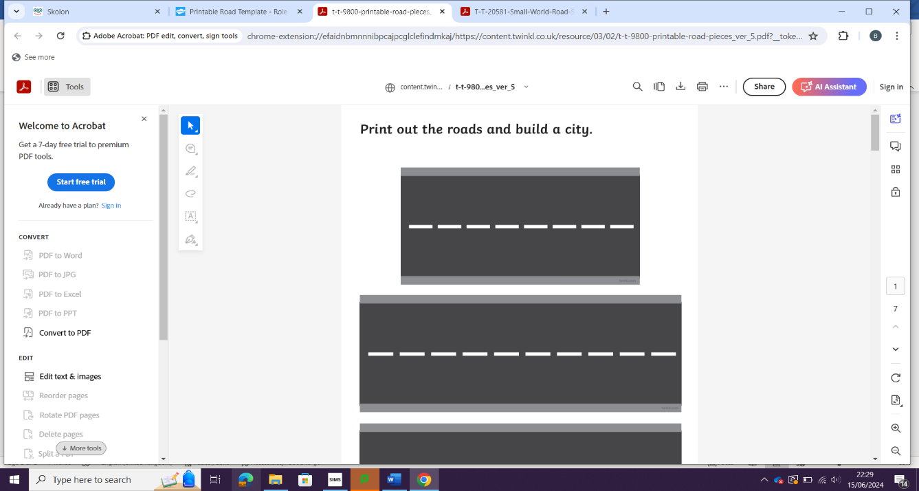
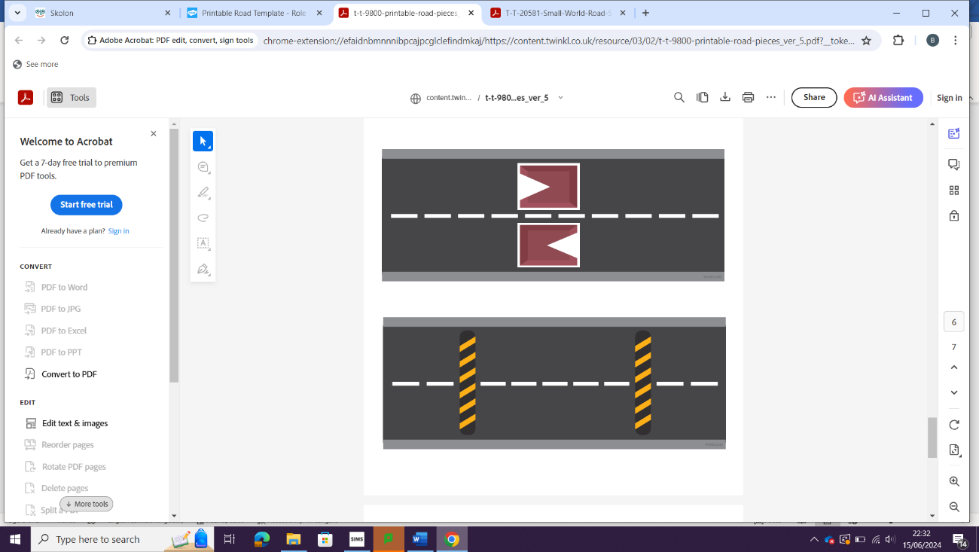
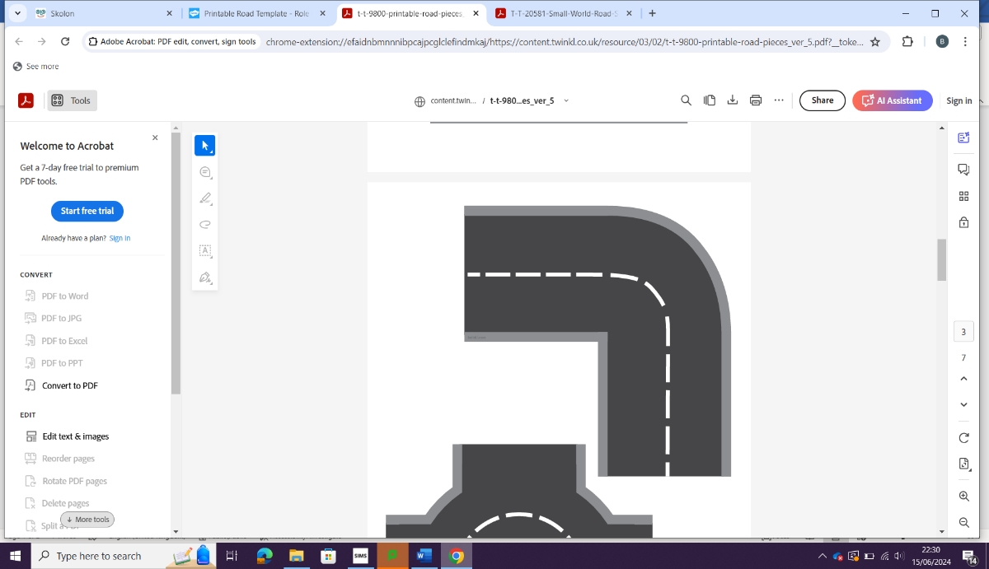


Qualitative and quantitative skills delivered throughout e.g., map skills, drawing graphs and using numeracy skills, statistics and literacy (developing reasoned arguments using case study material and reaching balanced conclusions)
- Wonders of the World
- Tectonic hazards
- Development
- Regional Study: Africa
- Rivers
- Regional Study: Asia
Year 7
KEY STAGE THREE

Geographical skills and fieldwork: build on their knowledge of globes, maps and atlases and apply and develop this knowledge routinely in the classroom and in the field; interpret Ordnance Survey maps in the classroom and the field, including using grid references and scale, topographical and other thematic mapping, and aerial and satellite photographs; use Geographical Information Systems (GIS) to view, analyse and interpret places and data; use fieldwork in contrasting locations to collect, analyse and draw conclusions from geographical data, using multiple sources of increasingly complex information
- Natural Resources
- The UK and Coasts
- Urbanisation
- Russia and weather and Climate
- Regional Study: The Middle East
- Hot Deserts
Year 8

- Climate change and industry
- Regional Study: South America
- What in the World? (contemporary geographical issues)
- DISASTERS!
- Decision making: US tourism / immigration
- Ecosystems
- Living World – Tropical rainforests / Cold Environments (G.C.S.E. AQA Geography Paper 1)

Year 9
G.C.S.E.

