Year 13 Learning Journey: A Level Geography
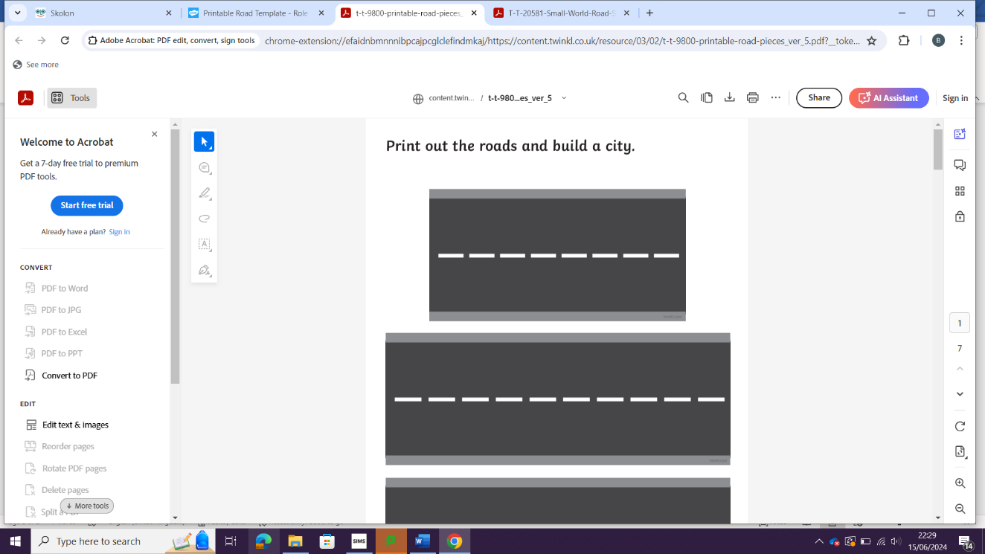
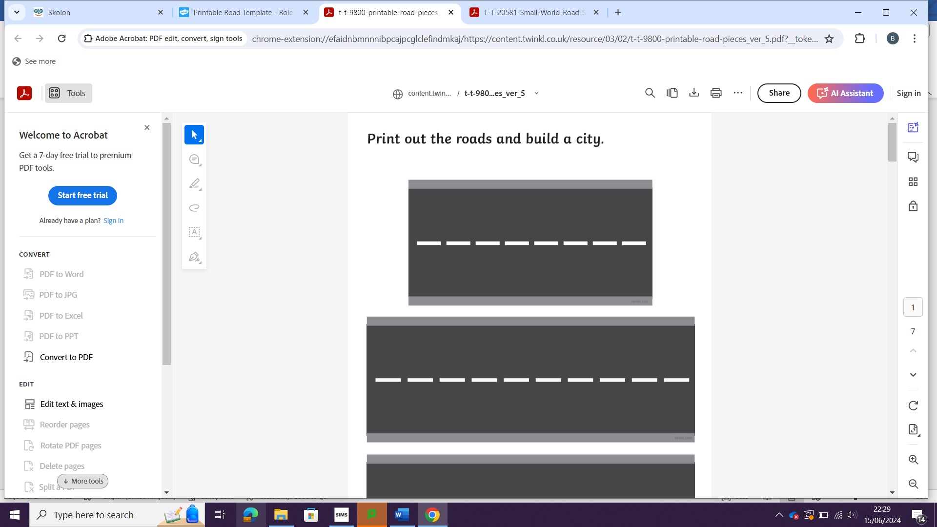
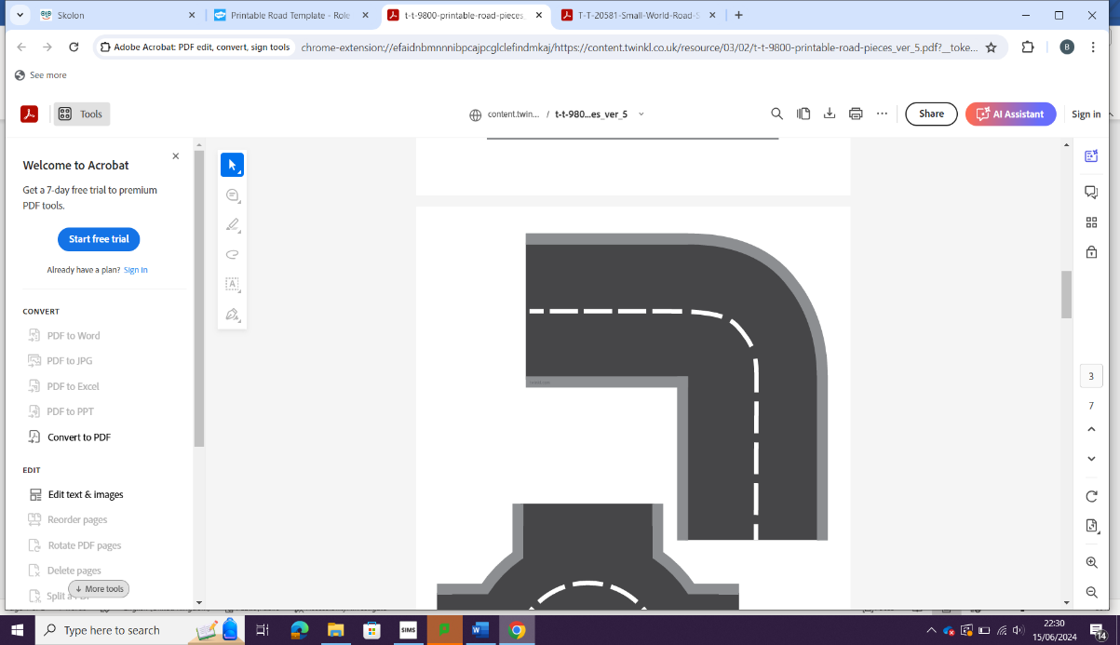
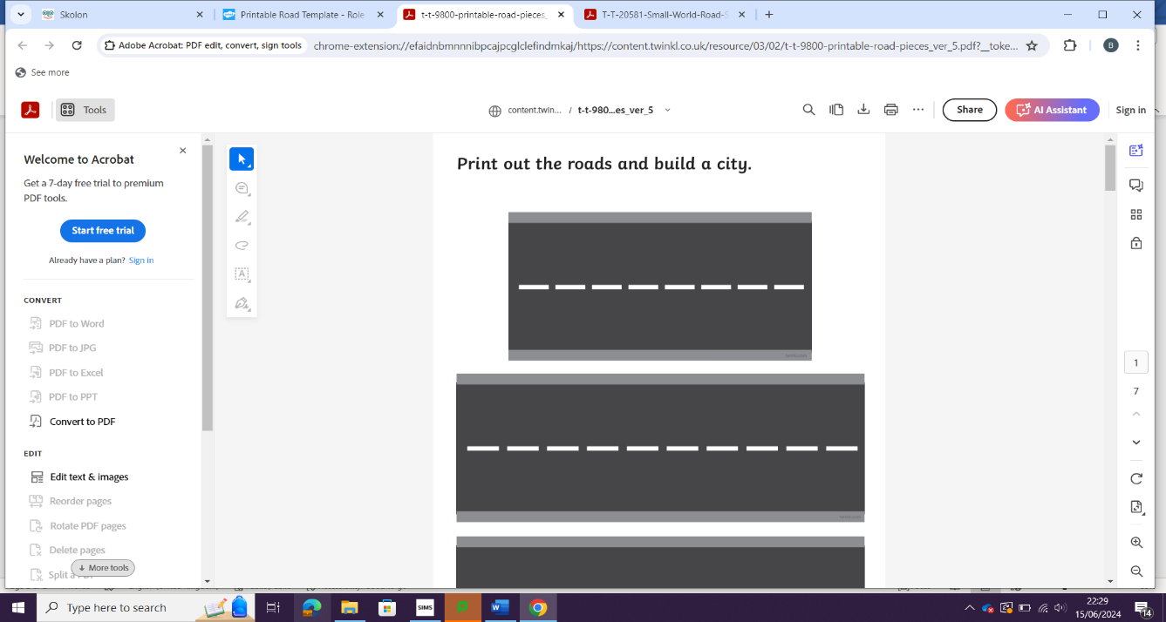
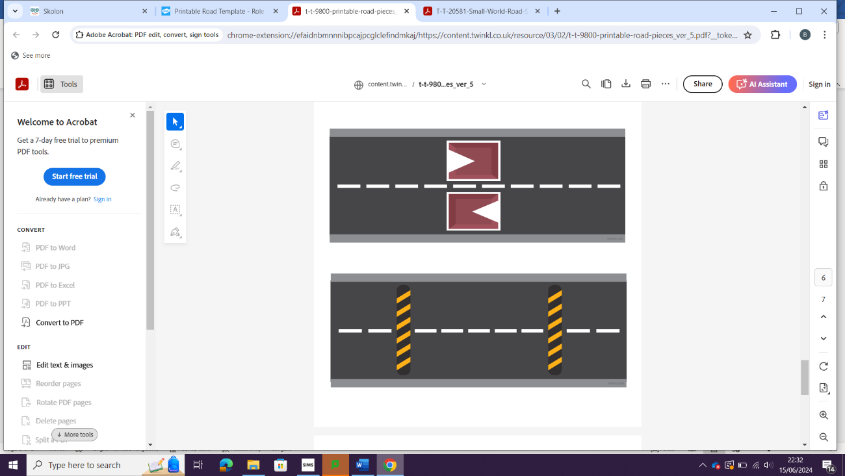
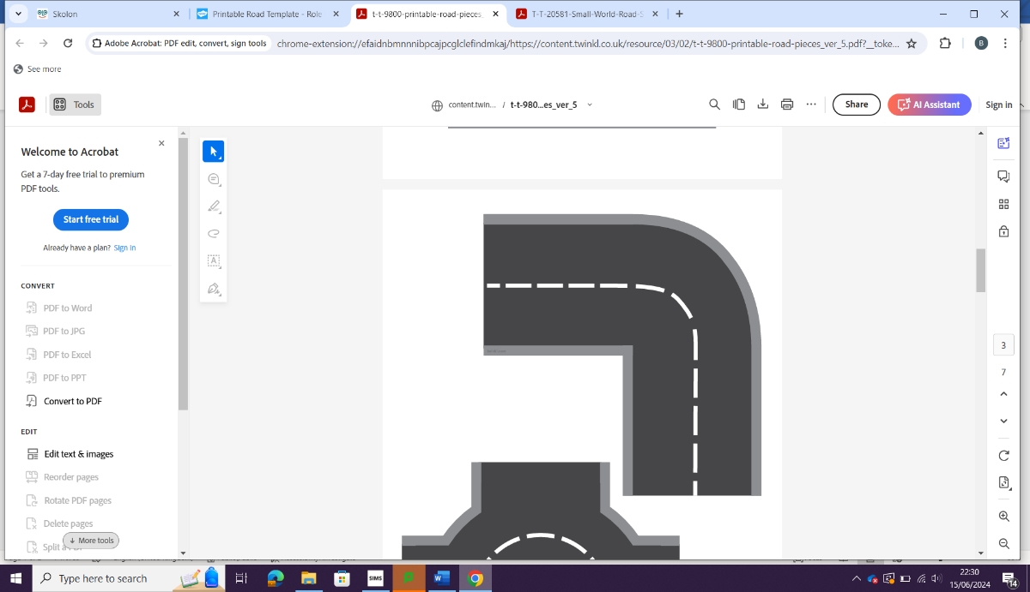

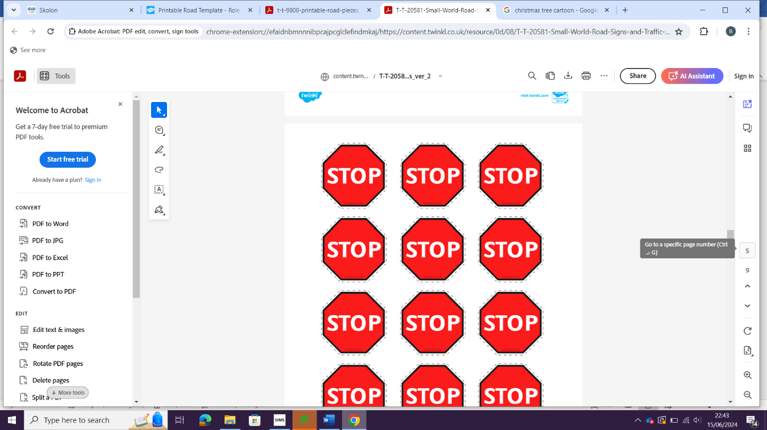
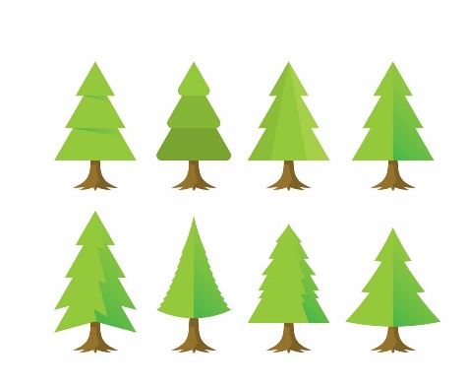

EXAMS
PPE
Next steps
Population and the Environment
Biologically transmitted disease
(Malaria)
Strategies to ensure food supply
2 agricultural systems
2 zonal soils
Human Geography
Coastal systems

NEA
Coastal systems and processes
Physical Geography
Processes, landforms and landscapes

Non-communicable disease - (asthma)


Dorset

Dors
Emergence and Submergence

Coastal management

Sundarbans

Population and environment / health
PRP Model, Malthus, Boserup and Simon / Population Futures

International agencies and NGO’s - and disease
S’s


CHANGING PLACES
GLOBAL SYSTEMS & GOVERNANCE
REVISION
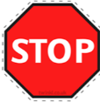

EXAM SKILLS / PRACTICE
HAZARDS
WATER AND CARBON CYCLES
REVISION

ASSESSMENT OBJECTIVES: AO1, AO2 and AO3
AO1: Demonstrate knowledge and understanding of places, environments, concepts, processes, interactions and change, at a variety of scales.

AO2: Apply knowledge and understanding in different contexts to interpret, analyse and evaluate geographical information and issues.
Geography case study
AO3: Use a variety of relevant quantitative, qualitative and fieldwork skills to: investigate geographical questions and issues; interpret, analyse and evaluate data and evidence; construct arguments and draw conclusions.

