AO4: Select, adapt and use a variety of skills and techniques to investigate questions and issues and communicate findings (25%, including 5% used to respond to fieldwork data and context(s)).
AO3: Apply knowledge and understanding to interpret, analyse and evaluate geographical information and issues to make judgements (35%, including 10% applied to fieldwork context(s)).
G.C.S.E. Assessment Objectives
AO2: Demonstrate geographical understanding of: concepts and how they are used in relation to places, environments and processes; the interrelationships between places, environments and processes (25%).
AO1: Demonstrate knowledge of locations, places, processes, environments and different scales (15%).
Geography Learning Journey: Key Stages 4 (G.C.S.E.) Year 11

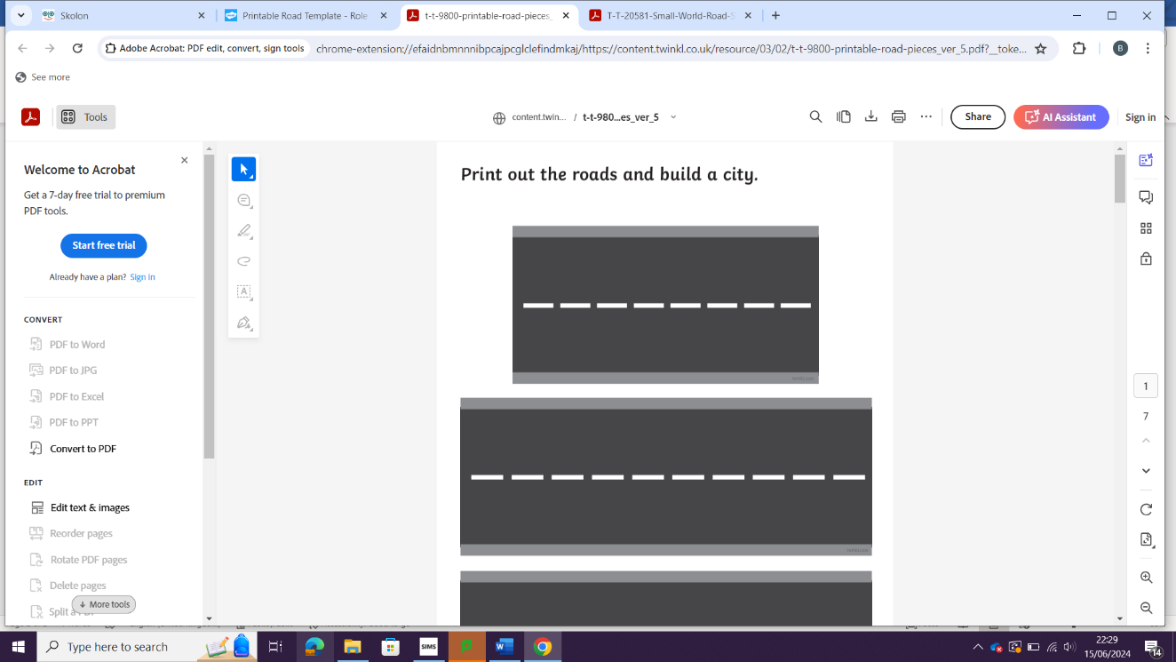
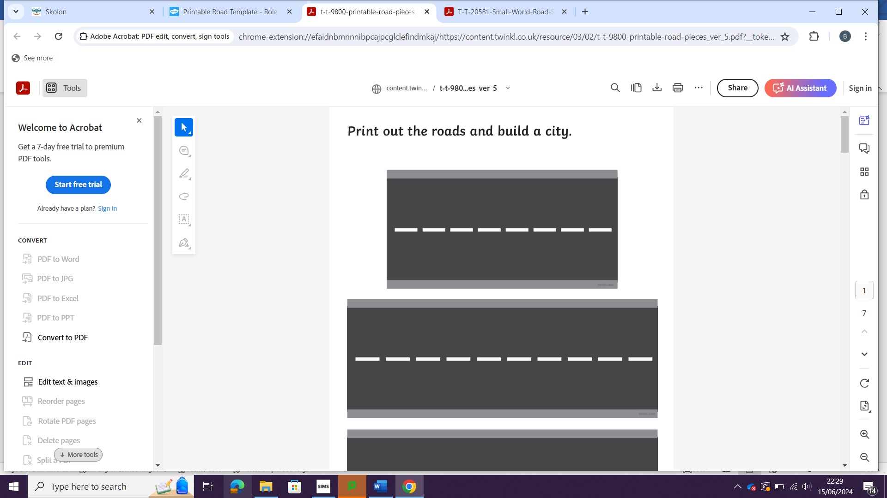
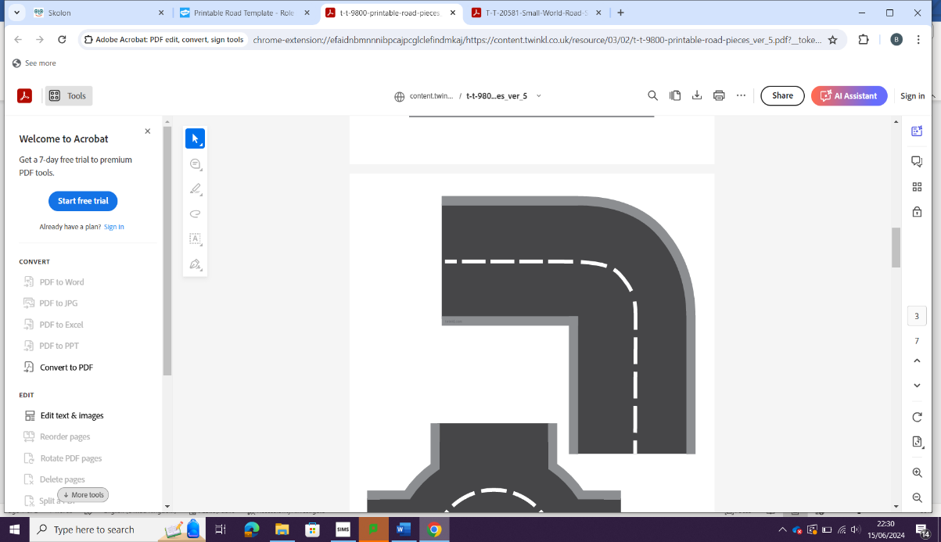
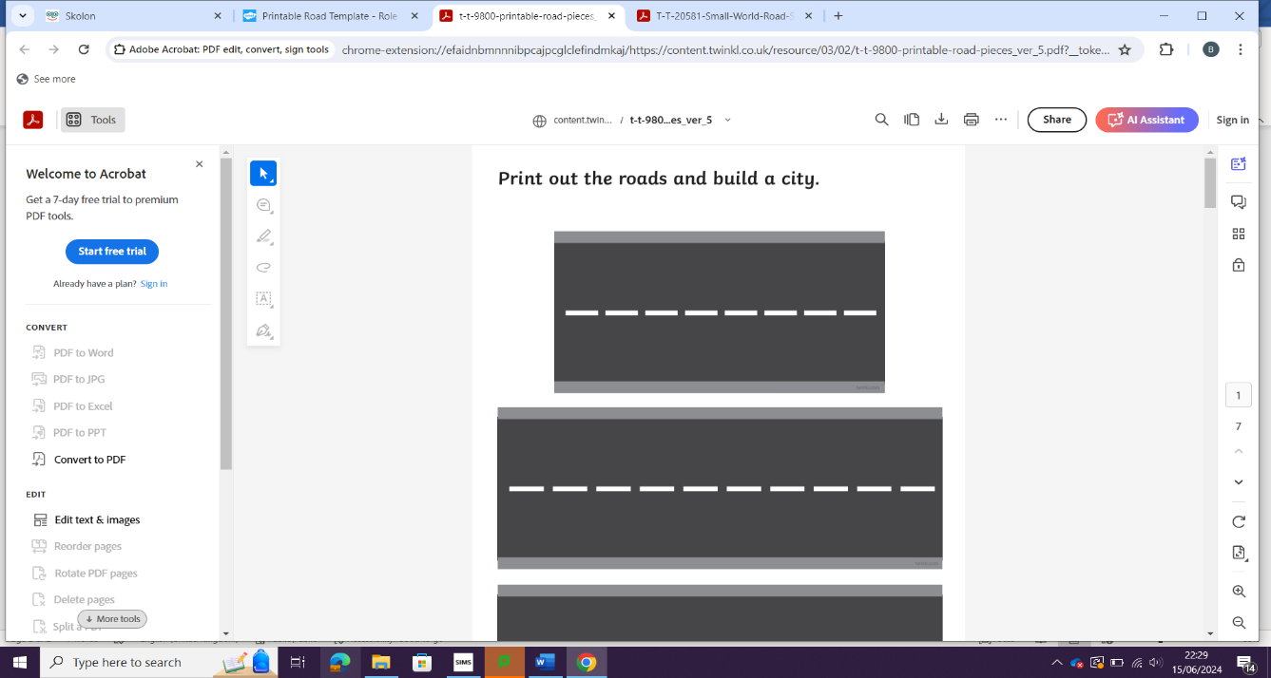
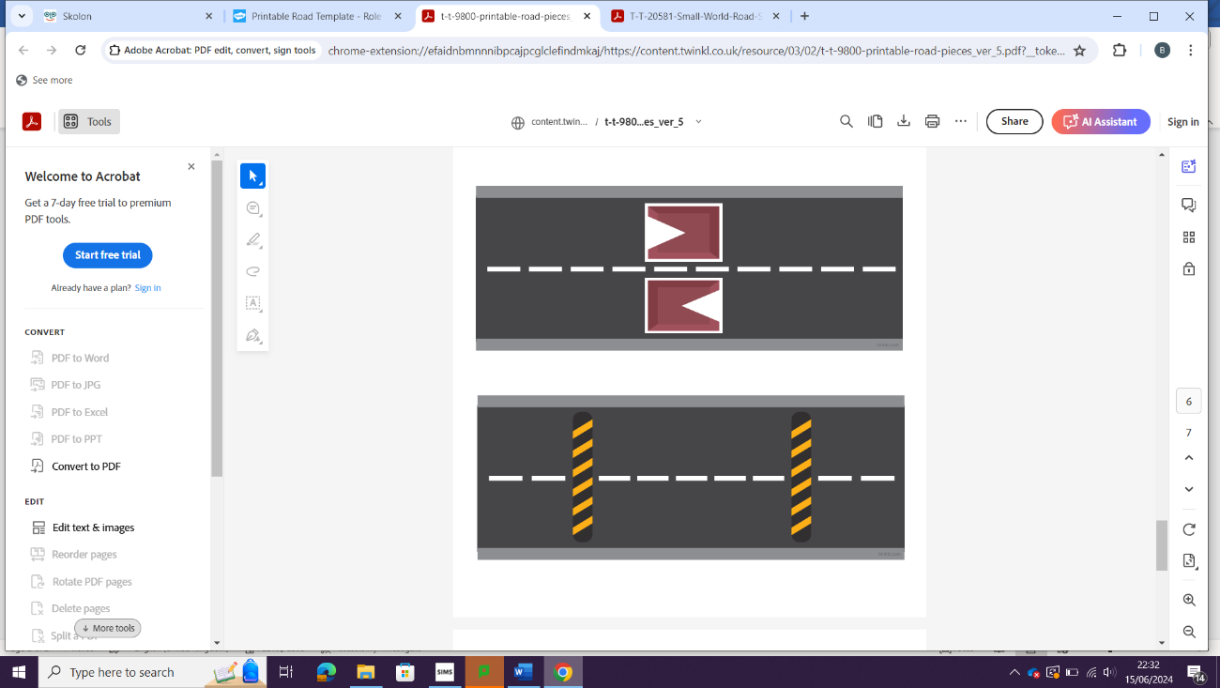
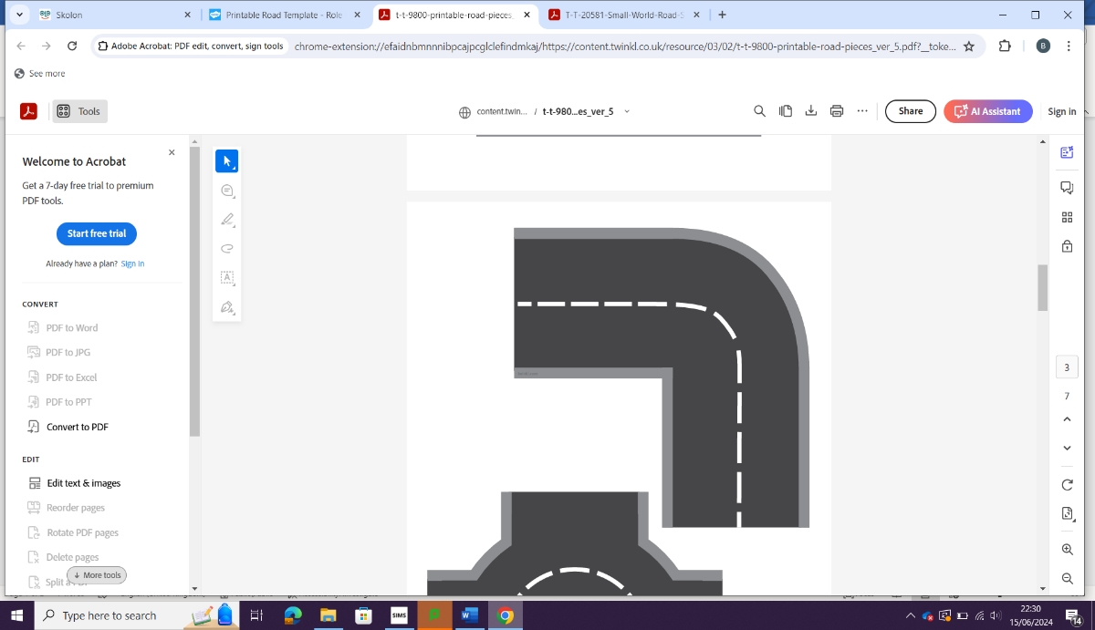


Physical landscapes of the UK: Rivers (Paper 1)
Year 11
G.C.S.E. (AQA)
Urban Issues and Challenges: The UK / Nigeria (Paper 2)

Changing Economic World: The UK (Paper 2)
Masterclasses 3:10-4:00 pm Masterclasses 3:10-4:00 pm Masterclasses 3:10-4:00 pm Masterclasses 3:10-4:00 pm

Exam preparation – revision (content / skills)
The Challenge of Resource Management (Paper 2)
Pre-release material preparation – Issue Evaluation

Masterclasses 3:10-4:00 pm Masterclasses 3:10-4:00 pm Masterclasses 3:10-4:00 pm Masterclasses 3:10-4:00 pm

A Level

