Year 12 Learning Journey: A Level Geography
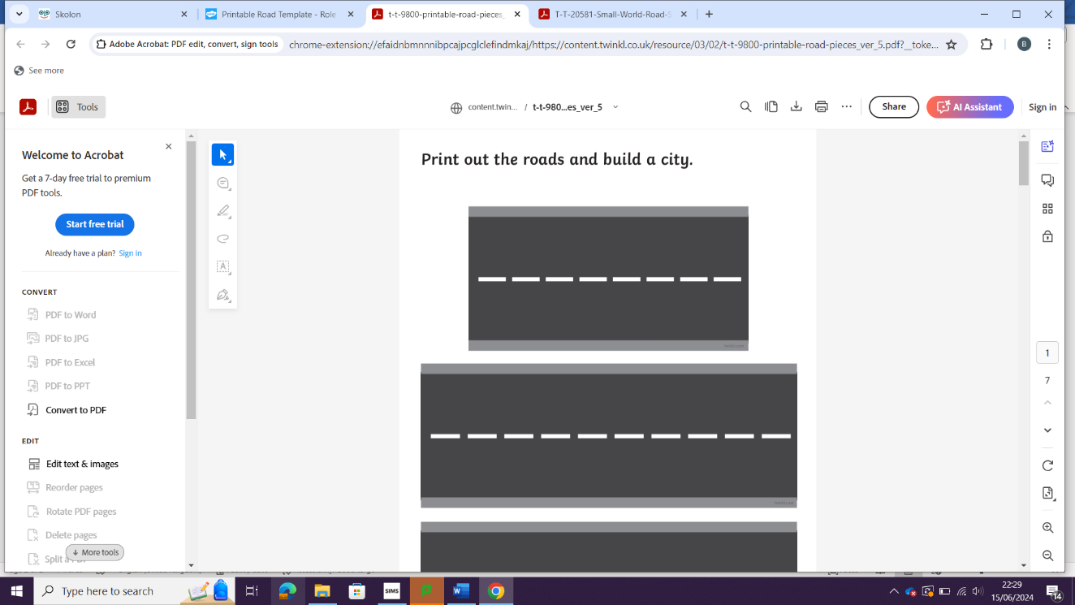
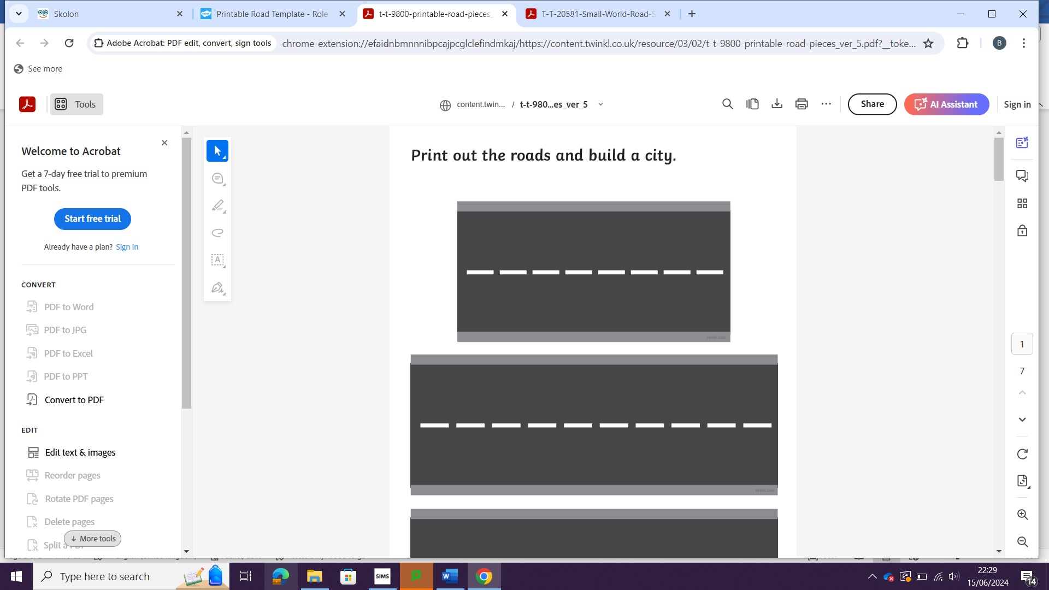
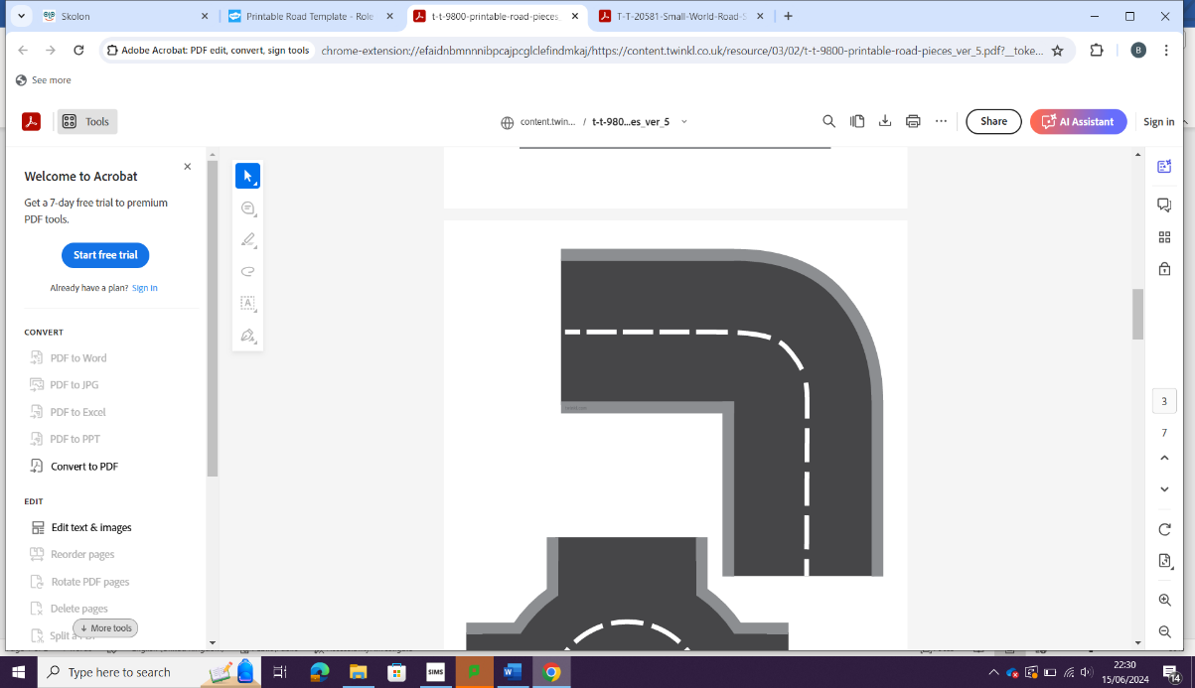
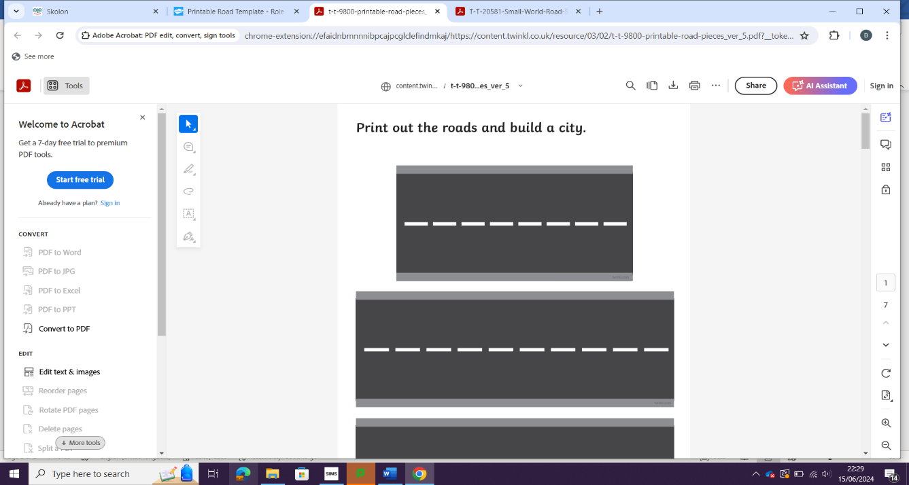
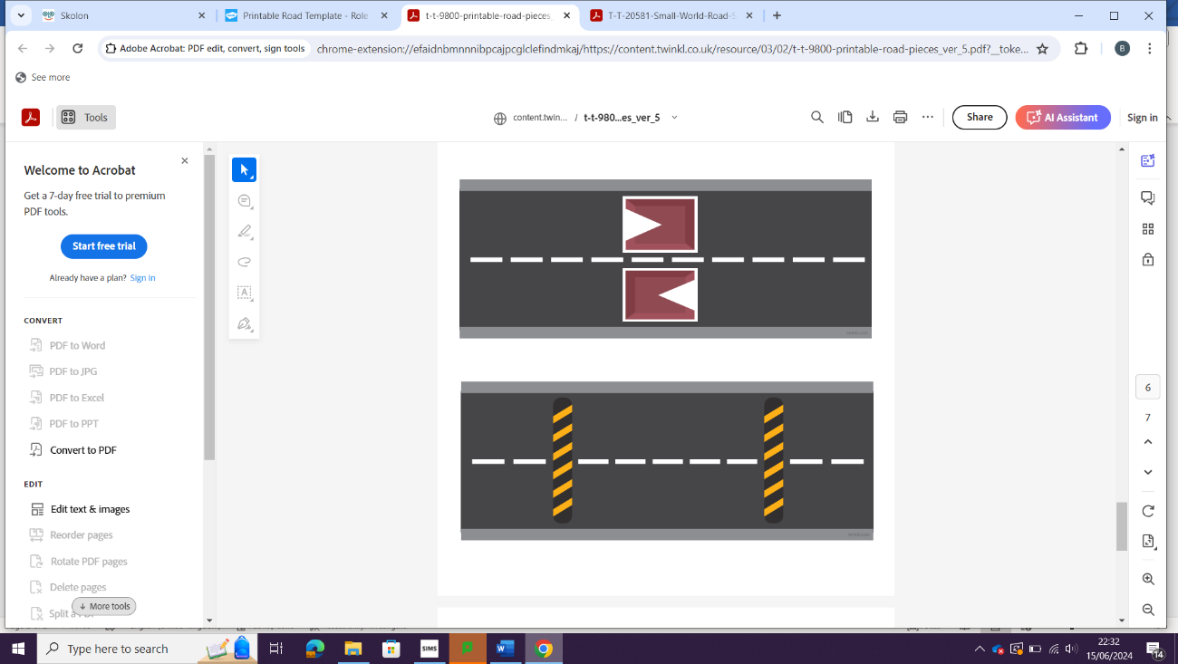
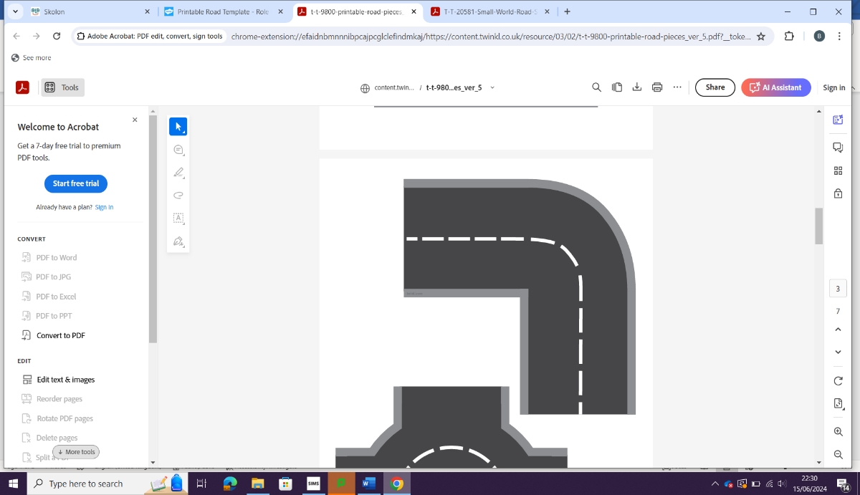

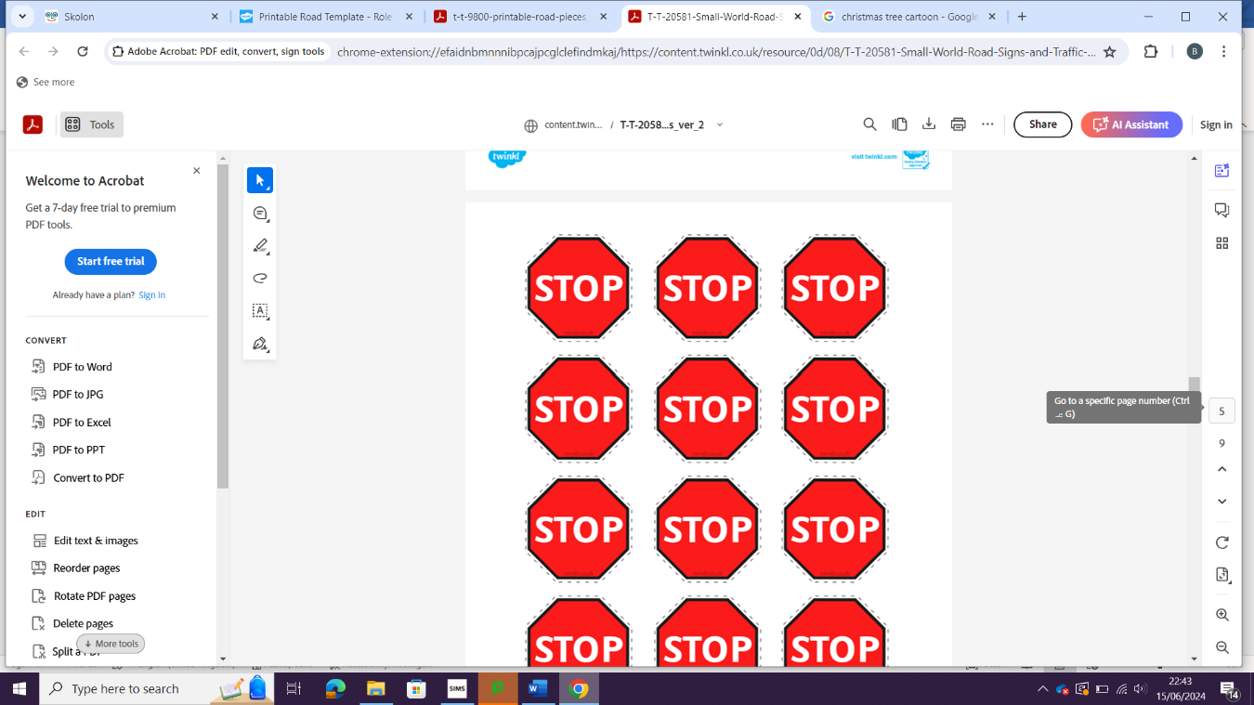
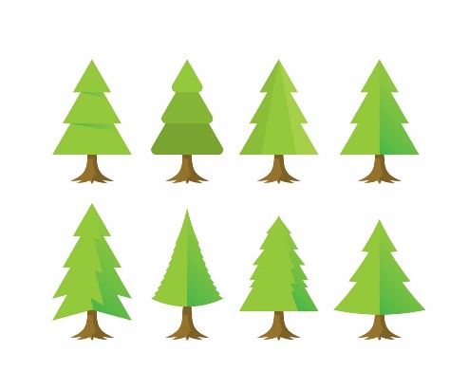


Assessment
PPE 2
PPE 1
Year 13
Global Systems
Trade in 1 food commodity / manufactured product

Human Geography
Theory

River catchment

Water and Carbon Cycles
Physical Geography

Recent event
Recent event
Recent event
Hazards
Tropical storms – HIC / LIC

Tectonics / theory

Earthquakes

Volcanic eruptions

Antarctica as a global commons

Global Governance


Changing Places
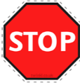

Changing demographic and cultural characteristics
2 contrasting places, 1 local
Local place study in hazardous environment

Multi-hazardous environments

Wildfires

Recent event
Recent event
ASSESSMENT OBJECTIVES: AO1, AO2 and AO3
AO1: Demonstrate knowledge and understanding of places, environments, concepts, processes, interactions and change, at a variety of scales.

Recent event
AO2: Apply knowledge and understanding in different contexts to interpret, analyse and evaluate geographical information and issues.
Geography case study Recent geography example
AO3: Use a variety of relevant quantitative, qualitative and fieldwork skills to: investigate geographical questions and issues; interpret, analyse and evaluate data and evidence; construct arguments and draw conclusions.

