AO1: Demonstrate knowledge of locations, places, processes, environments and different scales (15%).
AO3: Apply knowledge and understanding to interpret, analyse and evaluate geographical information and issues to make judgements (35%, including 10% applied to fieldwork context(s)).
G.C.S.E. Assessment Objectives
Geography Learning Journey: Key Stages 4 (G.C.S.E.) Year 10
AO2: Demonstrate geographical understanding of: concepts and how they are used in relation to places, environments and processes; the interrelationships between places, environments and processes (25%).
AO4: Select, adapt and use a variety of skills and techniques to investigate questions and issues and communicate findings (25%, including 5% used to respond to fieldwork data and context(s)).

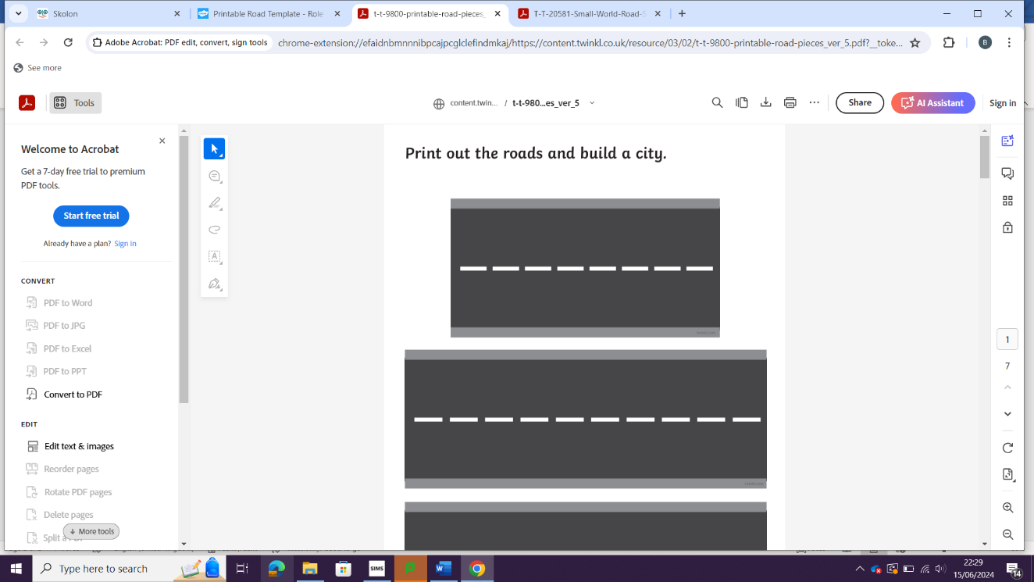
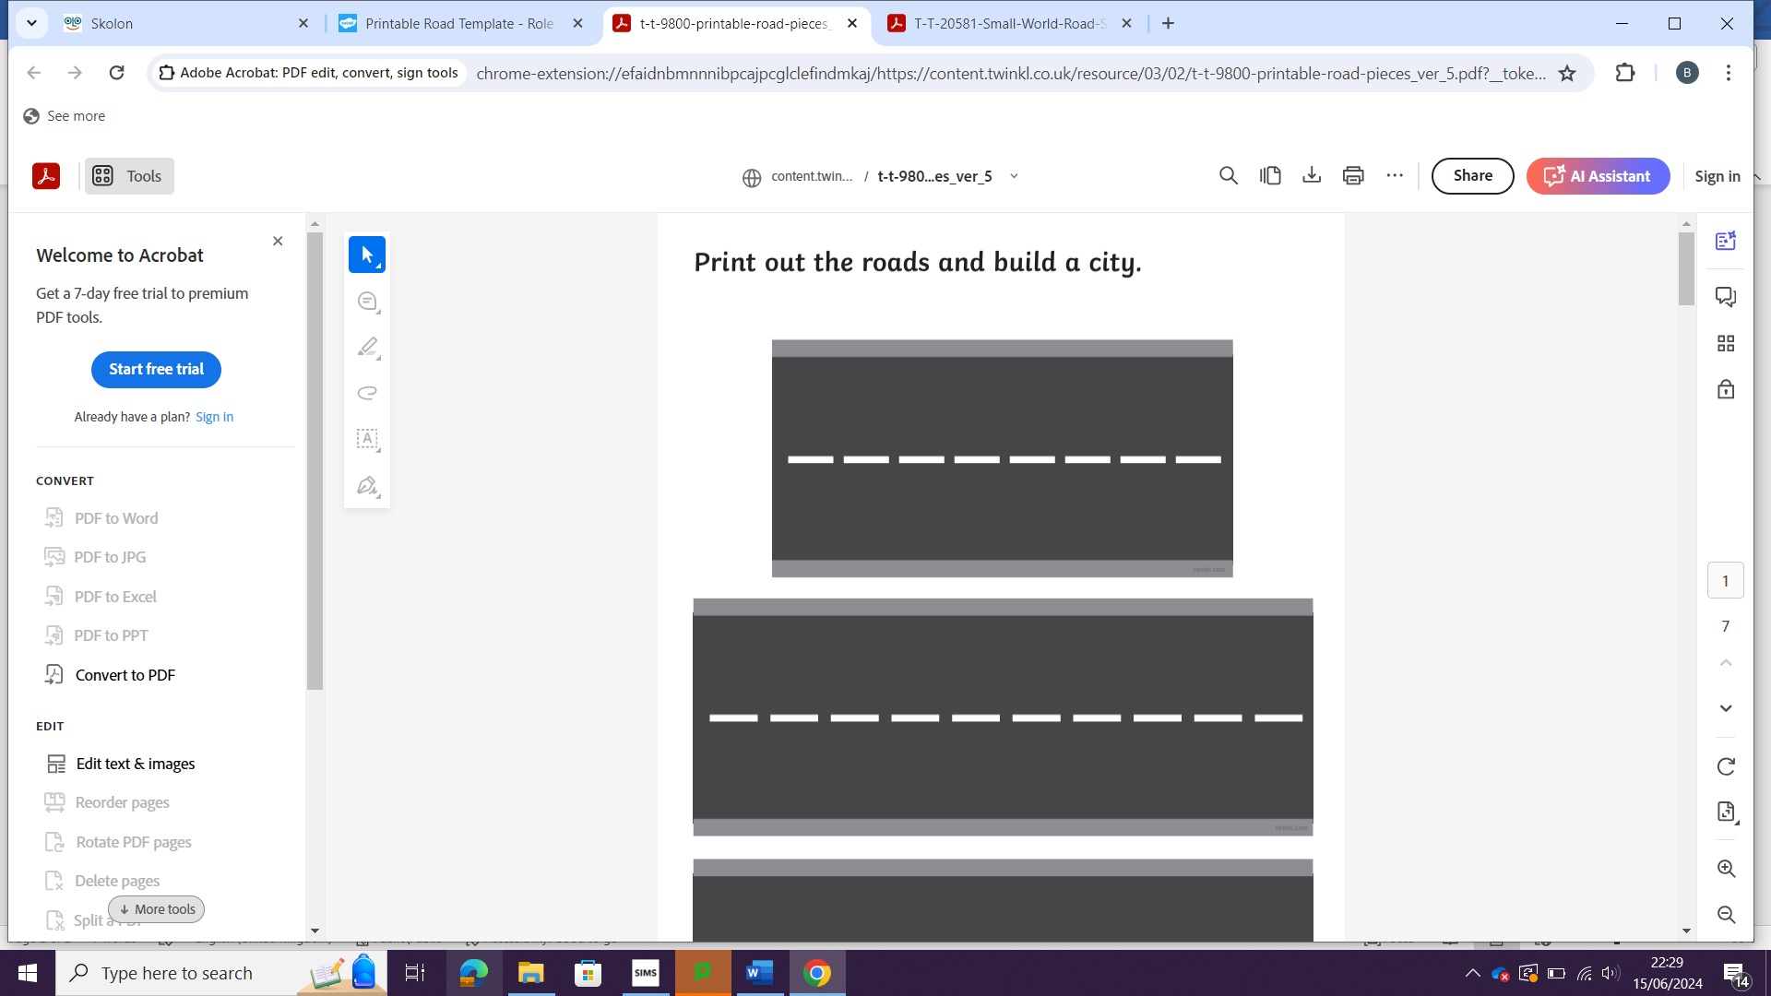
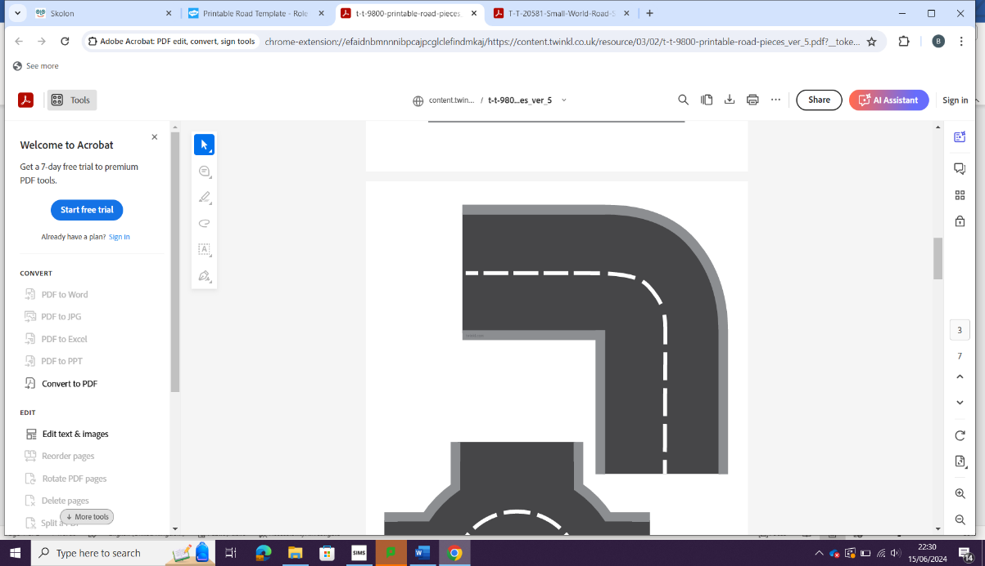
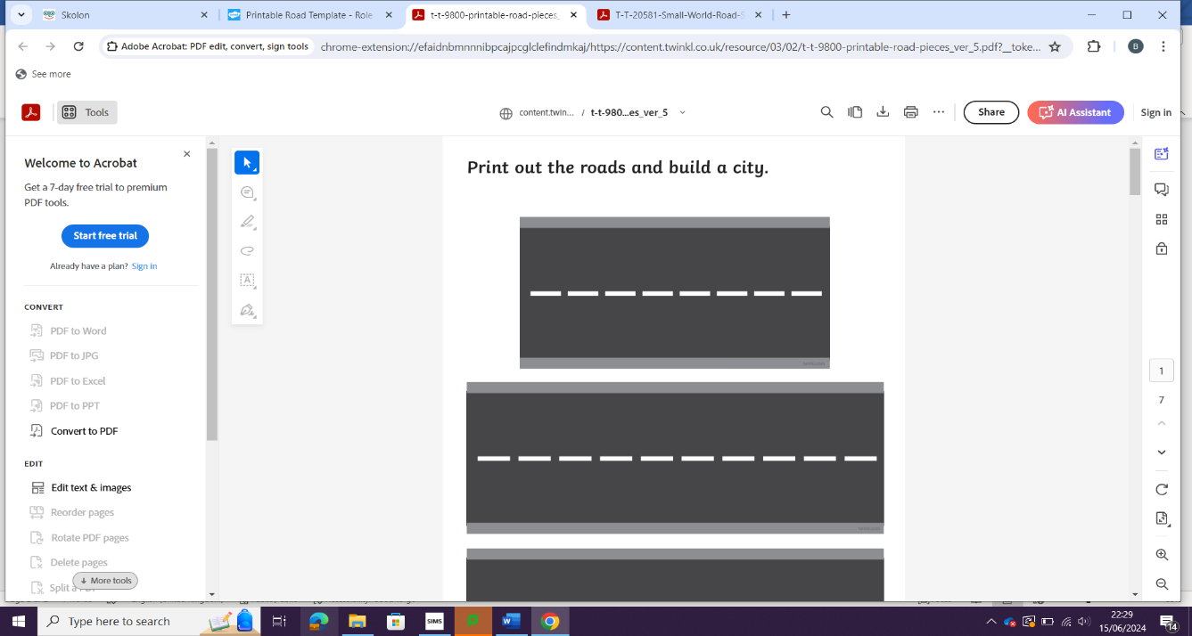
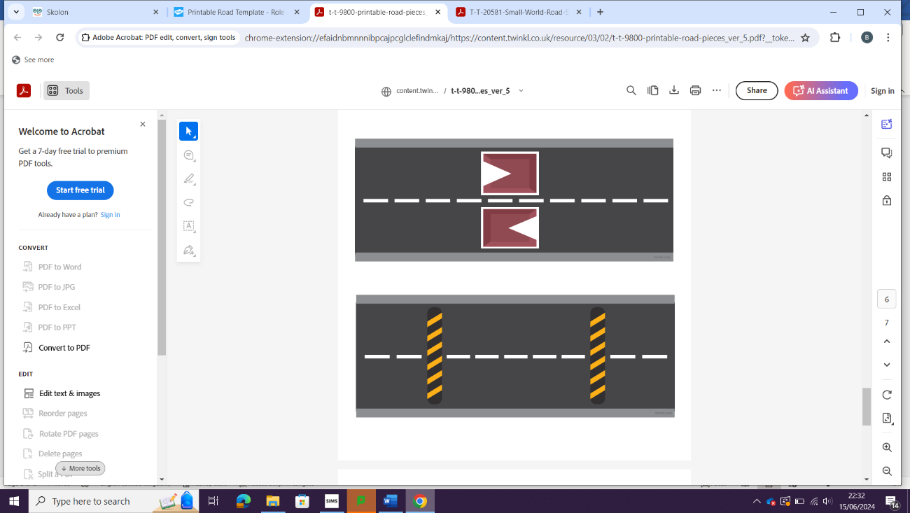
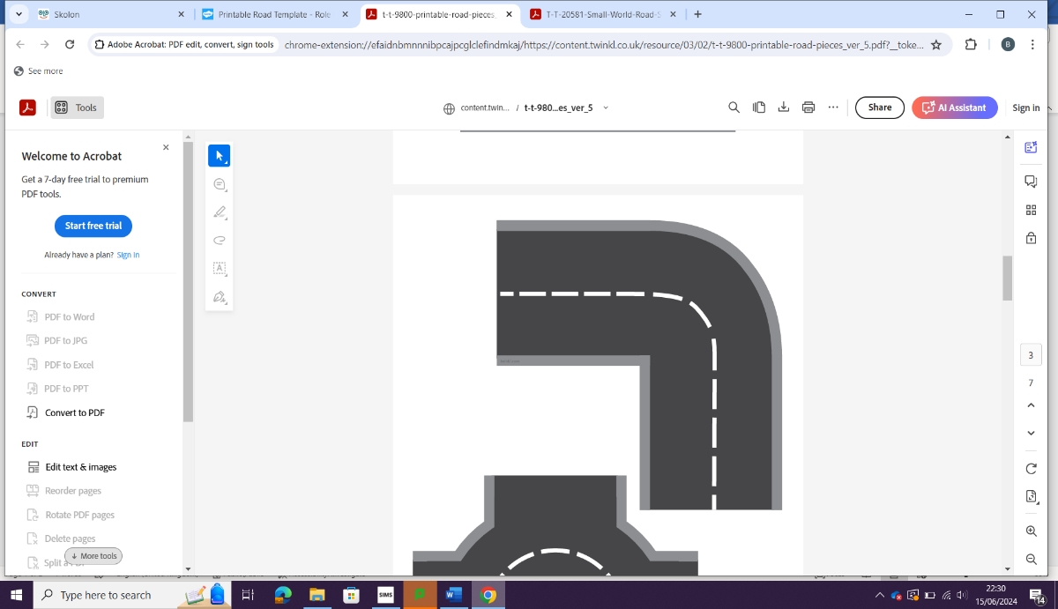


The Challenge of Natural Hazards: (Paper 1)

Year 10
G.C.S.E. (AQA)

Changing Economic World: Global / Nigeria (Paper 2)

Physical Landscapes of the UK: Coasts (Paper 1)

Fieldwork investigation write-up

Fieldwork – Hunstanton – coastal processes and defences
Year 11

