
Kingswood Secondary Academy

OCR A Level Biology

Transition work

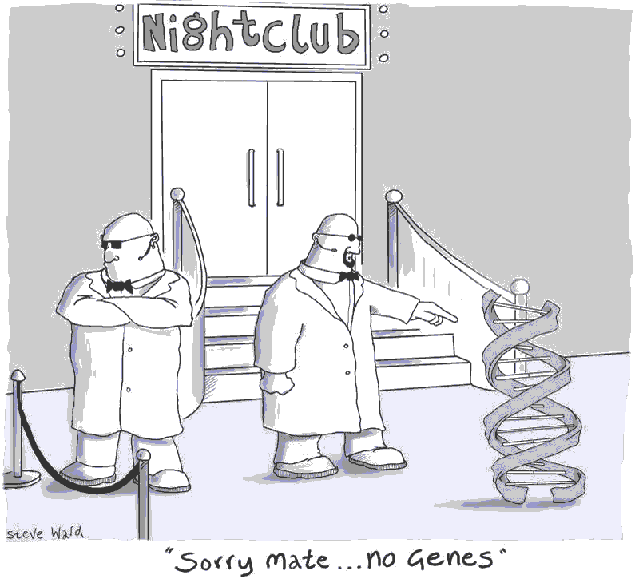

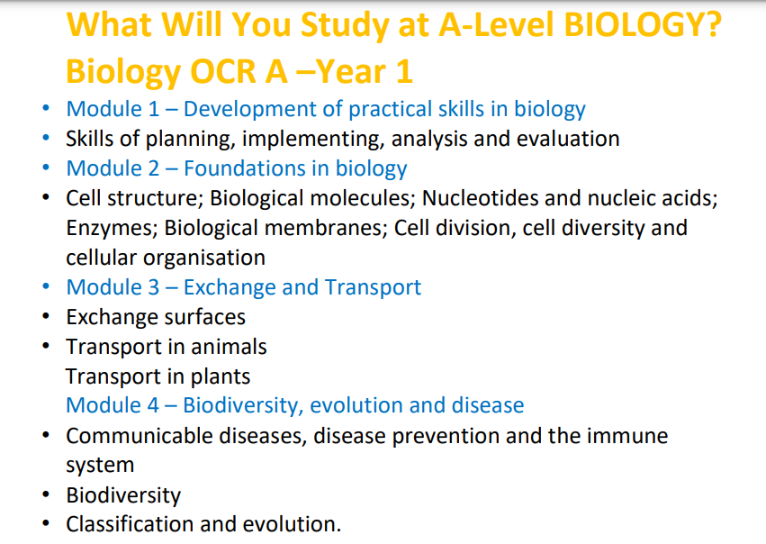

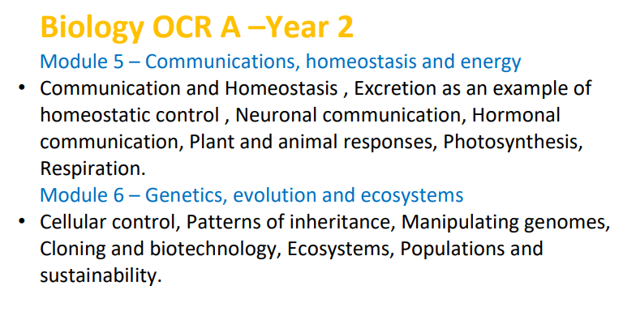

Task 1:

Organisation
You will be given an exercise book to make notes into, similar to previous years. However, all worksheets, assessments and other paperwork must be kept in a folder. This folder must be organised into modules as stated above.

Your first task will be to organise your folder into modules using dividers. You may choose to have a small ring binder to bring in to day to day, and then transfer all your work into a larger folder at home.

Task 2: Securing GCSE Triple Biology Knowledge
The table below lists topics that were not covered in Trilogy Biology along with links that will allow you to access the content. Use the links and other resources to make notes on the triple content to ensure your knowledge is secure.
Revision topics AQA GCSE Biology Specification:  https://filestore.aqa.org.uk/resources/biology/speci  fications/AQA-8461-SP-2016.PDF | Topics that were not covered in Trilogy Biology (combined) but you need to be aware of.
4.1 Cell Structure | Culturing microorganisms  https://www.bbc.co.uk/bitesize/guides/z8fkmsg/revision/7
4.2 Organisation | No triple content
4.3 Infection and response | Monoclonal antibodies https://www.bbc.co.uk/bitesize/guides/zt8t3k7/revision/1  Plant disease https://www.bbc.co.uk/bitesize/guides/z3tgw6f/revision/1
4.4 Bioenergetics | No triple content
4.5 Homeostasis and response | The brain  The eye  Control of body temperature  Maintaining water and nitrogen balance in the body. Plant hormones  Uses of plant hormones  https://www.bbc.co.uk/bitesize/topics/zy468mn
4.6 Inheritance, variation and evolution | Advantages and disadvantages of sexual and asexual reproduction.  DNA structure  Protein synthesis  Cloning  https://www.bbc.co.uk/bitesize/guides/z9pkmsg/revision/1  Theory of evolution  Speciation  The understanding of genetics https://www.bbc.co.uk/bitesize/guides/zcqbdxs/revision/1
4.7 Ecology | Decomposition https://www.bbc.co.uk/bitesize/guides/zy7gw6f/revision/1  Impact of environmental change https://www.bbc.co.uk/bitesize/guides/zt8f4qt/revision/1  Trophic levels in an ecosystem https://www.bbc.co.uk/bitesize/guides/zs7gw6f/revision/1  Food production https://www.bbc.co.uk/bitesize/guides/ztwvk2p/revision/1

Task 3 – Testing Your Knowledge

Both Section A and B are out of 20. Circle the correct answer.

SECTION A – Cell Biology

- Which cell group does not possess a true nucleus?

  - Prokaryotes b. Eukaryotes c. Plants d. Animals

Which of the following is a eukaryote?

  - Bacteria b. Virus c. Archaea d. Sperm

Which of the following is found in all prokaryotic cells but only some eukaryotic cells?

  - Cell membrane b. Cell wall c. Mitochondria d. Ribosome

Where in the cell are proteins synthesised?

  - Mitochondria b. Vacuole c. Ribosomes d. Nucleus

Where do the majority of metabolic reactions take place?

a . Cytoplasm b. Nucleus c. Cell membrane d. Ribosomes

How do you calculate the magnification of a magnified object?

  - Image size x actual size b. Image size ÷ actual size

c. Actual size x image size d. Actual size ÷ image size

Which of these cells contain spirals of lignin?

  - Palisade cells b. Bacterial cells c. Yeast cells d. Xylem cells

What are cells called if they are adapted to perform a certain job?

  - Specific b. Functional c. Unique d. Specialised

What are cells produced by mitosis called?

  - Sister cells b. Daughter cells c. Haploid cells d. Zygotes

How many cell divisions occur in mitosis?

  - None b. 1 c. 2 d. 3

A cell that has half the usual number of chromosomes is called what?

  - Haploid b. Diploid c. Homozygous d. Heterozygous

What is the name of the first stage of mitosis?

  - Prophase b. Metaphase c. Anaphase d. Telophase

What is the term for when a cell divides?

  - Cytolysis b. Cytocrenation c. Cytodivision d. Cytokinesis

Diffusion is the movement of particles from…

  - a higher concentration to a lower concentration.
  - a lower concentration to a higher concentration.
  - a higher water potential to a lower water potential through a partially permeable membrane.
  - a lower concentration to a higher concentration using ATP.

Small circular pieces of DNA in a bacterial cell are called:

  - Plasmids b. Loose DNA c. Ribosomes d. Enzymes

Root hair cells are adapted to absorb water and mineral ions by…

  - having no chloroplasts. b. being transparent.
c. having a thick cell wall. d. having a large surface area.

Respiration in the mitochondria requires which two chemicals?

  - Glucose b. Carbon dioxide c. Water d. Oxygen

Electron microscopes are able to distinguish between two points just a few nanometers apart. This is
called…
  - magnification b. resolution c. resolving power d. image size

The food producer within the plant cell uses energy from the sun and converts carbon dioxide and water into sugars. This sub-cellular structure is called the…

  - vacuole. b. mitochondria. c. chloroplast. d. nucleus.

The thick rigid layer that surrounds plant cells and provides support and structure is called the…

  - nucleus b. mitochondria. c. cell wall. d. chloroplast.

SECTION B –Transport systems

- What are the four main components of blood?

  - Red blood cells, white blood cells, plasma, carbon dioxide
  - Red blood cells, white blood cells, oxygen, sugar
  - Plasma, red blood cells, white blood cells, platelets
  - Oxygen, platelets, red blood cells, white blood cells

What is the function of red blood cells?

  - Carry oxygen b. Carry carbon dioxide c. Carry glucose d. Carry water

Which of these statements is not an adaptation of the red blood cell?

  - Biconcave disc shape b. No nucleus c. Contains haemoglobin d. Has a flagellum

Which blood vessels have thick walls made of muscle and elastic fibres?

  - Veins b. Arteries c. Capillaries d. Venules

Which blood vessel has very thin walls for efficient exchange of substances?

  - Veins b. Arteries c. Capillaries d. Venules

What are the top two chambers of the heart called?

  - Atria b. Ventricles c. Aorta d. Vena Cava

Why does the left ventricle have thicker muscle than the right ventricle?

  - Pumps blood to the lungs b. Pumps blood to the body

c. Increases blood pressure d. Reduces cardiac output

What treatments are available for blocked coronary arteries?

  - Heart transplant b. Valve transplant c. Pacemaker d. Stents

What are the movements of the diaphragm when breathing in?

  - Up/relaxes b. Down/contracts c. Dome/relaxes d. Flattens/contracts

When does air enter the lungs?

  - When pressure in the lungs is lower than atmospheric pressure.
  - When pressure in the lungs is higher than atmospheric pressure.
  - When pressure in the lungs is the same as atmospheric pressure.
  - When pressure in the lungs is the same as blood pressure.

Which of these is not an adaptation of the alveoli for gas exchange?

  - Thin walls b. Large surface area c. Good blood supply d. Large diffusion distance

Which cells in the leaf are adapted for photosynthesis?

  - Guard cells b. Palisade cells c. Upper epidermal cells d. Lower epidermal cells

Which two substances move in the xylem?

  - Sugar b. Amino acids c. Water d. Ions

By what process does water get into a plant?

  - Diffusion b. Active transport c. Co-transport d. Osmosis

What two are functions of the stomata?

  - Gas exchange b. Sugar production c. Water loss d. Absorb light

Sugar in plants is stored as starch. What chemical could you use to check for starch?

  - Ethanol b. Iodine c. Benedict’s solution d. Biuret reagent

What is transpiration?
  - Process of making glucose. b. Movement of sugars through a plant
c. Movement of H₂O through a plant. d. Movement of minerals through a plant.

What does not affect the rate of transpiration?
  - CO₂ b. Temperature c. Light d. Wind

Which structure in a plant has columns of hollow, dead reinforced cells?
  - Phloem b. Xylem c. Roots d. Leaf

Translocation occurs in the…
  - Phloem b. Xylem c. Lungs d. Kidneys

Task 4 – Cell Biology
Build the bridge between GCSE and A Level Cell Biology. These questions will require more detail than GCSE.

QUESTION 1: Explain how the main sub-cellular structures, including the nucleus, cell membranes, mitochondria and chloroplasts in plant cells as well as plasmids in bacterial cells, are related to their functions.

Website – https://www.khanacademy.org/test-prep/mcat/cells/eukaryotic-cells/a/organelles-article Video - https://www.youtube.com/watch?v=JL19uv7NT7s
________________________________________________________________________________________________________________________________________________________________________________________________________________________________________________________________________________________________________________________________________________________________________________________________________________________________________________________________________________________________________________________________________________________________________________________________________________________________________________________________________________________________________________________________________________________________________________________________________________________________________________________________________________________________________________________________________________________________________________________________________________________

QUESTION 2: Explain the importance of cell differentiation
Website – http://www.bbc.co.uk/schools/gcsebitesize/science/add_ocr_gateway/living_growing/growt hdevrev5.shtml
Interactive - https://www.youtube.com/watch?v=9db44fBrWrE
____________________________________________________________________________________________________________________________________________________________________________________________________________________________________________________________________________________________________________________________________________________________________________________________________________________________________________________________________________________________________________________________________________________________________________________________________________________________________________________________________________________________________________________________________________________________________________________________________________________________________________________
QUESTION 3: Compare and contrast an electron microscope with a light microscope
Video - https://www.youtube.com/watch?v=b4WOsYktdn4

____________________________________________________________________________________________________________________________________________________________________________________________________________________________________________________________________________________________________________________________________________________________________________________________________________________________________________________________________________________________________________________________________________________________________________________________________________________________________________________________________________________________________________________________________________________________________________________________________________________________________________________________________________________________________________________________________________________________________________________________________________________________________________________________________________________________________________________________________________________________________________________________

QUESTION 4 - Describe the cell cycle including the stages of mitosis
Website – http://www.biology.arizona.edu/cell_bio/tutorials/cell_cycle/cells3.html Interactive - http://www.sumanasinc.com/webcontent/animations/content/mitosis.html
__________________________________________________________________________________________________________________________________________________________________________________________________________________________________________________________________________________________________________________________________________________________________________________________________________________________________________________________________________________________________________________________________________________________________________________________________________________________________________________________________________________________________________________________________________________________________________________________________________________________________________________________________________________________________________________________________________________________________________________________________________________________________________________________________________________________________________

