

Welcome to A Level Sociology

In this pack you will find tasks to complete for September. Please use the attached websites for additional information.

In the course you will study:

Paper 1: Education with Theory and Methods
Paper 2: Topics in Sociology
Paper 3: Crime and Deviance with Theory and Methods

Please email if you have any questions:
mhodgkins@kingswoodsecondaryacademy.org
bhardy@kingswoodsecondaryacademy.org

We look forward to teaching you in September

Miss M Hodgkins
Mrs B Hardy

Sociology
Please complete the middle task and two other tasks from the task list below.
Research a political party, i.e., the Conservatives or Labour party. Explain five of their key aims. Write a critique of these five aims. | Write an email to your local MP about a current affairs issue that is important to you. If you do get a reply, annotate it, and bring this with you. | Read and summarise the perspectives on Health from the booklets provided – this can be done using a mind map, or summary in a different format
Design a brochure to identify the different institutions in society. Include education, health, beliefs and crime. Explain the impact of each on society. | Write a 500-word essay response to the question ‘What is sociology?’ | Write a 500-report discussing the following statement: ‘We are socialised in the same way.’
Research the meaning of meritocracy. Write a report to identify the arguments for and against the UK being a meritocratic society. | Create an annotated timeline detailing the main changes in education from 1944 to present date. | Create a leaflet to outline the key health issues facing people living in the UK today
Equipment needed for Sixth Form study:
No specialist equipment required.

Suggested book/reading list/website links:
Browne, K. Sociology for AQA Volume 1 – AQA approved (Polity 2015)
https://www.aqa.org.uk/subjects/sociology/as-and-a-level/sociology-7191-7192
https://revisesociology.com/
https://getrevising.co.uk/revision-notes/sociology-a-level
https://app.senecalearning.com/courses?Price=Free&text=sociology
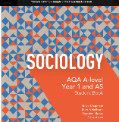
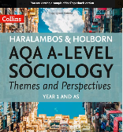
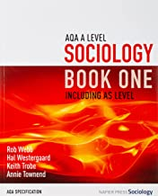
Other relevant textbooks:

The sociological perspectives

- Produce a mind map or use your preferred learning style to explain:

Functionalism – what is the functionalist perspective?
Marxism – what is the Marxist perspective?
Interactionism – what is the interactionist perspective?
Feminism – what is the feminist perspective? Include the different types of feminism.
New Right Theory – what is the New Right Theory?
Postmodernism – what is the postmodernist theory?

Include supporting sociologists and evidence.
Add any key terms and/or scholars to a ‘glossary’ page/ book.
Useful websites:
https://revisesociology.com/2017/07/18/sociological-perspectives-summaries-pictures/
https://www.cliffsnotes.com/study-guides/sociology/the-sociological-perspective/three-major-perspectives-in-sociology
Padlet- to help you with the tasks
https://padlet.com/bhardy6/a-level-sociology-transition-2024-7anqvgclffl3x2mv

