A Level History summer work

Studying the Early Tudors (Paper 1)
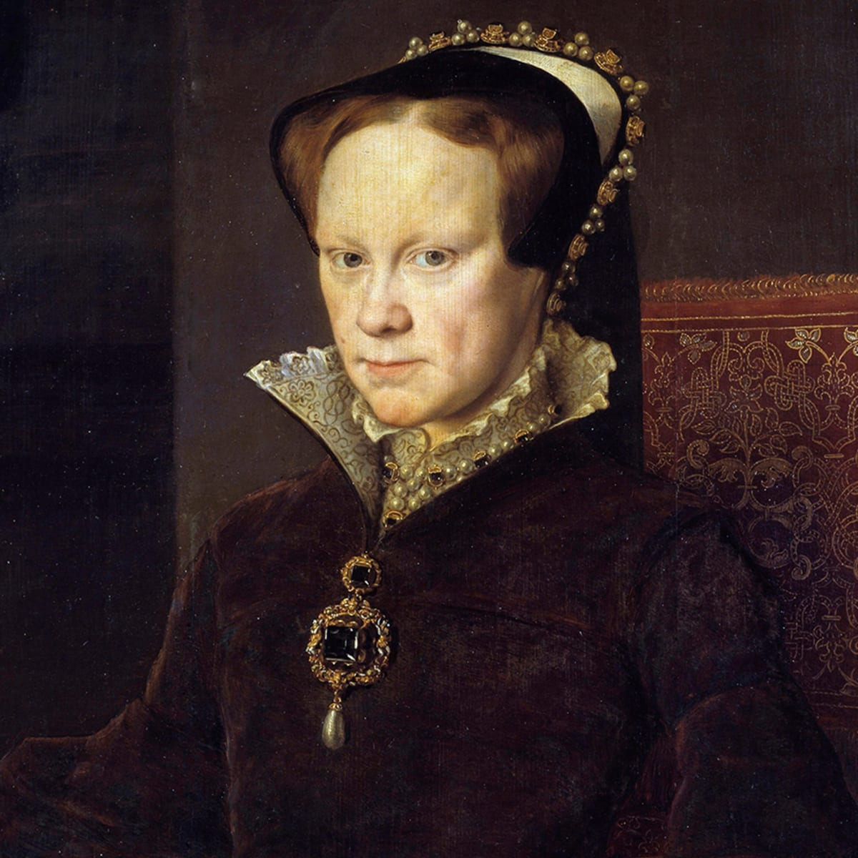
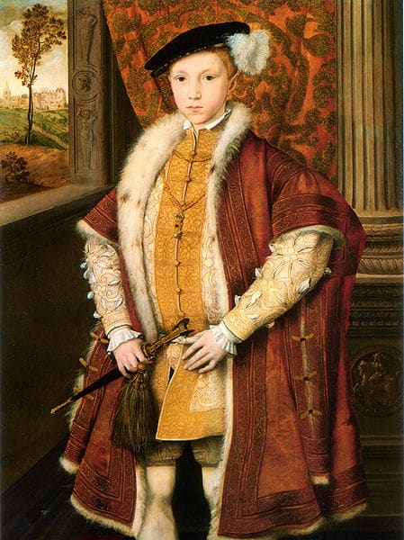
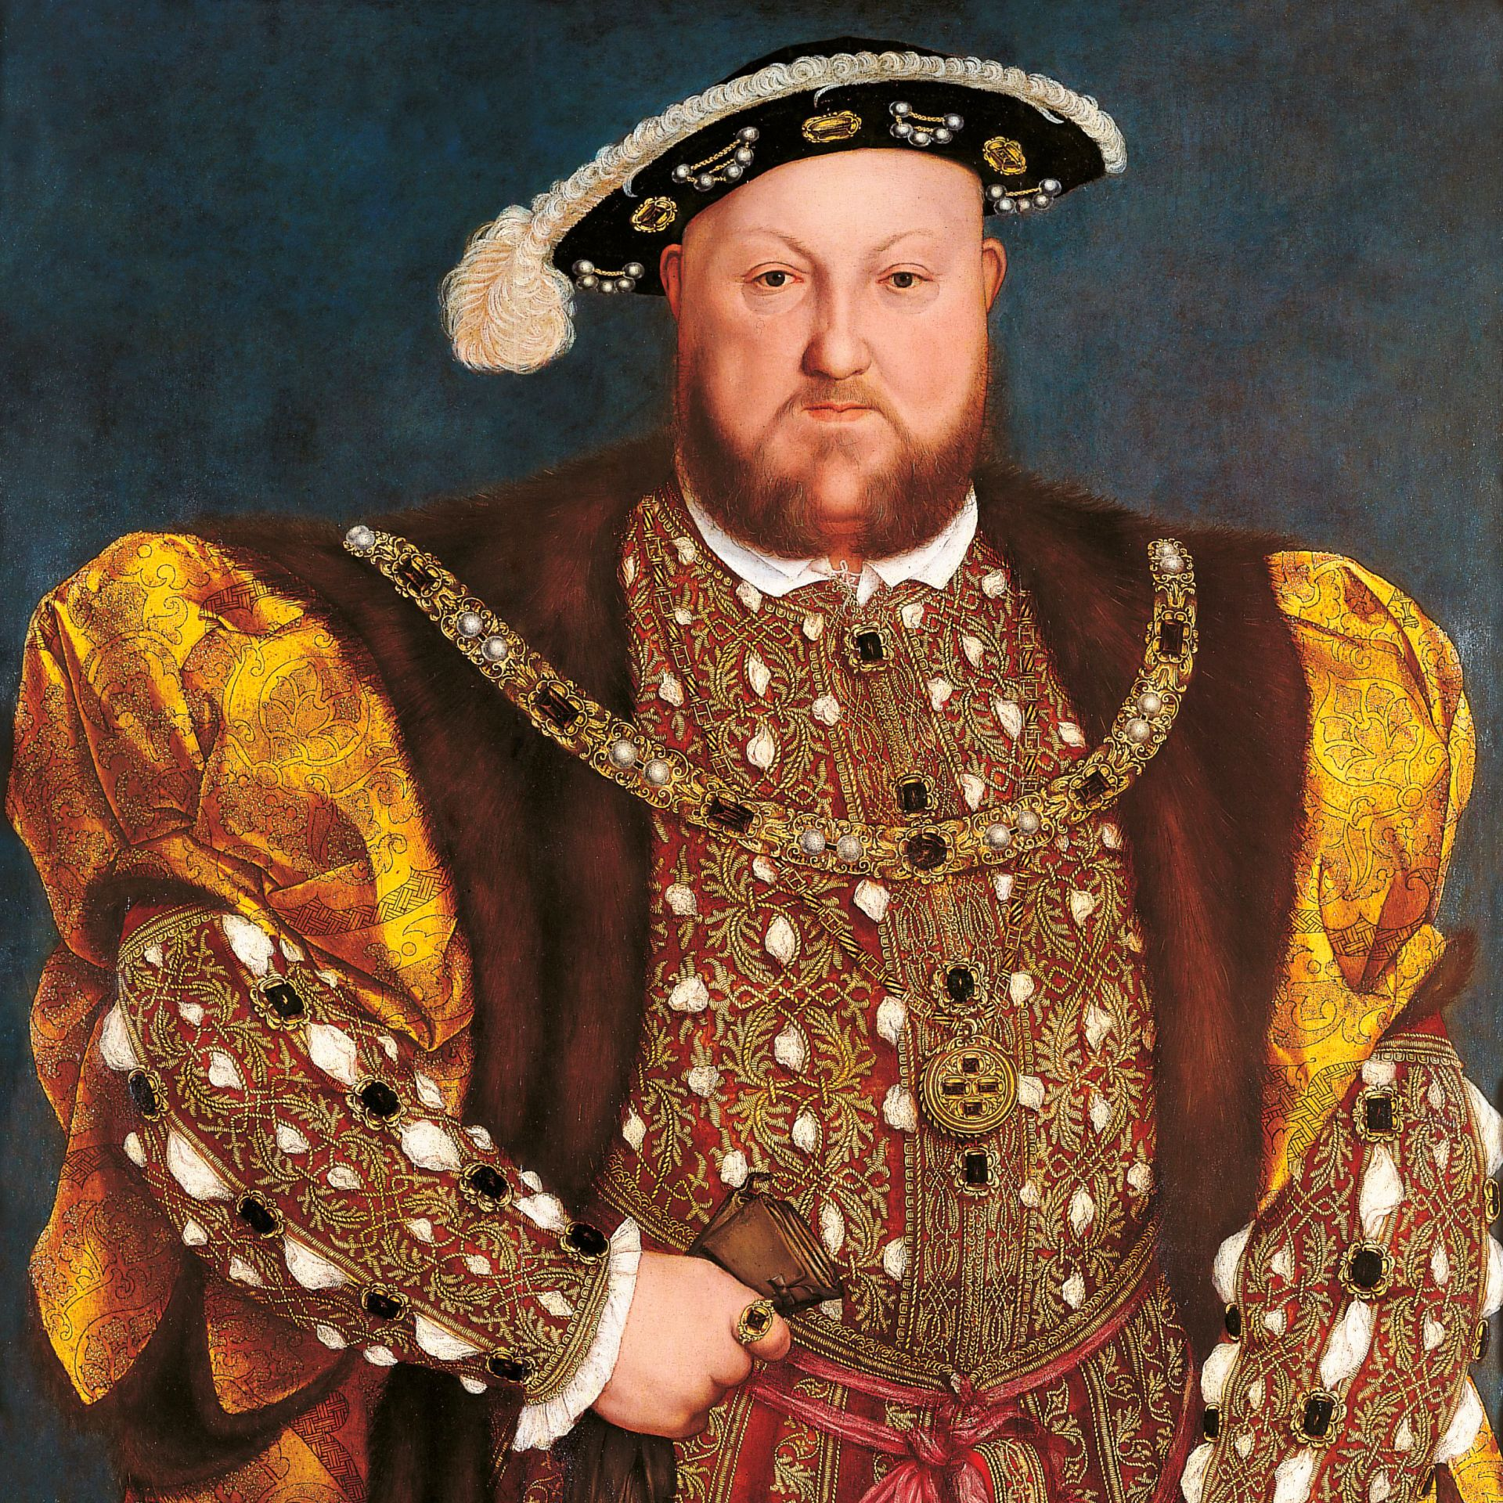
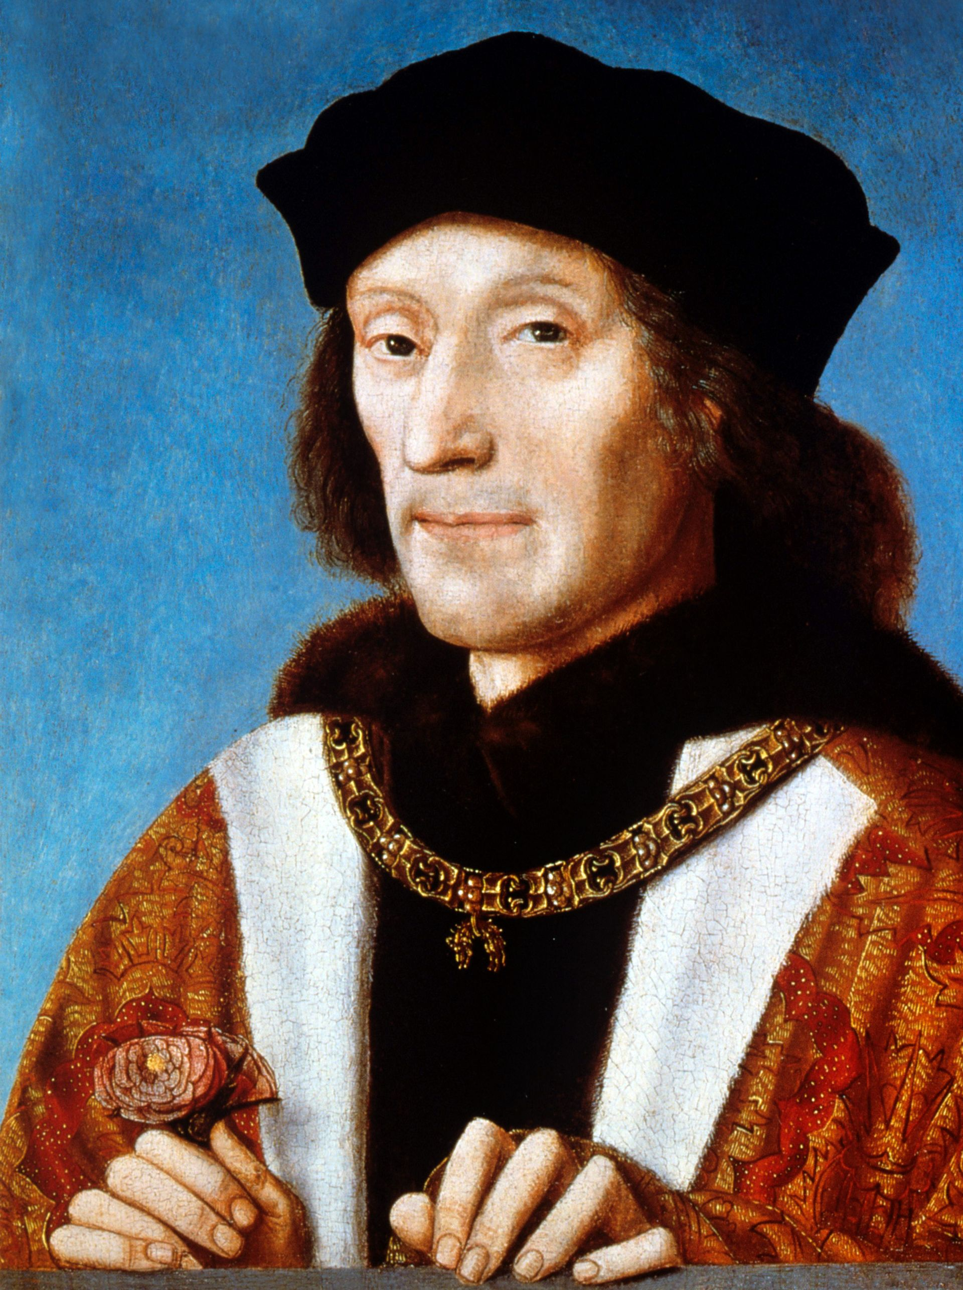

Course information:
- Unit 1 is worth 25% of your overall A Level result and it will be studied in Year 12
- The exam will be for 1 hour and 30 minutes
- The exam is worth 50 marks and there are two questions:
- 20 marks for an essay based on content learned about Henry VII and/or Henry VIII
- 30 marks for an enquiry question based on the use of four sources related to the reigns of Edward VI and Mary I.

What you will study:
- The government of Henry VII and threats to his rule
- Henry VII’s foreign policy
- Henry VIII and Wolsey
- The reign of Henry VIII after 1529
- The stability of the monarchy: Edward VI and Mary I
- Religious changes: Edward VI and Mary I
- Rebellion and unrest: Edward VI and Mary I

Textbooks:
The text that the History Department would ask students to purchase themselves is:

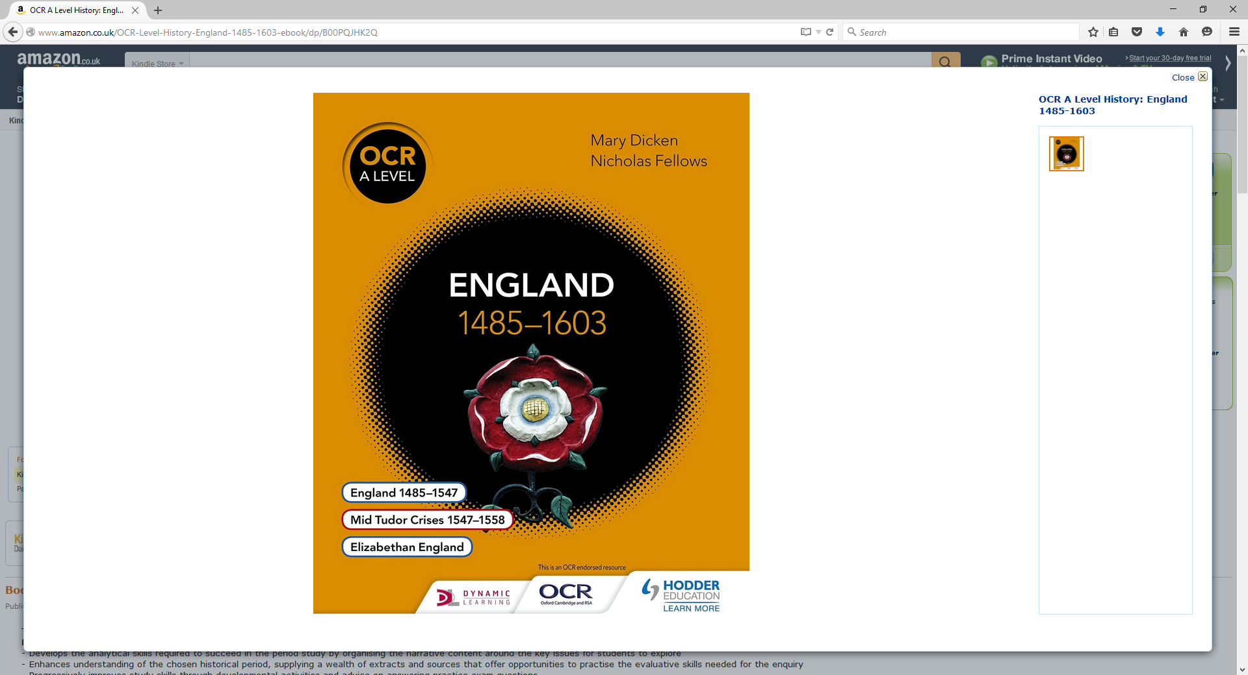
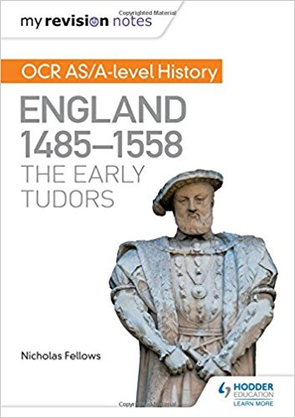

Studying the Early Tudors
Arguably the most exciting dynasty in British royal history, the Tudors ruled England from 1485- 1603. Comprising of five monarchs, the dynasty paved the way for modern Britain. From the first queen in her own right, Mary I, to the tyrannical Henry VIII, famed for his six wives and severing England’s link with the Catholic Church, the Tudors are one of the most recognisable and influential royal families in British history. In Year 12 we will look at Henry VII, Henry VIII, Edward VI, and Mary I.
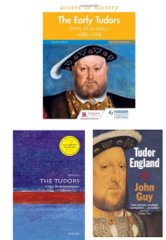
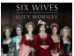
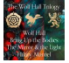
Documentaries
• Lucy Worsley - Six Wives of Henry VIII
• Thomas Penn – The Winter King
• David Starkey – Henry VIII: The Mind of a Tyrant
• Lucy Worsley and David Starkey – Britain’s Tudor Treasure: A Night at Hampton Court
• Suzannah Lipscomb and Dan Jones – Henry VIII and His Six Wives

Historical Fiction
• Hilary Mantel – Wolf Hall trilogy
• C. J. Sansom – Shardlake series
• Allison Weir books
• Phillipa Gregory books
Podcasts
• British Library – British Library Henry VIII Podcasts
• BBC History Extra – The Origins of the Tudors with Stephen Gunn, October 2017
• Versus History – The Dissolution of the Monasteries
• Versus History – The Break with Rome
• BBC History Extra – Henry VIII with John Guy, January 2015
Pre-Course Reading
If you fancy learning a bit about the Tudors before your course starts, then here are a few recommendations. All of these books will be useful for A Level study, although you do not need to buy them to achieve a good grade. They are all available from Amazon in print and e-book format:
• Roger Turvey - The Early Tudors, Henry VII to Mary I (1485-1558) – this is useful for introducing key themes and the key players within Tudor England.
• John Guy – A Very Short Introduction to the Tudors – one of the most well-informed historians of the Tudor period, John Guy’s ‘very short introduction’ sums up the period very well and in 158 pages!
• John Guy – Tudor England – again, this book provides a very good overview of the Tudor period.

Complete TWO of the tasks below:
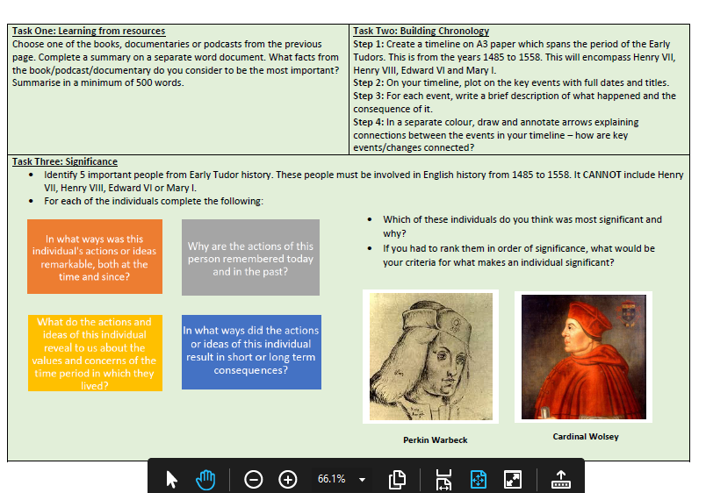

Complete the COMPULSORY tasks below:
- Read the handout and take detailed notes about Henry VII, his character, his background, and his claim to the throne of England
- Complete the task about Henry VII’s family tree. Answer the following:
- Is his claim direct and unchallengeable?
- Does he descend in a clear and obvious way from a previous monarch?
- Was he always an obvious and strong claimant?
- Did other people have stronger claims?
- Was Henry VII a usurper?
- How would Henry’s character have been shaped by his upbringing? Think about his attitude to others, his levels of trust, his approach to problems, his view of kingship, etc.
- Assess the reasons why Henry VII’s position as King of England was so weak. Write a minimum of 500 words.

Studying Italy 1896-1943 (Paper 2)
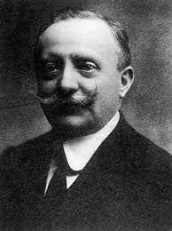
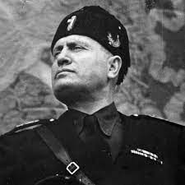
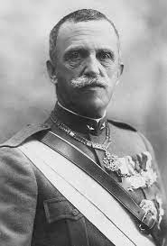
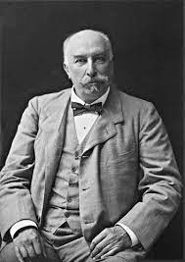

Course information:
- Unit 2 is worth 15% of your overall A Level result and it will be studied in Year 12
- The exam will be for 1 hour
- The exam is worth 30 marks and there are two questions:
- 20 marks for an essay
- 10 marks for a comparison question

What you will study:
- Italy 1896-1915
- Italy 1915-25
- Fascist Italy 1925-1943
- Foreign Policy of Mussolini 1922-43

Textbooks:
The text that the History Department would ask students to purchase themselves is either of these:

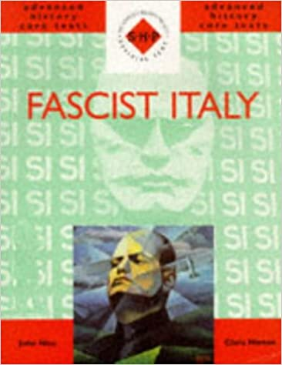
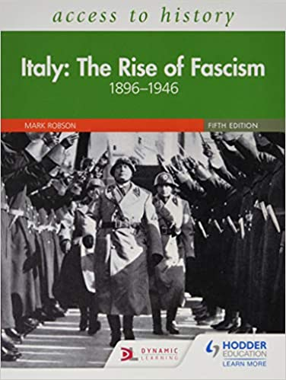

Studying Italy
You will learn how Mussolini rose from obscurity to overthrow the Liberal system of government and create Europe’s first Fascist dictatorship. You will learn the circumstances in which Italy became a united country in 1870 and the weaknesses of the Italian state in the years immediately prior to the First World War.

Documentaries

- Ten Minute History - Mussolini and Fascist Italy (Short Documentary)

https://www.youtube.com/watch?v=QOzezrUxAMk&t=1s

- Benito Mussolini: Biography of Fascist Italy's Dictator
https://www.youtube.com/watch?v=8OetedJuu4k

- Videos to help you with your research: https://www.youtube.com/watch?v=XyW32rNZ9-8
good overview of Fascist period up to the death of Mussolini in 1945: 50 minutes https://www.youtube.com/watch?v=o1Ps_4Pqc0M
BBC documentary on rise of fascism: first 10 minutes

Both available on Youtube

Podcasts

- History Extra – Fascism everything you wanted to know

- BBC Radio 4 Great lives- Mussolini

- Audiopi- Italian Fascism 1900-1945

Complete TWO of the tasks below:

Use one of the podcasts or documentaries above to complete a summary about what facts you think are the most important. Summarise in a minimum of 500 words. | What is fascism? Using the websites below research and answer the following questions:  1. What is fascism?  2. How did fascism rise to power in Italy?  3. What was life like in Fascist Italy? https://time.com/5556242/what-is-fascism/  https://www.telegraph.co.uk/news/0/fascism-fascists-today/  www.historylearningsite.co.uk/modern-world-history-1918-to-1980/italy-1900-to-1939/life-in-fascist-italy/
Who’s who in Italy, c1896-1943 – Research the following individuals and write down 5 pieces of information you found out about each of them:
Fascists Benito Mussolini (1883–1945), Roberto Farinacci (1892–1945)
Liberal Prime Ministers 1896–1922 Giovanni Giolitti (1842–1928), Antonio Salandra (1853–1931)
Opponents of the Fascist regime Giacomo Matteotti (1885–1924)
Italians of Historical note King Victor Emmanuel III (1869–1947), Pope Pius XI (1857–1939), Gabriele D’Annunzio (1863–1938)
Foreign Leaders Engelbert Dollfuss (1892–1934)

Complete the ALL the COMPULSORY tasks below:

Research and take notes on the following ideas and themes. They will be very important for your Italy Unit.

Systems of Government in Italy
- voting system
- parliament
- government
- cabinet
- ministers
- members of parliament
- Prime Minister

Role of King in 1900
- Who was King of Italy in 1900?
- What role did they have in government?

Political Parties and Ideologies- what do these political parties believe in?
- Liberal Party
- Socialists
- Communists
- Fascists

Write the definitions of these key words and learn them
- constitution
- legislation
- portfolio
- enfranchisement
- franchise
- white paper
- nationalism
- proletariat
- coup d etat
- martial law
- unification
- republic
- democracy
- aristocracy
- class- working class, middle class, upper class

