A Level Geography Summer work
Water Cycle
Introduction
The water cycle, also known as the hydrological cycle, describes how water continuously moves between different parts of the Earth. It involves processes like evaporation, condensation, precipitation, and collection:
Evaporation: Energy from the sun heats up water in rivers, lakes, and oceans, causing it to turn into water vapour (a gas). Plants also lose water through their leaves in a process called transpiration.
Condensation: Water vapour rises into the sky, cools down, and forms clouds. These clouds move around the globe.
Precipitation: When water droplets in the clouds become too heavy, they fall back to Earth as rain, snow, hail, or sleet.
Collection: The fallen precipitation collects in bodies of water (rivers, lakes, oceans), where it will eventually evaporate again, restarting the cycle.
- Water can change from a solid (ice) to a gas (water vapour) without becoming a liquid first. This process is called sublimation.
Agriculture:
Irrigation Availability: The water cycle ensures a reliable water supply for agriculture, even in areas with scarce rainfall. Through evaporation, condensation, and precipitation, water replenishes sources like rivers, lakes, and groundwater. Farmers can use this water for irrigation, sustaining crop growth and productivity.
Nutrient Transport: Water carries essential nutrients from the soil to plant roots, supporting healthy plant development and higher yields.
Industry:
Water as a Resource: Industries rely on water for manufacturing, cooling, and energy production. The water cycle ensures a continuous supply, allowing factories and power plants to function efficiently.
Wastewater Management: Proper water management prevents pollution and ensures that industrial wastewater is treated and returned to the environment.
Resources:
Hydropower: The water cycle drives hydropower generation. Falling water (from precipitation) turns turbines, producing electricity.
Mineral Extraction: Rivers and streams transport minerals, eroding rocks and depositing valuable resources.
Transport:
Navigable Waterways: Rivers and lakes created by the water cycle serve as natural transportation routes. Ships, barges, and boats use these waterways for trade and commerce.
Water-Based Transport: Coastal shipping and inland water transport rely on the water cycle for navigable channels.
Questions
- Where does the energy for the water cycle come from?
- What happens during condensation?
- Why is carbon dioxide crucial for plants during photosynthesis?
- How does water return to the atmosphere during the water cycle?
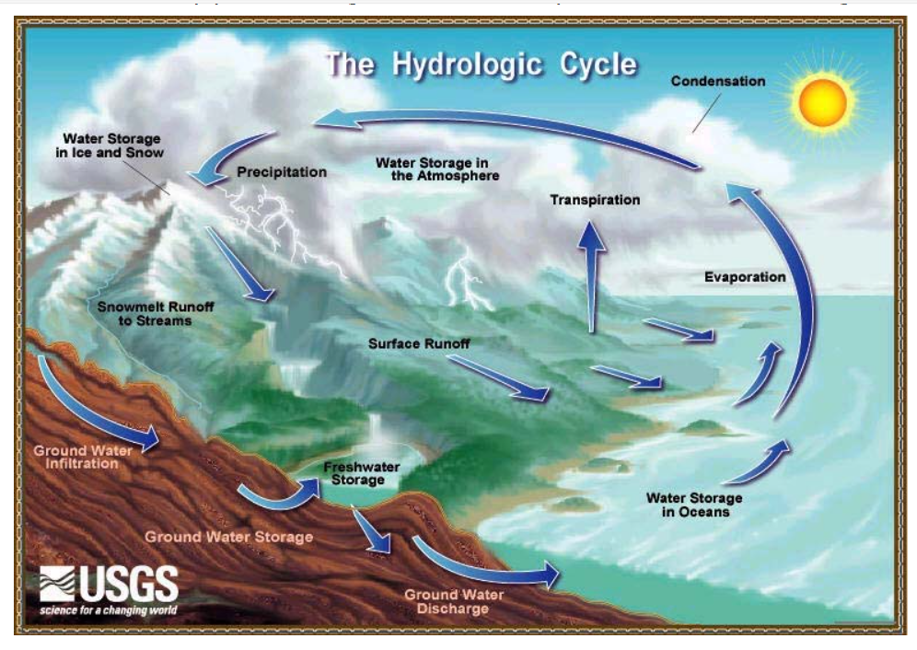

Carbon Cycle
Introduction
Carbon is a vital element found in the Earth’s atmosphere. It plays a crucial role in various natural processes. What is carbon’s significance, sources, and impact?
The carbon cycle is nature’s recycling system for carbon. Carbon is a fundamental element found in the air, the ground, and all living things. Here’s a succinct explanation:
Photosynthesis: Plants take in carbon dioxide (CO₂) from the air and use it, along with sunlight, to create food (glucose). Animals then consume these plants.
Respiration: Animals metabolize the glucose, releasing carbon dioxide back into the atmosphere.
Decomposition: When organisms die, their remains decompose, returning carbon to the soil.
Fossil Fuels: Over millions of years, some carbon becomes fossil fuels (like coal, oil, and natural gas).
- By weight, approximately 18% of the human body is carbon!
- Carbon is necessary for industries, energy generation, and even as a greenhouse gas (like CO₂).
- Did you know that diamonds are also a form of carbon? Carbon is essential for life and exists in various forms!
Questions
- What role does photosynthesis play in the carbon cycle?
- How do animals contribute to the carbon cycle?
- Why are fossil fuels considered part of the carbon cycle?
1. The Carbon Cycle
Briefly explain what the carbon cycle is and why it’s essential for maintaining Earth’s balance.
2. Carbon Sources
List three primary sources of carbon in the atmosphere.
Explain how human activities contribute to increased carbon emissions.
3. Greenhouse Effect
Define the greenhouse effect.
Describe how excess carbon dioxide (CO₂) contributes to global warming.
4. Mitigation Strategies
Provide two strategies to reduce carbon emissions.
Explain why reforestation is an effective approach.
Extended Writing (Choose one):
Imagine you’re a climate scientist addressing a group of concerned citizens. Write a persuasive paragraph urging them to take action to reduce their carbon footprint.
Discuss the impact of carbon emissions on ocean acidification and its consequences for marine ecosystems.
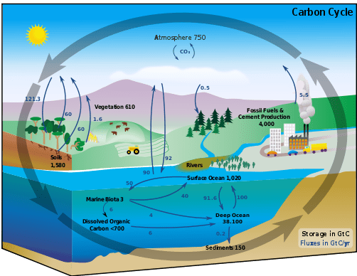

Population Change in Japan
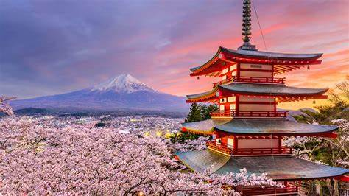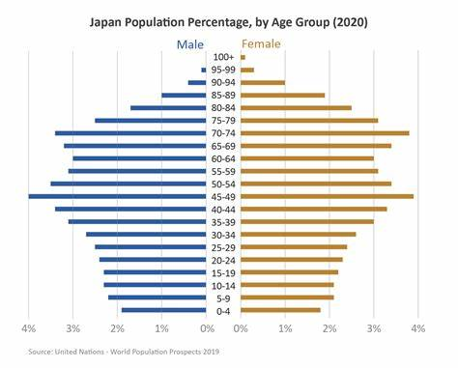

Introduction:
Japan, an island nation in East Asia, is experiencing significant demographic changes. This worksheet will help you understand the causes, effects, and responses to population change in Japan.

Section 1: Understanding Population Change
- Define the following terms:
  - Birth rate
  - Death rate
  - Aging population
  - Dependency ratio
  - Population pyramid
- Research Question:
  - What is the current population of Japan? How has it changed over the past 50 years?
- Short Answer:
  - Explain the trend of Japan's birth rate and death rate in recent decades.

Section 2: Causes of Population Change
- List and explain at least three factors that have contributed to the declining birth rate in Japan.
- Short Essay:
  - Discuss the role of social and economic factors in shaping Japan's population structure.

Section 3: Consequences of Population Change
- Identify and explain two major social consequences of an aging population in Japan.
- Identify and explain two major economic consequences of an aging population in Japan.

Section 4: Responses to Population Change
- Research and list three strategies Japan is using to cope with its aging population.
- Debate:
  - Do you think immigration is a viable solution to Japan's population issues? Why or why not? Provide evidence to support your argument.
- Creative Task:
  - Imagine you are a policymaker in Japan. Propose a new policy to address the population decline and aging issue. Justify your proposal.

