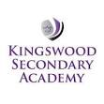
Year 11 into 12 Transition tasks for A’ Level Chemistry OCR
A Level Chemistry is taught and examined in the following modules
Content is in six modules:
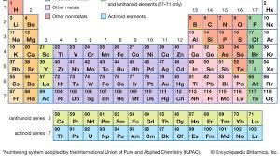
- Module 1 – Development of practical skills in chemistry
- Module 2 – Foundations in chemistry
- Module 3 – Periodic table and energy
- Module 4 – Core organic chemistry
- Module 5 – Physical chemistry and transition elements
- Module 6 – Organic chemistry and analysis

TEACHERS ARE: Miss Steed and Miss Lloyd for both Year 12 and 13
The following tasks need to be completed and handed into Miss Steed/Miss Lloyd on the first day we are back in school. The transition tasks are essential – to bridge the gap between GCSE and A Level (there is a HUGE jump in required knowledge!)
We would like everyone to get off to a running start by doing a bit of preparation and
revisiting of some key skills (chemistry and maths) from GCSE.

Please make sure that you have completed this booklet and hand it in to your
chemistry teacher in your first lesson in September.

If you want to do a bit more revision before you start there is a study guide which helps to bridge the gap between GCSE and A level: Head start to A level Chemistry by CGP retail price approx £4.95

Maths skills are much more evident in the new A level specification and 20% of questions will involve higher paper GCSE Maths skills. Another CGP guide which you might find useful is: Essential Maths Skills for A level Chemistry

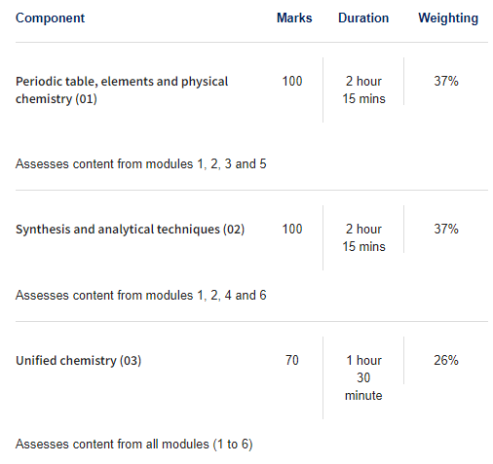

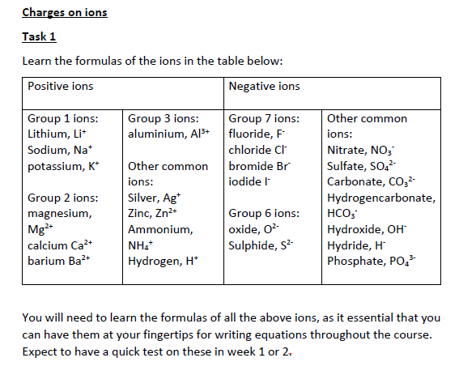

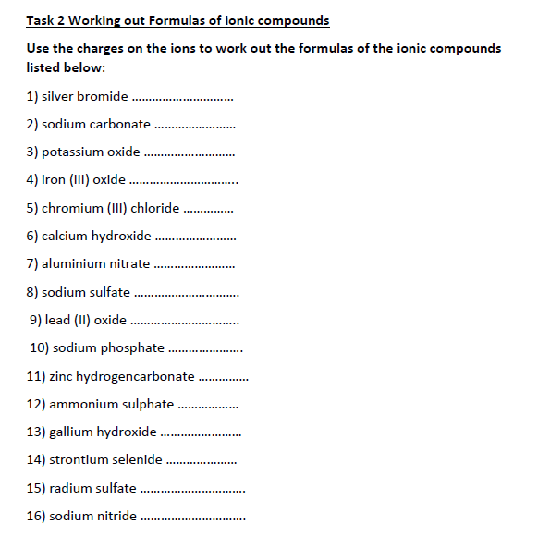

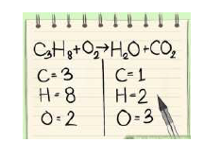

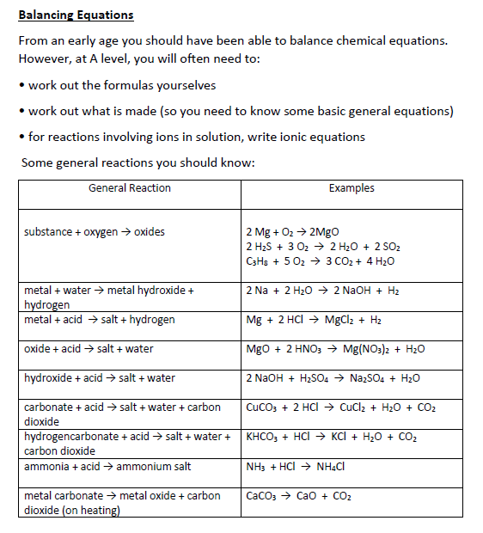
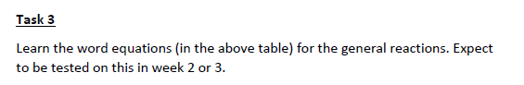
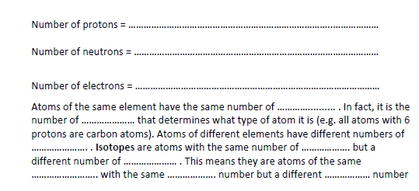
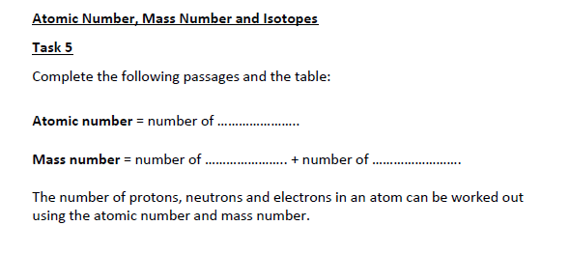
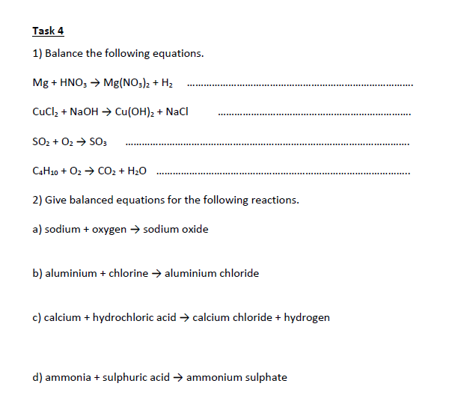
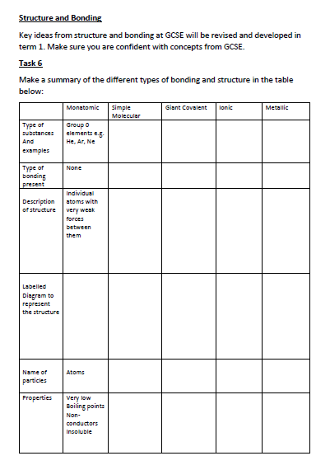
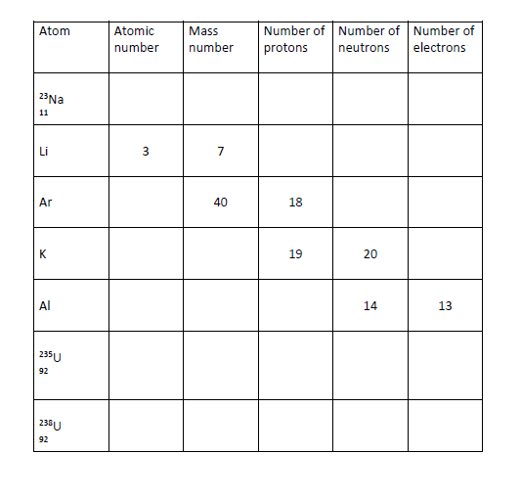
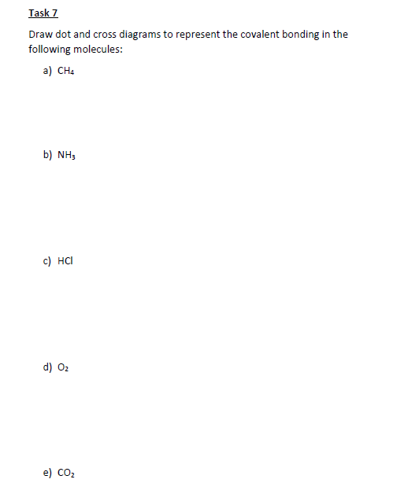

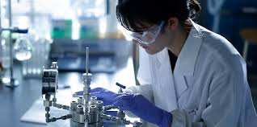
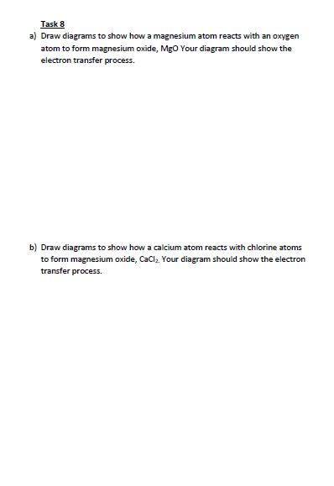
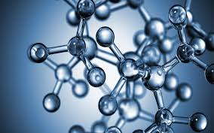
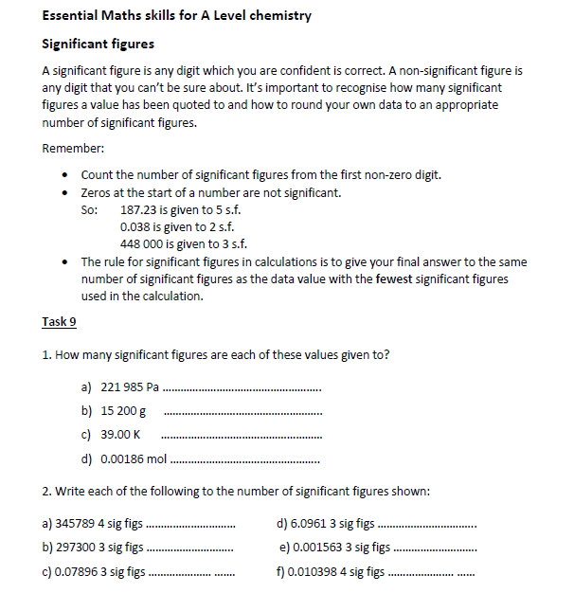
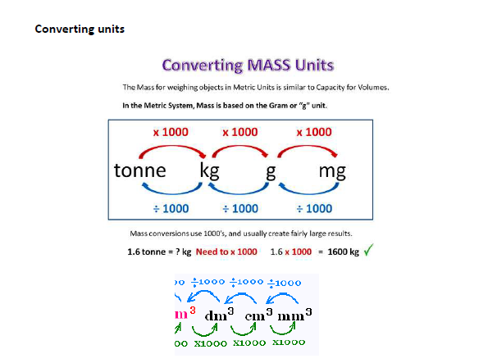
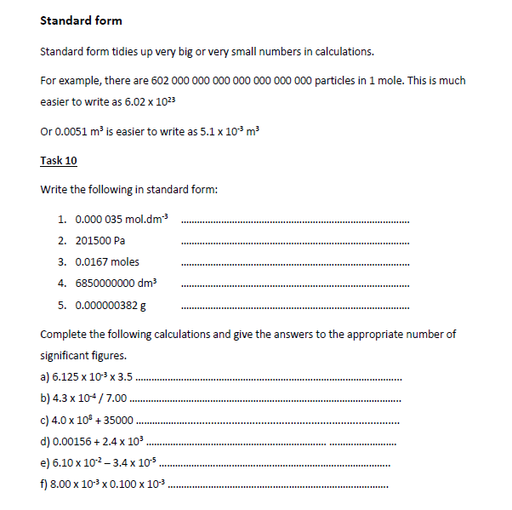
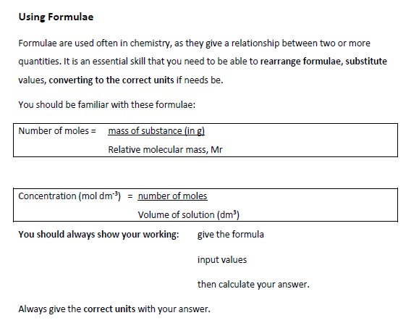
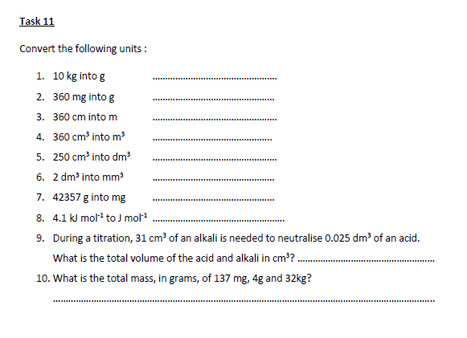
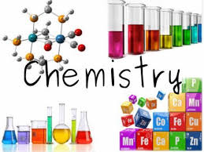
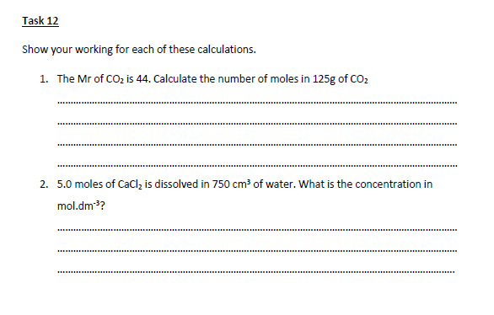
Reading during the course and over the summer:
Wider Reading About Chemistry:
Sam Kean - The Disappearing Spoon
John Emsley - Nature’s Building Blocks
Hugh Aldersey - Periodic Tales
Helen Arney / Steve Mould - The Element in the Room
Primo Levi - The Periodic Table
Oliver Sacks - Uncle Tungsten
James Keeler – Why Chemical reactions happen.

Wider Reading About Science:
Bill Bryson - A Short History of Nearly Everything
Richard Preston – The Hot Zone: A terrifying true story
Richard Feynman - Six Easy Pieces
Carlo Rovelli - Seven Brief Lessons on Physics
Chad Orzel - How to Teach Quantum Physics to Your Dog
Ben Goldacre - Bad Science
Stephen Hawking - A Brief History of Time
New Scientist - Does Anything Eat Wasps?
Thinking About Studying Medicine?
Jed Mercurio - Bodies
Max Pemberton - Trust Me I’m a (Junior) Doctor

Other resources:
Periodic Table of Videos by Martyn Poliakoff www.youtube.com
Royal Society of Chemistry - www.rsc.org.uk
Institution of Chemical Engineers - www.icheme.org
http://nobelprize.org – Details of the history of the best scientific discoveries
http://nature.com – The site of the scientific journal
http://royalsociety.org – Podcasts, news and interviews with scientists about recent scientific
developments
http://www.bmj.com – The website of the British Medical Journal
http://www.bbc.co.uk/news/science_and_environment - The BBC news page for Science and the
Environment
A level Chemistry suggested reading list
https://pmt.physicsandmathstutor.com/ - Had a wealth of information on many different A level subjects,
including chemistry .
Daniel Dulek - How big is a mole? (Not the animal, the other one.) | TED Ed
Rachel Pike - The science behind a climate headline | TED Talk
Elements of the Periodic Table | Open Learning

