
Post 16 Registration Form

Section 1 - Your Information
Question | Your answer
Legal First Name(s)
Legal Last Name
Date of Birth (dd/mm/yyyy)
Your personal email address
(Please do not use your school email as this may become disabled after you finish school in June.)
Parental/Carer email address
Address Line 1
Address Line 2
Town
County
Postcode
Contact telephone number
This should be your main contact number e.g your mobile number.
Current School attended
Inclusivity and personalisation information
Making sure all our students feel included and supported is really important to us. We are a diverse and inclusive school and we want to make sure you are comfortable through all stages of the application process.
Please specify any medical disabilities you think the school should be aware of otherwise, leave blank.
Please specify any learning disabilities you think the school should be aware of otherwise, leave blank.
Is there anything else you would like us to know about you before joining our Sixth Form?

Section 2 - Your Qualifications
Add all the qualifications you are currently studying at school. You will also need to add the ones that you have completed and have a result for.

Question | Your answer
Qualifications studying and Predicted Grade.

Please add your qualifications you are currently studying in the following format:
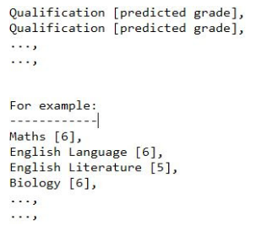
Qualifications you have completed and have a grade in

Please tell us if you have completed any qualifications in the following format. Leave blank if not applicable.
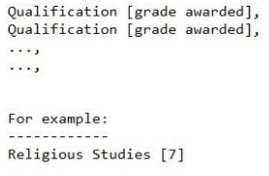
I confirm that the grades I have submitted are entirely accurate (Sign in the box opposite)

Section 3 - Work Experience

Question | Your answer
Have you had the opportunity to undertake work experience? | - Yes - I have had the opportunity to undertake some form of work experience (GO TO SECTION 4)  - No - I have not had the opportunity to undertake any form of work experience (GO TO SECTION 5)

Section 4 - Work Experience Details

Please write about any work experience you have done, any part-time jobs you have or have had and any volunteering you have undertaken, including start and end dates (if known).

Section 5 - Subject Choices
Please identify the subjects you wish to study in order of preference. Our aim is to place you in to your top three choices. Please look at Kingswood Secondary Academy's Prospectus on our website to understand what subjects are available. You must select at least four subjects.

Subject Preference 1*
Subject Preference 2*
Subject Preference 3*
Subject Preference 4*
Subject Preference 5
Subject Preference 6

Why have you chosen your courses?

For example, they will lead to a type of career, it's an area that you are interested in etc. if you have chosen different types of courses, you should also explain why. Don't feel you have to write too much here - it just helps during your interview to have something prepared.

Section 6 - Finalising the application

Thank you for considering Kingswood Secondary Academy. We love teaching and helping students realise their full potential.

To help us plan our staffing and rooming requirements, it would help us to understand whether you are considering us as your first choice placement.

This will not affect your application in any way. We understand that people change their minds about where to study and it can be down to personal needs and circumstances.

Question | Your answer
Is Kingswood Secondary Academy your... | - First choice  - Second choice  - Third choice or lower

Please drop this form into Sixth form reception; if you would prefer to send it digitally, please email it to: kalexander@kingswoodsecondaryacademy.org

