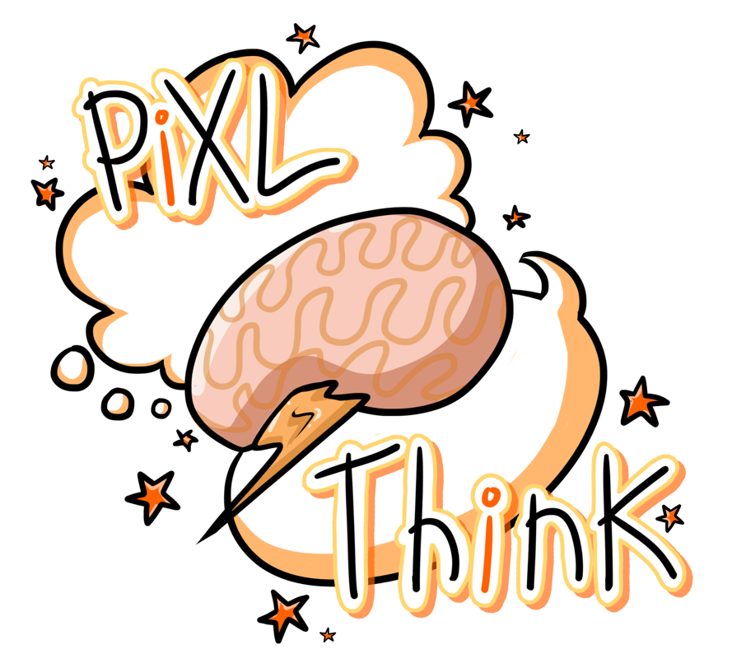

PiXL Revisit
A Strategy for Revision

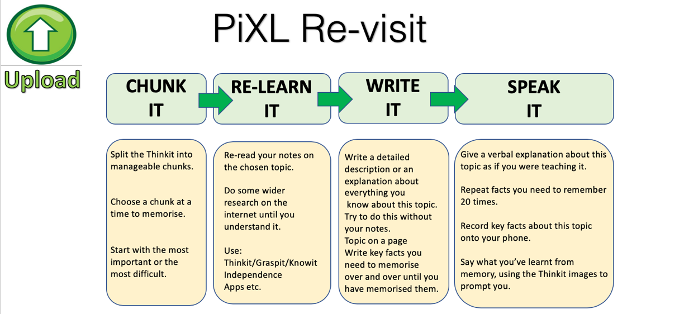

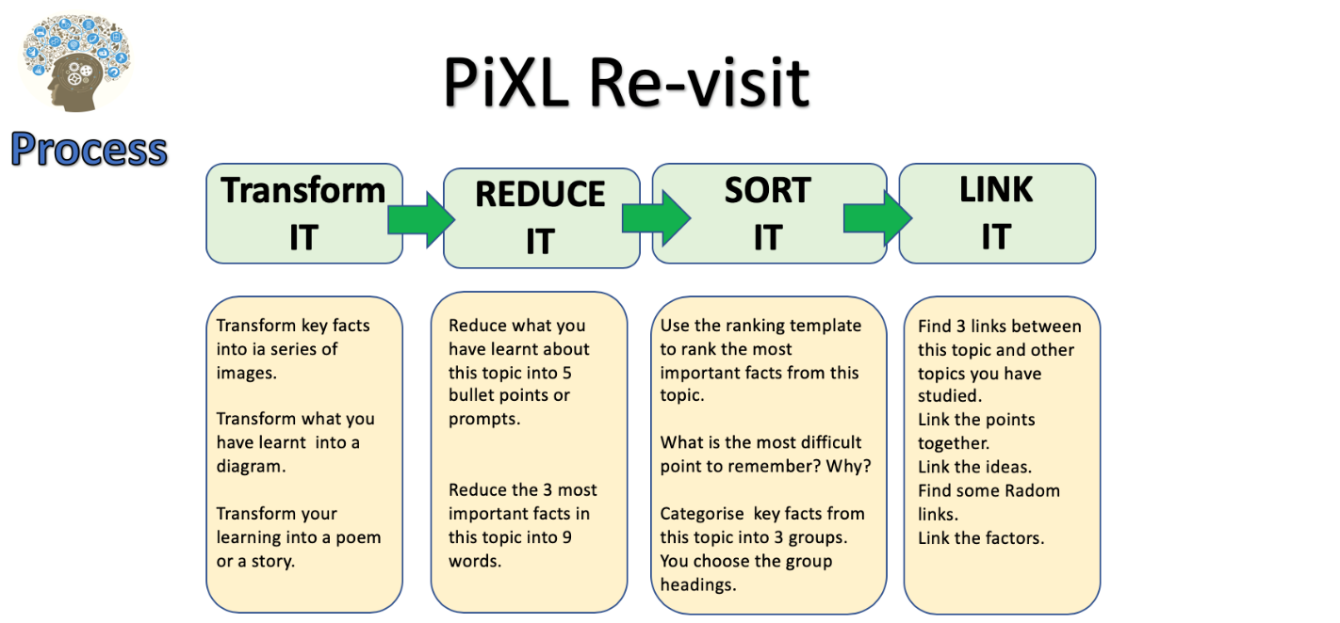

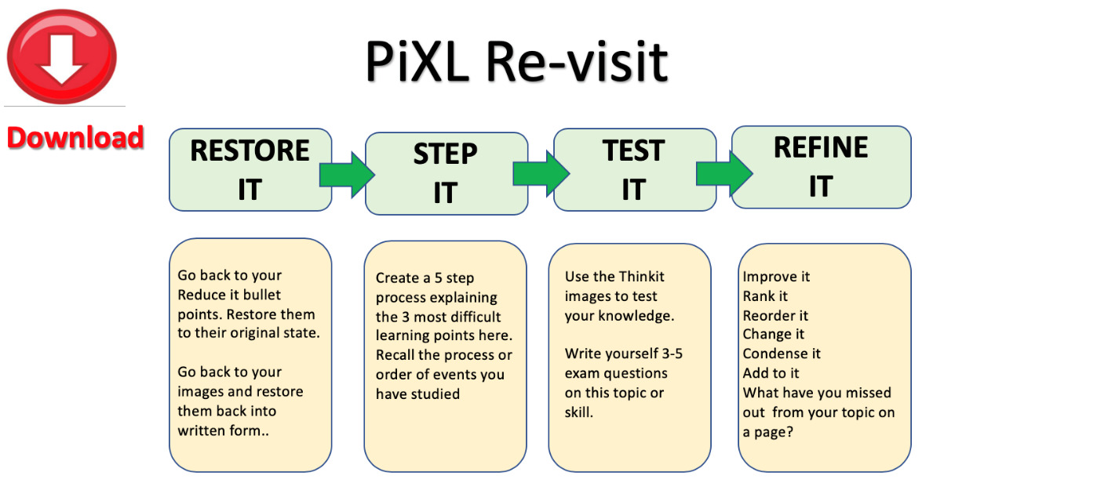

PiXL Revisit: Reduce and Transform
Unit / Topic:

1.

2.

3.

4.

5.

Unit / Topic:
PiXL Revisit: Prioritise - Significance and Importance
5.

3.

1.
Notes:

WHY?

WHY?
Key Facts, Dates, Words, Vocab:
Number of Priority:

WHY?

WHY?
2.

4.

WHY?

PiXL Revisit: 3 x 2 Testing
Unit / Topic:

Last Lesson
Key facts:
Last Week
Key facts:
Last Year
Key facts:
One topic to revise next:

PiXL Revisit: Process and Categorise
Steps and stages explained

Unit / Topic:

Which is the most important stage?

WHY?

Key Facts / Observations

PiXL Revisit: Chunk It
Unit / Topic:

10
Chunks of learning of this / topic / area
* You could start with the most important or the most difficult to learn

1.
2.
3.
4.
5.
6.
7.
8.
9.
10.

PiXL Revisit: Ranking Triangle

Name of Topic: __________________________________________________________________________________________________
Name: __________________________________________________________________________________________________
Class: __________________________________________________________________________________________________

The most important information goes at the top and then the least important at the bottom. Make sure you justify WHY you think it the most/least important.


_______________________________________________________________________________________________________________________________________________________________________________________________________________________________________________________________________________________________________________________________________________________________________________________
PiXL Revisit: Thinking Hard Model

Name of Topic: __________________________________________________________________________________________________
Name: __________________________________________________________________________________________________
Class: __________________________________________________________________________________________________

Take a section of the text and do the following:

- Prioritise: Underline the three most important sentences here. Rank 1-3, briefly explain number 1. Cross out the least important sentence

- Reduce: Reduce the key information into 12 words

- Transform: Transform this information into 4 pictures or images (no words allowed)

- Categorise: Sort this information into three categories. Highlight and think of a suitable title for each category.

- Extend: Write down three questions you’d like to ask an expert in this subject.

PiXL Revisit: ‘Boxing Up’ Activity

Name of Topic: __________________________________________________________________________________________________
Name: __________________________________________________________________________________________________
Class: __________________________________________________________________________________________________

Read the text and then put your thoughts in to different boxes so that you have ‘boxed up’ the text.

Box 1 – 3 things I did not know

Box 2 – 3 things I understand better now

Box 3 – 3 things I already knew

PiXL Revisit: Question Time

Name of Topic: __________________________________________________________________________________________________
Name: __________________________________________________________________________________________________
Class: __________________________________________________________________________________________________
When you read any text, you should be asking it questions NOT just letting it wash over you. Read your text and pause and ask it questions - e.g. ‘what do you mean when you say ‘….”?’

Questions I’m asking the text |  | Answers to those questions |  | Things I need to ask my teacher
PiXL Revisit: Quizzing

Name of Topic: __________________________________________________________________________________________________
Name: __________________________________________________________________________________________________
Class: __________________________________________________________________________________________________
Read the text and come up with 20 questions to ask someone about the text.
 | Question | Answer
1
2
3
4
5
6
7
8
9
10
11
12
13
14
15
16
17
18
19
20

PiXL Revisit: Transforming

Name of Topic: __________________________________________________________________________________________________
Name: __________________________________________________________________________________________________
Class: __________________________________________________________________________________________________
Turn the material you have read into up to 6 pictures – one per paragraph or one per key piece of information. The pictures must represent the information so that they can act as a reminder of what the text said. Underneath each picture, explain your thinking.

1. | 2. | 3.
4. | 5. | 6.

Now restore your pictures back into its original form.

Chapter theme / topic
Main idea 1
Specific detail A
Specific detail B
Specific detail C
Main idea 2
Specific detail D
Specific detail E
Specific detail F
Specific detail G
Specific detail H
Specific detail I
Specific detail J
Specific detail K
Specific detail K
Main idea 4
Main idea 3

Taken from the article: ‘What Will Improve a Student’s Memory?’ By Daniel T Willingham (http://www.aft.org/sites/default/files/periodicals/willingham_0.pdf)

Taken from the article: ‘What Will Improve a Student’s Memory?’ By Daniel T Willingham (http://www.aft.org/sites/default/files/periodicals/willingham_0.pdf)
PiXL Revisit: Transform
Unit / Topic:

Key Points

1.
2.
3.
4.
5.
6.
7.
8.
9.
10.

PICTURE/ SOURCE/ INFO/ RESOURCE

Most important + WHY:

PiXL Revisit: Examine It

Key Dates
Exam Question
NOTES
Topic:
1.
2.
3.
4.
5.
6.
Key Facts
Key Quotes
Key Formulae
Key Words

PiXL Revisit: Flexibility of thinking Connection Map

Title

PiXL Revisit: Flexibility of thinking Connection Map
Draw lines linking the boxes. The darker /stronger the line the stronger the link.
Title
Place the information/ factors/knowledge in the boxes. Add as many boxes as you want to.

On the line give reasons for the links - explain the LINK /importance or significance.

You could also add formula/dates/facts/quotes near or on the line to exemplify knowledge

PiXL Revisit: Experiment on a page
Experiment Title:

Process / Method

1.
2.
3.
4.
5.
6.
7.
8.
9.
10.

Formulae
Label
Label
Label
Experiment Diagram
Results

PiXL Revisit: Transform
Unit / Topic:
Picture
NOTES:

Picture

PiXL Revisit: Reduce to 6 points
Unit / Topic:

Information

Information
Reduce to 6 points

1.
2.
3.
4.
5.
6.
Prioritise (most important)

1.
2.
3.
4.
5.
6.

WHY?
P
R
I
O
R
I
T
I
S
E

Reduce to 3 key points

A.

B.

C.
R
E
D
U
C
E

