



Community Careers Newsletter

Parent/Guardian Edition: Year 9 Options

Making decisions about what you want to study during years 10 and 11 can be feel empowering and exciting. For most students these decisions are relatively easy, they might know the career they want to enter or the area in which they would like to work, they might have subjects that they favour and there will be subjects in which they excel. However, for some students it can be a time of uncertainty and change, and they will need more support.

Support within the Academy comes in many forms:

All students will also need support from people at home. This could be relatives or friends of the family. This advice could be in the form of:

What can we do to support our child at home?

The best advice we can give is to talk to your child about their options. Ask them if they have a particular career in mind and find out through research whether there are specific subjects that would help them on this path or a specific qualification level or type they need (e.g., G.C.S.E. or vocational courses) to get onto Level 3 courses (A Level and equivalent).

Have a look at the websites below to help you with these discussions.







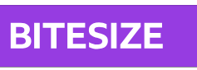



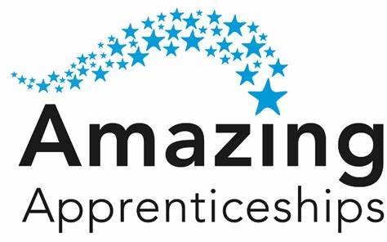

Reasons your child should not choose subjects

- Because their friends have chosen the option
- Because they like the teacher
- Because it sounds easy

Students need support to make the most appropriate choice about their Level 2 courses, talking to the right people at school and home can make this process much smoother and less worrying.

Students need to be reminded that there are multiple routes into different careers and no one route is the right one. Apprenticeships, academic courses and vocational studies have different advantages and disadvantages and if students have considered these they are more likely to make the best choice for their preferred style of learning and career.

Who can my child go to for support in the Academy?

Ian Doherty is our independent careers advisor, he is happy to provide support for your child in the form of advice and guidance that might help them make the most appropriate decision if they are linking their Level 2 courses (G.C.S.E. / national certificate / national diploma) to a specific career path or Level 3 course.

He runs a drop-in session in H5 on a Tuesday during break 2. All children are welcome to ask him any questions they may have about their choices and courses after Year 11 and 13. Other questions can be emailed to Mrs Hardy at bhardy@kingswoodsecondaryacademy.org

CAREERS FAIR – 22nd January 2025

.. CAREERS FAIR 2025 ..

To further support your child’s option decision making, we are holding our second careers fair on the 22nd January 2025. Please come and meet a range of employers, ask them questions about their routes into work, the qualifications they need, their daily activities and potential for progress within their field. Parents and guardians are very welcome to attend this event at the end of the school day.

We would like to take this opportunity again to welcome all members of the community to our Careers Fair on the 22nd January 2025. Last year (2024) we welcomed 42 employers and their employees into the Academy to give our students a valuable insight into a range of careers. This year we have over 50! Please join us as Kingswood Welcomes Corby
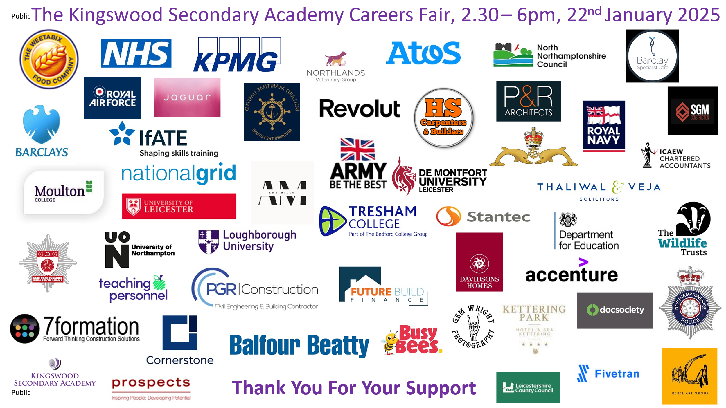
Our aims for the 2025 event are for students to know of the different pathways to employment including apprenticeships, T Levels, academic routes and internships.

We will continue to update you on the event and which employers are involved. If you are an employer and would like to be involved in our 2025 event please get contact Beth Hardy using the email bhardy@kingswoodsecondaryacademy.org and we will get in touch to arrange a pre-event meeting to facilitate your participation.
If you are a parent or carer and want to know how to get involved, keep your eye on communication from the Careers team here at Kingswood Secondary Academy and please encourage your child to speak with either Beth Hardy, their form tutor or Ian Doherty (from Prospects) for guidance and support with their future plans and aspirations.
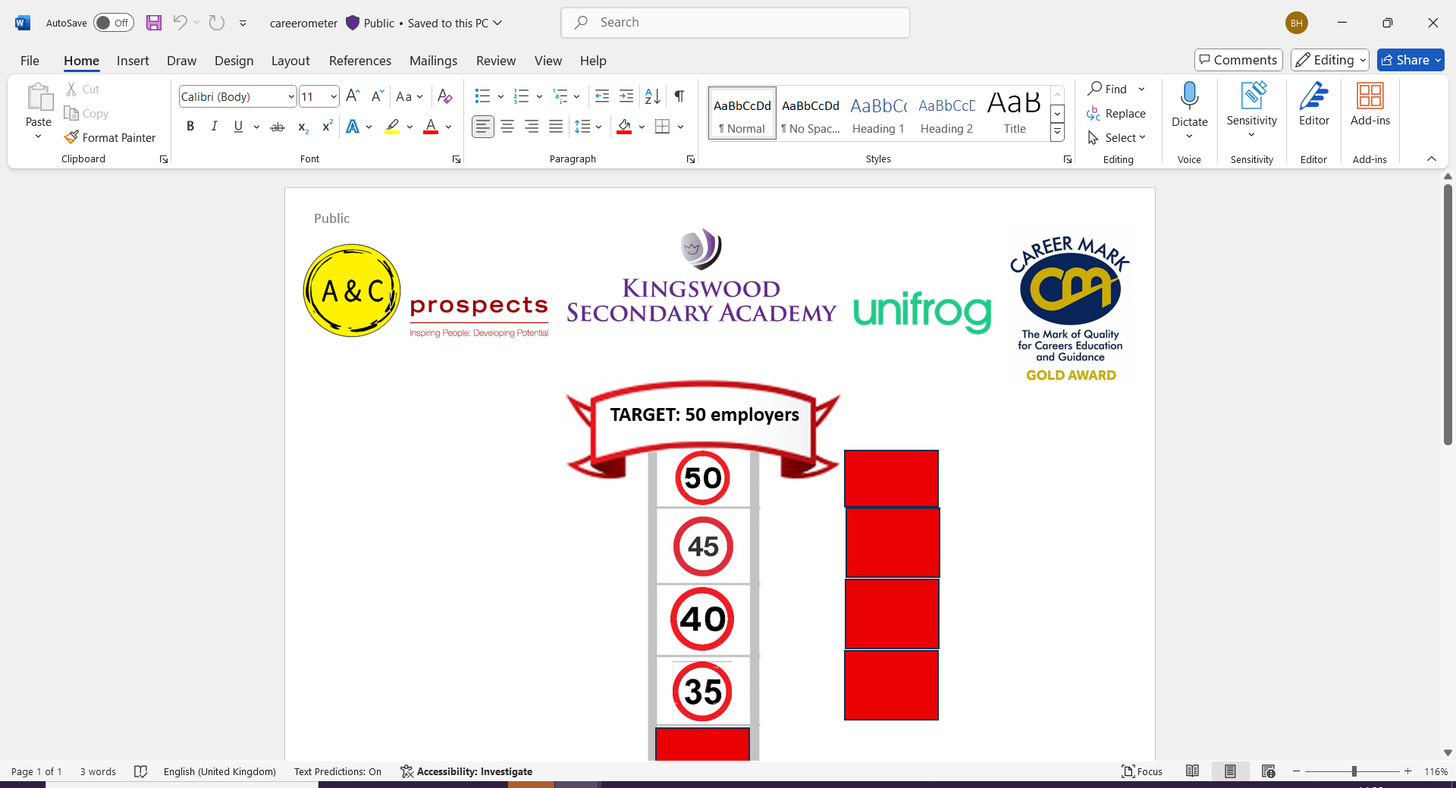
Thank you again for your continued support of the work of the Careers team within the academy, we look forward to informing you of other upcoming careers events through X, Facebook, the Academy website and Groupcall. If you have any questions, please ask.

