Who is your Sporting or Coronavirus Hero ?
We would like to use the time we have at the moment to think about how our values can be shown in real life, through the things people do and say.
At Kingswood we have written our new values from what both pupils and staff have told us is important to them. We would like to use them to now think about who demonstrates those values to us.
We have all had extra time to think and reflect on the values that others are showing in these difficult times right now, and this has inspired us all to help others more.
Using the Kingswood Values opposite, and the template on the next slide, can you create a values shield for your favourite Sports star or Corona virus hero. I have researched David Beckham as an example at the end.
We will then display the best ones in PE on our return. Stay safe !

At Kingswood:
We act with integrity, doing the right thing even when nobody is looking as we build the community we wish to live in and treat each other with the Respect.
We are independent learners because we always come to school on time, in the correct uniform and with the right equipment.
We live enriching lives beyond the classroom which includes participation in clubs, leadership and charitable activities enabling us to become Empathetic citizens with a sense of service to our community.
We are proud to contribute to our school and town community, proud to be Corby, proud to be Kingswoodians - so now let’s RISE together!


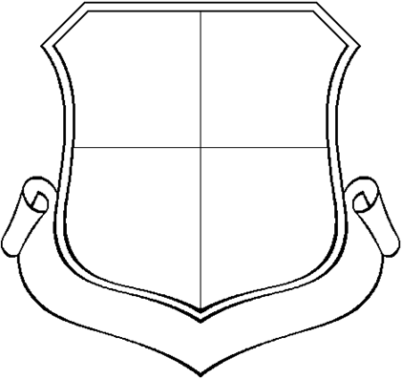

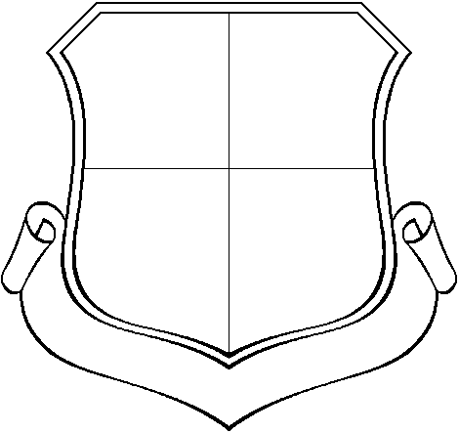

INDEPENDENCE
RESPECT

EMPATHY
SERVICE TO COMMUNITY



Kingswood Values
Respect
Independence
Service to the Community
Empathy

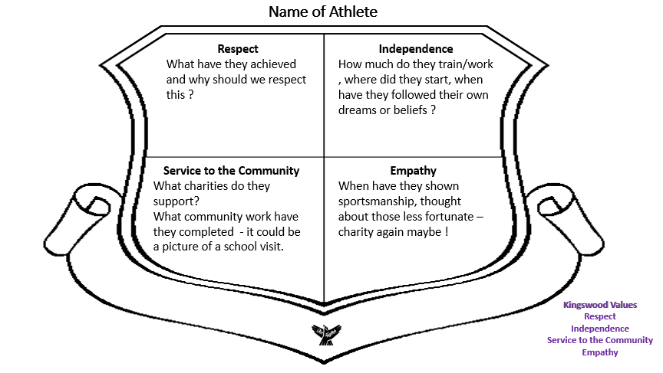
Help sheet



