Year 13 Learning Journey: A Level Sociology
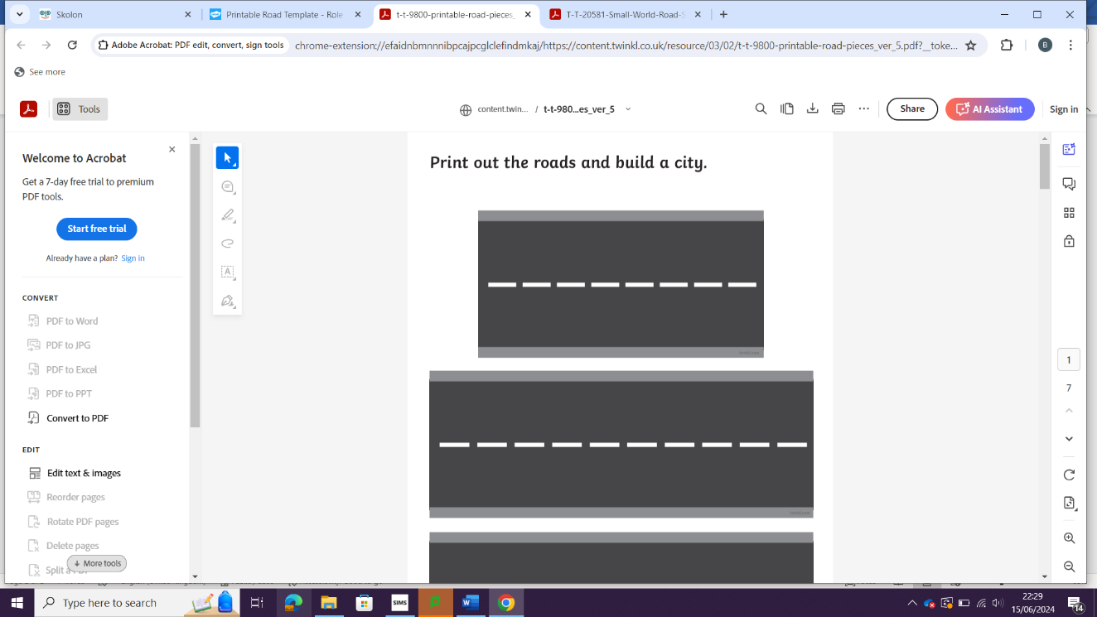
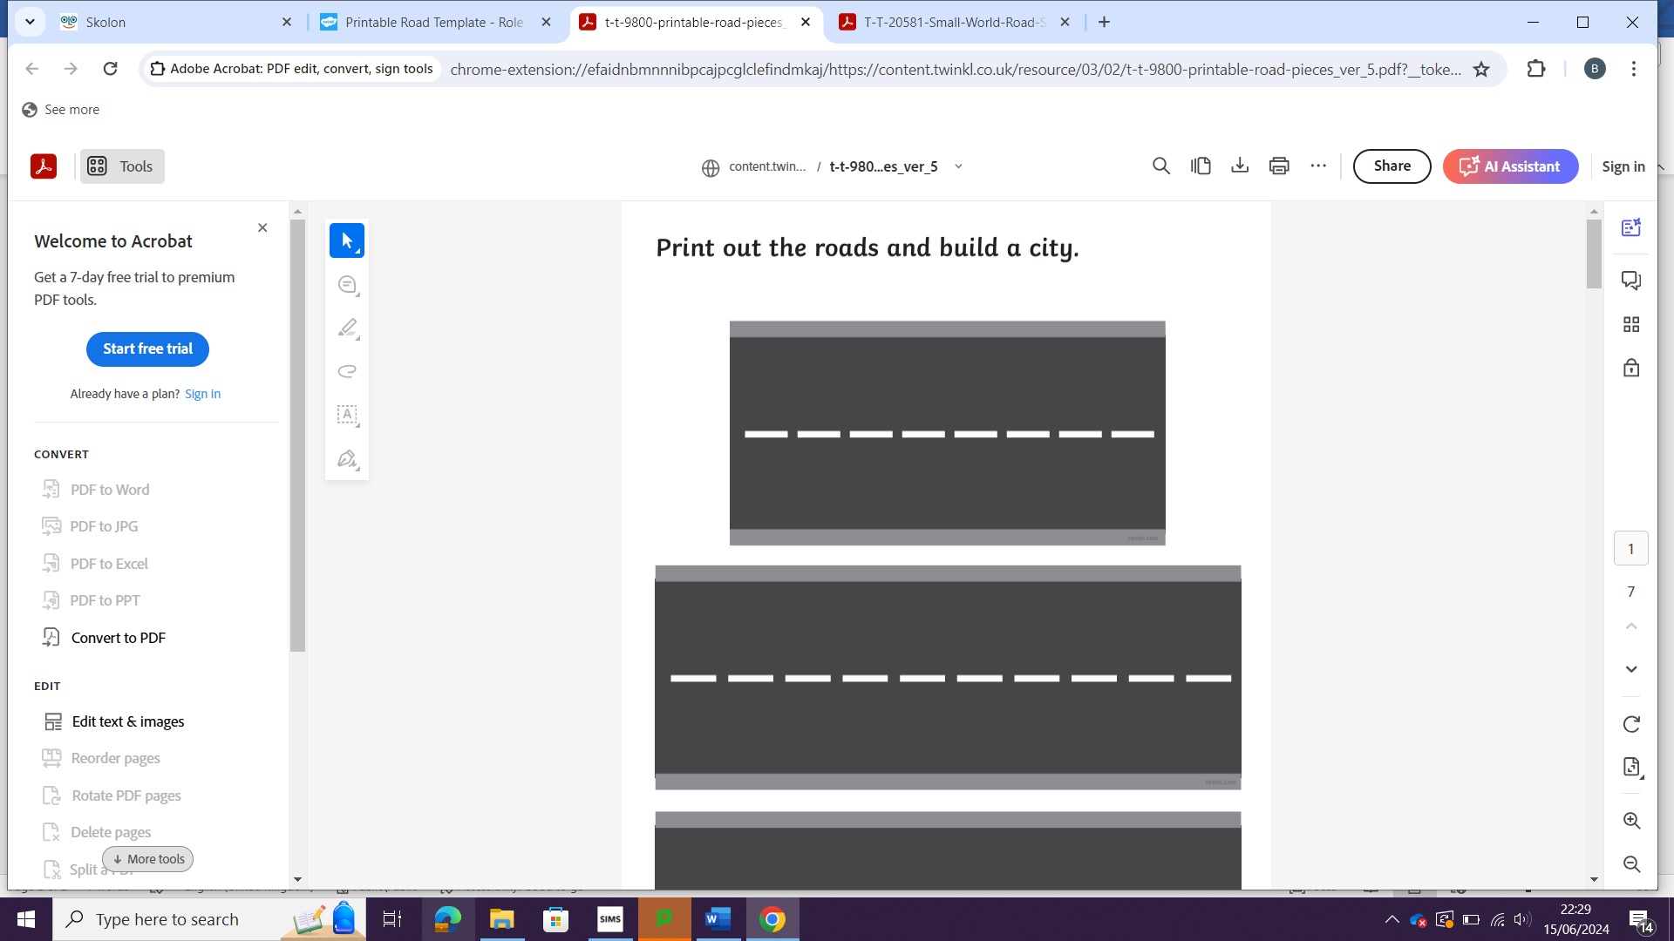
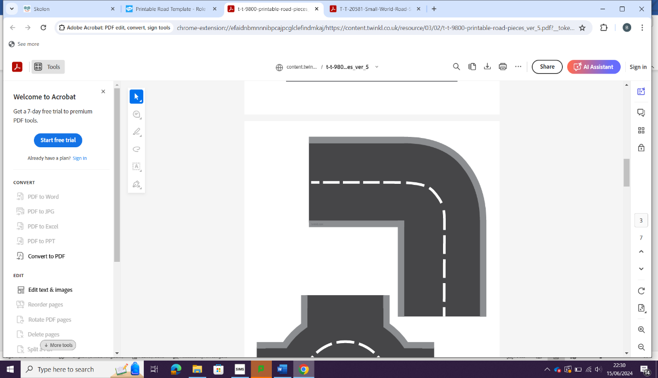
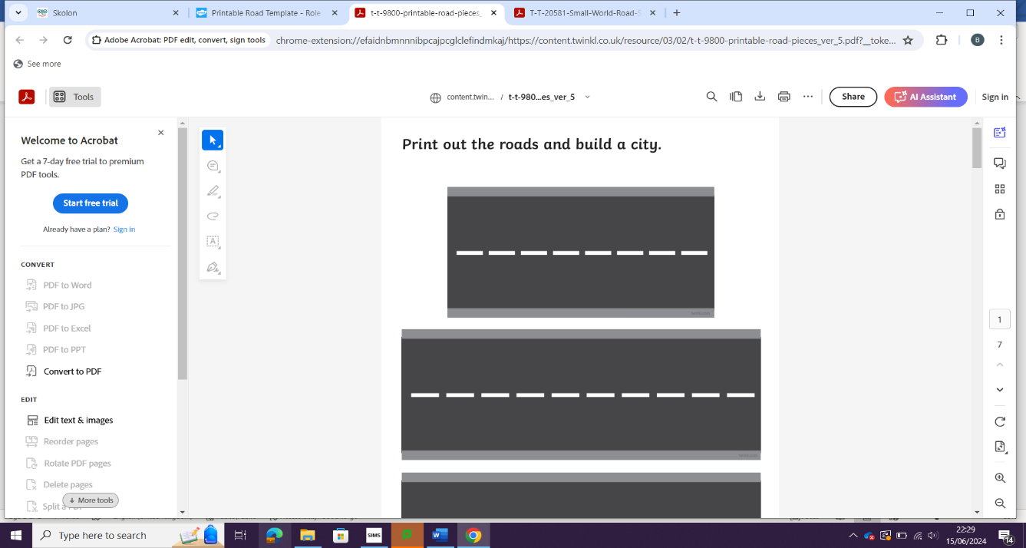
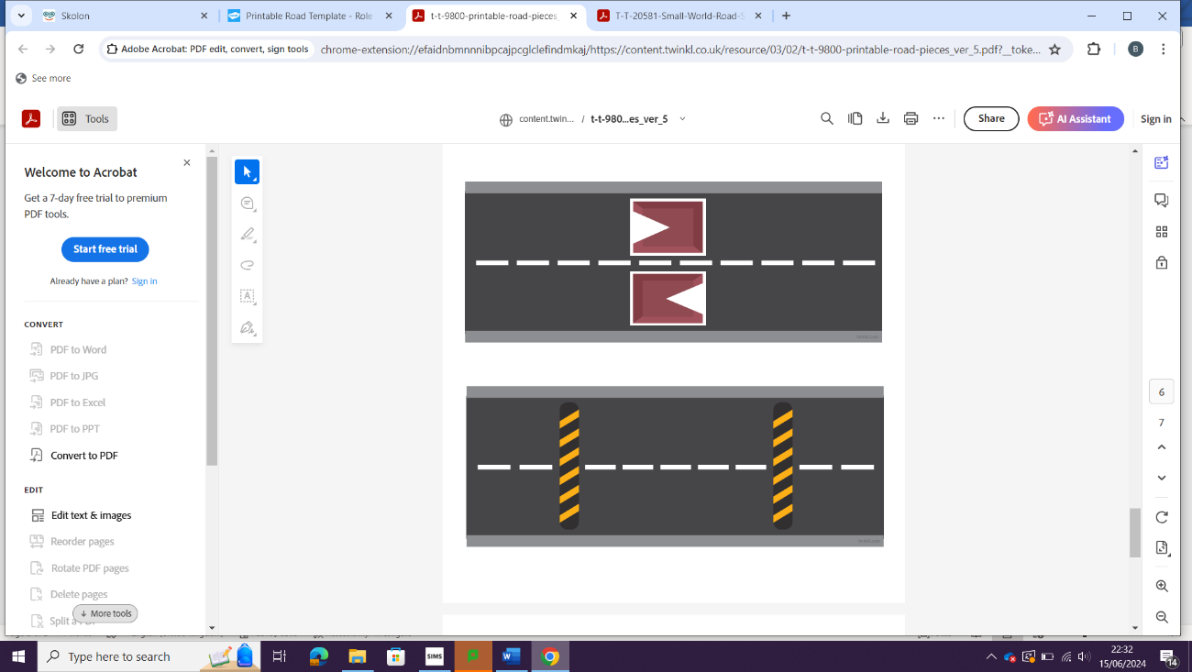
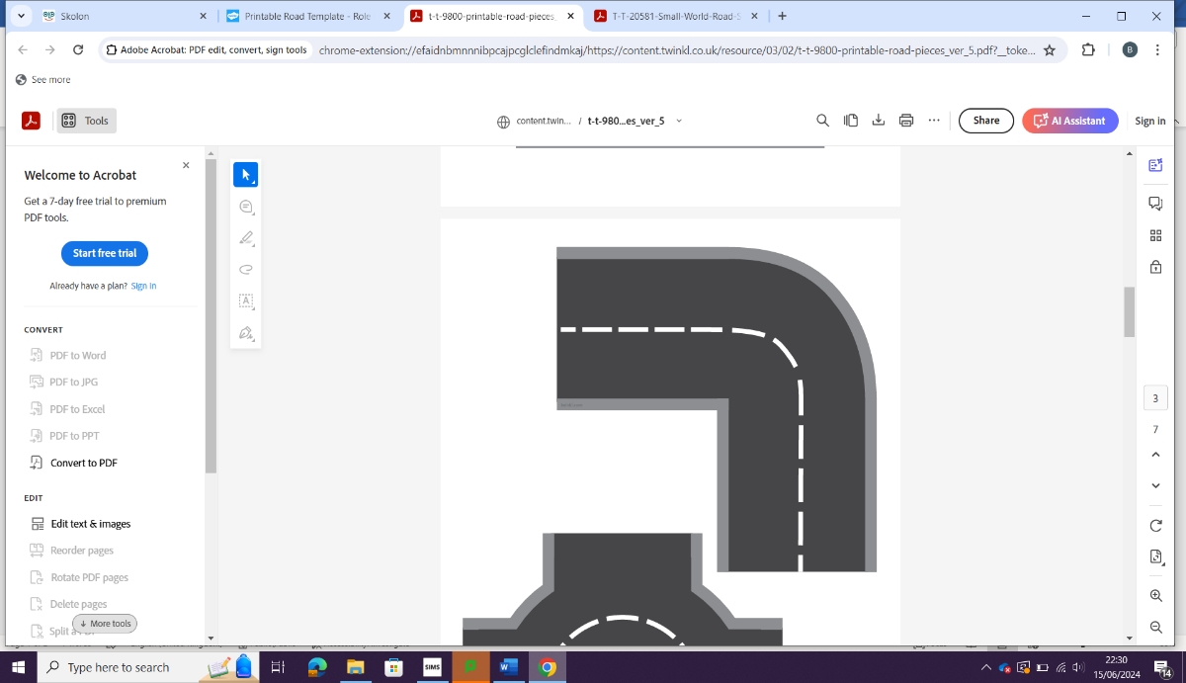

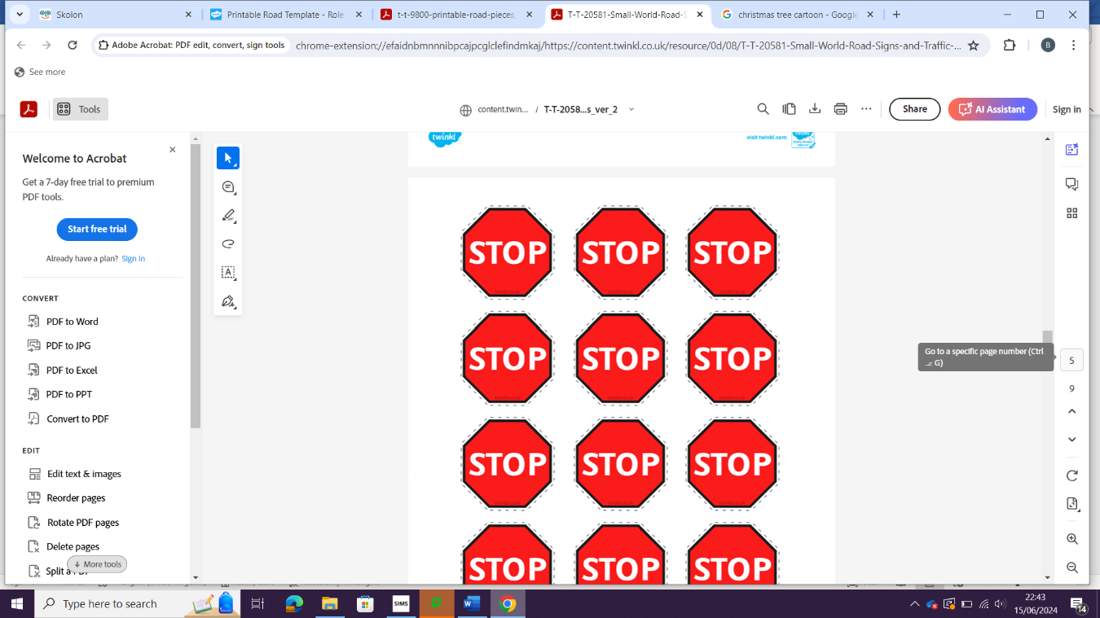
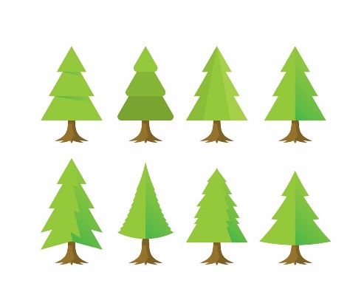

The relationship between different social groups and religious/spiritual organisations and movements, beliefs and practices
Religious organisations, including cults, sects, denominations, churches and New Age movements, and their relationship to religious and spiritual belief and practice
The relationship between social change and social stability, and religious beliefs, practices and organisations
EXAMS
PPE
Next steps
Beliefs
PPE

The social distribution of crime and deviance by ethnicity, gender and social class, including recent patterns and trends in crime
Globalisation and crime in contemporary society; the media and crime; green crime; human rights and state crimes
Crime and Deviance

EDUCATION
REVISION
Crime control, surveillance, prevention and punishment, victims, and the role of the criminal justice system and other agencies.

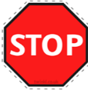



BELIEFS
The significance of religion and religiosity in the contemporary world, including the nature and extent of secularisation in a global context, and globalisation and the spread of religions.
EXAM SKILLS / PRACTICE
RESEARCH METHODS
METHODS IN CONTEXT
HEALTH
PERSPECTIVES
REVISION
AO1: Demonstrate knowledge and understanding of sociological theories, concepts and evidence, as well as sociological research methods.
ASSESSMENT OBJECTIVES: AO1, AO2 and AO3
AO2: Apply sociological theories, concepts, evidence and research methods to a range of issues.
AO3: Analyse and evaluate sociological theories, concepts, evidence and research methods in order to present arguments.

