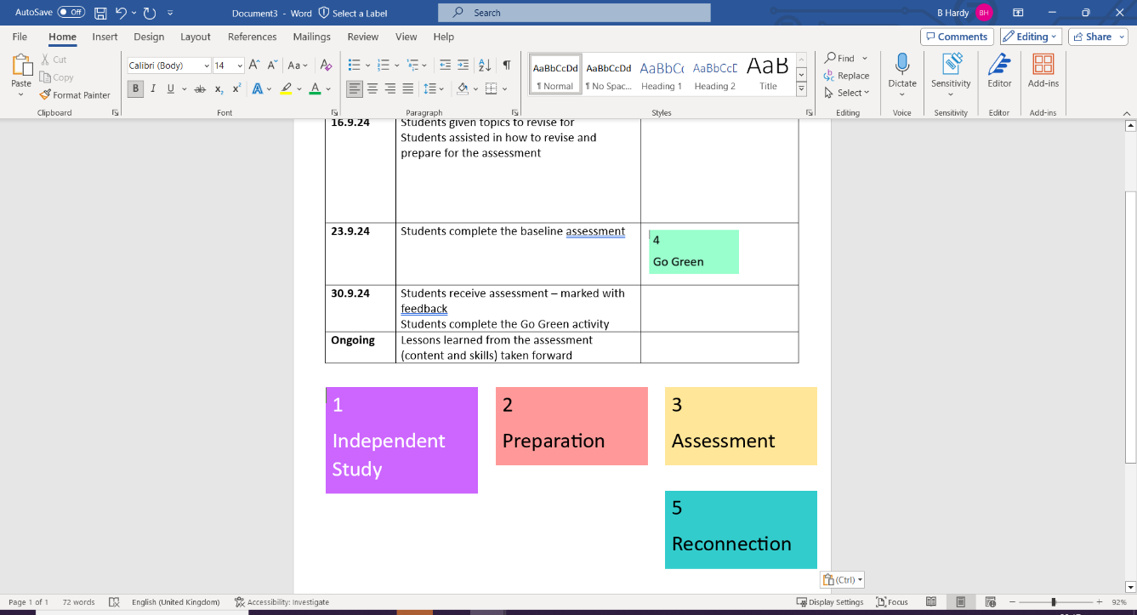
Key concepts Structure
To develop knowledge and understanding of some moral issues including abortion and capital punishment. To understand and apply religious beliefs, teachings, and sources of wisdom and authority.
- Define (3 marks)
- Outline x2 (2 marks)
- Explain x2 (4 marks)
- Evaluation (5 marks)

Knowledge mapping – Learn and revise the information:
Keywords – Learn all key terms and definitions
Christian attitudes to some moral issues:
Abortion |  | Capital punishment
Arguments for | Arguments against | Arguments for | Arguments against
Some Christians are pro-choice. | God breathed life into humans (Genesis 1:27). | ‘An eye for an eye’ – for some it is fair retribution. | Against the Sanctity of life.
Sometimes the Sanctity of life can be broken. | God planned everyone before they existed (Jeremiah 1:5). | Justice is served. | The criminal does not have the chance to reform.
Not all believe life starts at conception. | Some believe life starts at conception.  Pro-life. | Capital punishment is legal in some countries. | It doesn’t allow time for forgiveness or show compassion.
Moral | To do the right thing / a good action.
Immoral | Doing something that is considered wrong.
Sanctity of life | The belief that all life is God-given and sacred / holy.
Quality of life | Standard of health, comfort and happiness enjoyed by an individual.
Genesis | The first book in the Old Testament (‘In the beginning’).
Abortion | The termination of a foetus during pregnancy.
Conception | The action of conceiving a child or of one being conceived (to become pregnant).
Pro-life | Holding the belief that the foetus has a right to life.
Pro-choice | Holding the belief that the mother should be able to choose whether to have an abortion.
Capital punishment | The death penalty – the legalised killing of a person for committing a crime.
The Ten Commandments | Ten laws instructing people how to live – given to Moses by God.

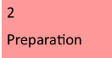

What are moral issues?
The following websites shares some useful information: https://www.bbc.co.uk/teach/class-clips-video/religious-studies-gcse-matters-of-life-and-death/zy24bqt
https://www.bbc.co.uk/bitesize/guides/zhbqf4j/revision/1

