KS3 Science Knowledge Organiser Year 7
Earth  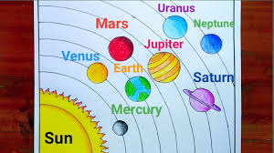 | - Order of planets, Sun, Earth, Moon models  - Use of satellites: communication, weather, GPS  - Force keeping satellites in orbit: gravity
Energy  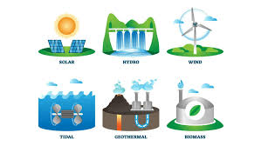 | - Daily variation in solar energy  - Calculating energy use and time  - Fixed vs. tracking solar panels  - Angle per hour: 180° ÷ 12 hours = 15° per hour
Organisms  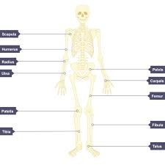 | - Functions of joints: allow movement  - Ribcage: moves to help breathing  - Nutrients for strong bones and teeth: calcium  - Muscles: work by contracting and pulling on bones
Waves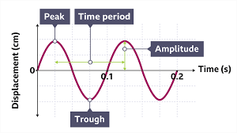 | - Reflection: light bounces, angle of incidence = angle of reflection  - Sound: vibrations make surfaces vibrate  • Oscilloscope: shows changes in pitch and volume
Matter  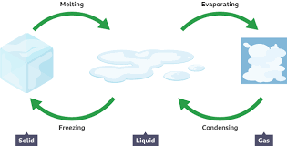 | - Names of changes: melting, freezing, evaporation, condensation  - Melting point of pure water: 0°C  - Effect of salt on melting point: lowers it
Variation and Adaptation  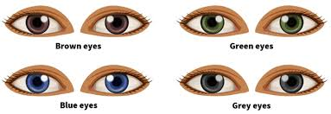 | - Differences between organisms (physical traits)  - Definition of variation  - Reproductive cells: egg cell, sperm cell  - Fertilisation: joining of egg and sperm  - Peppered moth example: environmental changes affect populations  - Reading data: graphs (show change over time), maps (show geographic spread)

