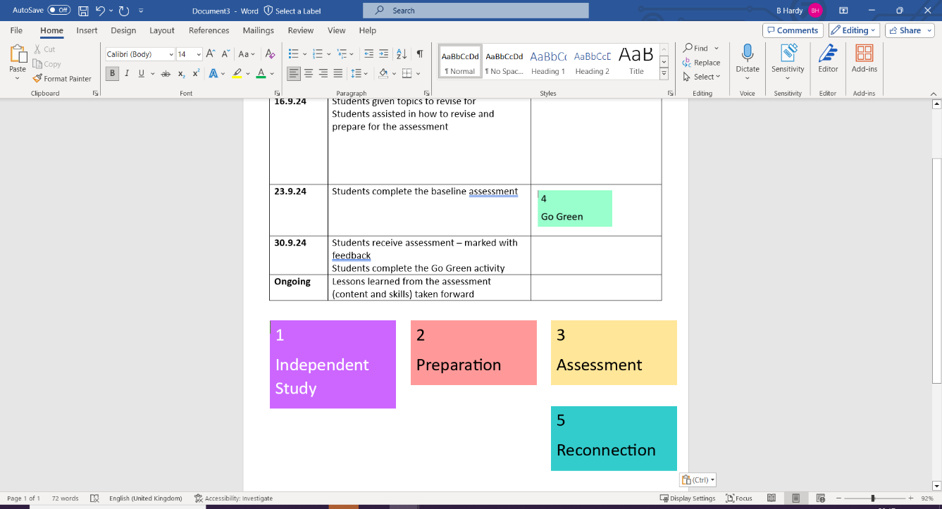
Key concept Structure
To gain knowledge and understanding of the main world religions (religious founders, places of worship and religious texts) and the reasons why the UK is a multifaith and diverse society.

- Name or state (10 marks)
- Outline (2 marks)
- Explain (8 marks)

Knowledge mapping – Learn and revise the information:
Keywords – Learn all definitions
Religion | Founder | Place of worship | Sacred Text
Buddhism | Siddhartha Gautama | Temple | Tipitaka
Christianity | Jesus | Church | Bible
Hinduism | No specific founder | Mandir/ temple | The Vedas
Islam | Muhammad | Mosque | Qur’an
Judaism | Abraham | Synagogue | Torah
Sikhism | Guru Nanak | Gurdwara/ any place that houses the Guru Granth Sahib | Guru Granth Sahib
Agnostic | A person who is unsure about God’s existence and what to believe.
Atheist | A person who disbelieves or lacks belief in the existence of God.
Diversity | Accepting and appreciating differences, i.e., different religions.
Equality | The state of being equal/ treating everyone fairly.
Identity | Our sense of who we are as individuals and as members of social groups.
Integration | The process of combining two or more things so that they work together.
Multicultural | Several cultures or ethnicities living in a society.
Multi-faith | Lots of different faiths coexisting in a society.
Theist | A person who believes in the existence of a God.

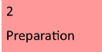

What does it mean to live in a multi-faith society? Produce a mind-map.

The following website shares some good examples: https://www.bbc.co.uk/bitesize/topics/zkdk382/articles/zvbp7nb

