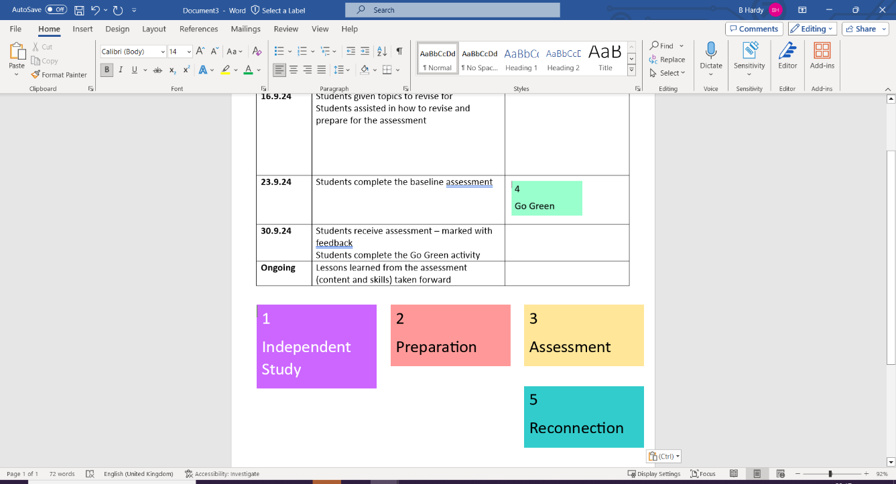
Key concept Structure
To gain knowledge and understanding of the causes and responses to conflict by engaging with belief, value, meaning, purpose, truth, and their influence on human life.
Focus on the importance of forgiveness in a named religion and learn the Just War theory.

- Multiple choice (2 marks)
- Outline (4 marks)
- Explain (8 marks)
- Evaluate (6 marks)

Knowledge mapping – Learn and revise the information:
Keywords – Learn all key terms and definitions:
Religious attitudes to peace and forgiveness | Religious responses to conflict
Christianity teaches that people must forgive the sins of others for God to forgive them their sins (Matthew 6-14-15). | Qur’an, Surah 49:9 explains that reconciliation is needed after conflict.
The Lord’s prayer teaches humanity to forgive others. | Qur’an, Surah 8:39 shows that Muslims did not start the conflict mentioned but fought as a last resort in defence of their lives and freedom.
Sikhs practise selfless service to others (Sewa). This shows love and care for others and links to peace and equality. | When wars are fought to protect people, it could be seen as an example of Jesus’ teaching: ‘Love your neighbour as you love yourself’ (Matthew 22:39).
Conflict | A serious disagreement or argument.
Peace | Freedom from conflict / the absence of conflict.
The Just War Theory | A set of conditions used to justify a war, i.e., a just cause or as a last resort.
Greater Jihad | Striving spiritually to resist evil within oneself.
Lesser Jihad | Striving physically to resist an evil in the world.
Nuclear weapons | A bomb or missile that uses nuclear energy to cause an explosion.
Weapons of mass destruction | (WMD) Nuclear, biological, or chemical weapons that cause widespread devastation and loss of life.
Forgiveness | To pardon / to stop blaming a person for a wrong they have done.
Reconciliation | Restoring harmony after relationships have broken down.

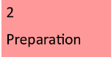

Responses to conflict

The following websites share some useful information:

https://www.bbc.co.uk/bitesize/guides/z2xxk2p/revision/1

https://classroom.thenational.academy/units/peace-and-conflict-c461

