KS3 Humanities Project:
How and why do we celebrate
religious festivals?
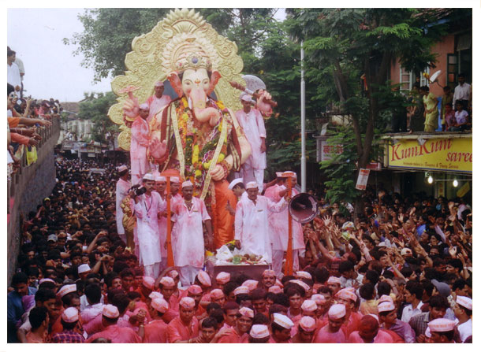
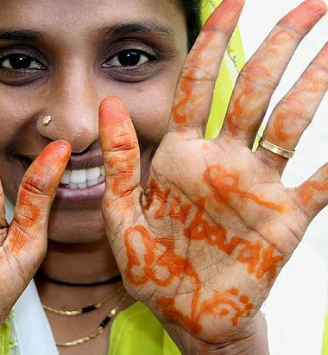

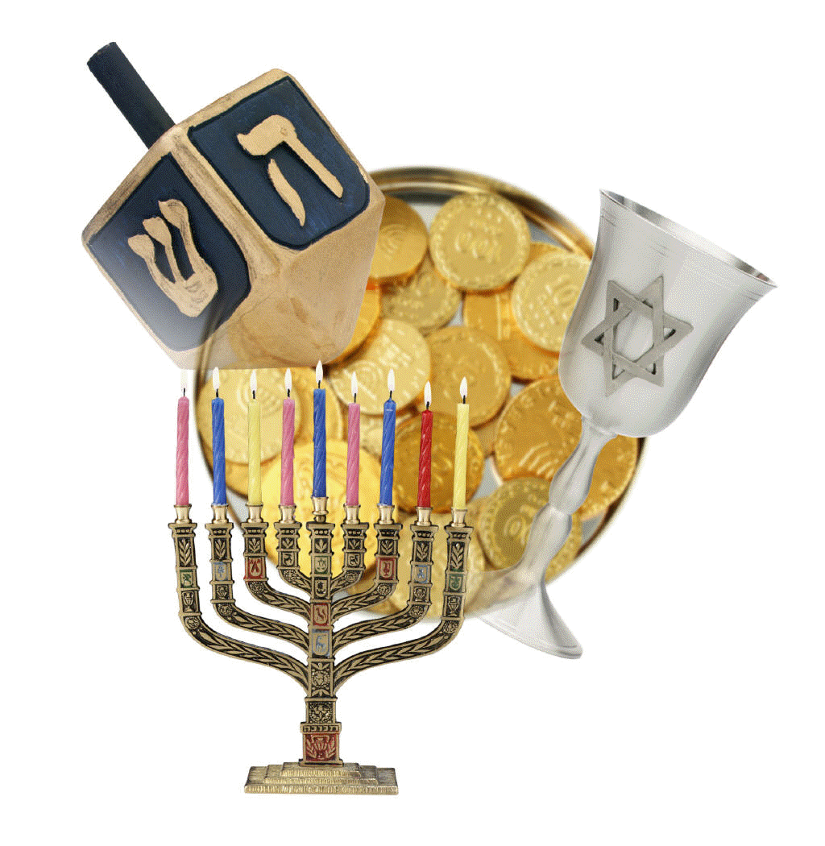
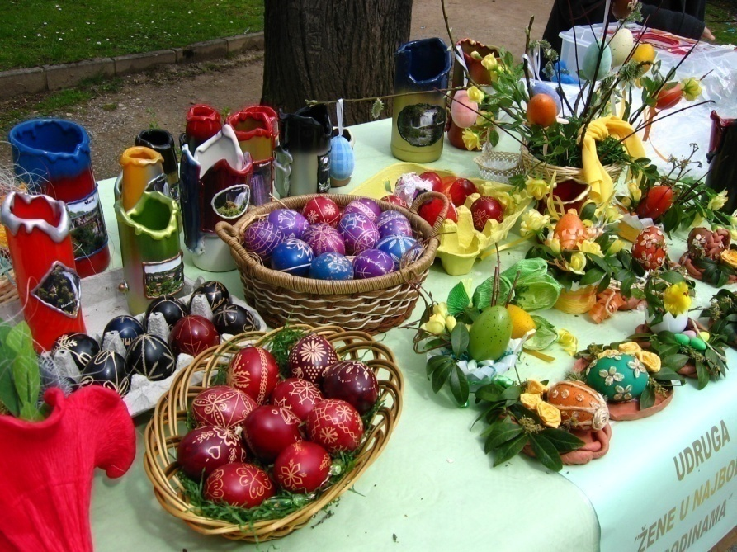

Name
Teacher

TASK:
Produce a research project about a religious festival of your choice. You will present this in future Humanities lessons.
You need to investigate how it is celebrated around the world and then produce a detailed piece of work/research project.

Introduction – What do I need to do?
You need to research how religious festivals are celebrated around the world.
To complete this task you must research a specific religious festival and create a detailed piece of work to illustrate how and why this festival is celebrated.
Stretch and Challenge: Compare two religious festivals. How are they similar? Different?
You can choose one of the festivals suggested in this leaflet or you can choose you own.
Where can I go for help?
If you need some assistance talk to your Humanities teacher and they will be happy to help you.

How will my work be levelled?

 | Learning from religion  (why we celebrate) | Learning about religion  (how we celebrate)
WT-1 | Identify religious characters either being celebrated or remembered in the festival’s story. | Identify ways the festival is celebrated, for example the different types of food or music.
2-3 | Describe the story behind the festival. | Describe how the festival is celebrated by people in that religion.
4-5 | Explain why the festival is important to the people of the religion. For example:  - What are they remembering about how characters in the story behaved?  - Is there a moral behind the story of the festival?  - Why does it make people feel a certain way? | Explain why people celebrate in a particular way. For example:  - Why do people decorate themselves in a certain way?  - Why is it celebrated on that date?  - Why do people sing particular songs or exchange gifts?
6+ | Assess which is the most important part of the festival and explain why you think it is the most important. | Compare how your festival is celebrated in different countries.  Why are there differences?  Why does this or doesn’t this matter?

STEP 1 - Choosing a festival to research
It is important to spend some time thinking about which festival you want to research before you begin. Ask for some advice from family and friends.
Do some research before making a final decision.
You could choose your own or one of following:
Passover Christmas Magha Puja Day Purim
Eid al-Adha Baisakhi Holi Eid ul-Fitr Hanukkah Easter
Ganesh Chaturthi Diwali Wesak

STEP 2 – Prepare your project/presentation
Read the success criteria carefully before you start. You should know your target level so highlight this on the grid before you begin so you know what you are aiming for.

You should use the following questions to organise your project/presentation:
- Introduction: Outline what a festival is. Identify/name the festival/s.
- Who celebrates the festival/s and when?
- What is the story behind the festival? Explain the origins of the festival/s.
- Why is the festival celebrated by the people of the religion/s?
- How is the festival celebrated by the people of the religion/s?
- Conclusion: Which part of the festival do you think is the most important? Why? Justify your opinion.

Stretch and challenge: Compare two religious festivals. How are they similar? Different? What are the benefits of taking part in festivals? Do the benefits outweigh the limitations of taking part? Justify your response.

You may choose to create a PowerPoint presentation/leaflet/poster. You can add images/teachings/quotes.
Your teacher will provide you with paper. Please ask if you need extra resources.

