Name_________________________________

Teacher_______________________________
Crime through time History Project

This work booklet contains information about crime through different time periods. It gives a specific example of a crime in the 14th century: Robin Hood, the 16th and 17th Centuries: Witches, 18th Century: Highway Robbery and the 20th Century: Conscientious Objectors.

- Complete the workbook tasks:
Work your way through this project completing the tasks as you go.

- Independent Enquiry into Crime Through Time
Select one of the time periods/topics (or another time period/topic you are interested in to do with crime) in the booklet to create an independent project on.

You need to have an enquiry question which you will answer in your project e.g. How was Crime punished in the 18th Century?

Introduction: outline why you have chosen your question and what you hope to find out in your research

You then need 3-4 chapters in your project which look at different aspects of your question
- the types of crimes committed,
- the type of criminal and why they committed crimes (poverty etc…),
- what punishments were used in the time period and how effective they were (did they stop crime?),
- anything else you want to add that is relevant

Conclusion: here you summarise your main points and answer your enquiry question.

This can be produced on paper as a booklet using words, pictures and colour. Alternatively, this can be types in word or made into a powerpoint presentation.

Stretch and challenge: Evaluate which period had the most crime and dealt with crime most effectively. When was the worst time to be alive?

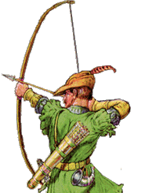
Why was the legend of Robin Hood popular in medieval England?

The general story of Robin Hood is that of an outlaw who lives in Sherwood Forest and robs from the rich Sheriff of Nottingham in order to give this money away to the poor. The first published form of this story was in the late 15th century and the story has continued to be popular right up until today with TV programmes and films still being made about this medieval hero.

Records of Robin Hood exist, but it is hard to separate the truth from the legends. He may have been a real person, if so his adventures have probably been exaggerated. He appears in many popular ballads from the 13th century, but his first datable appearance is in William Langland's Piers Plowman in the late 14th century. Until then few songs or ballads were written down so it is hard to be certain of the truth.
Sources:
Source A: Written by a Scottish Monk in 1521 | ‘About the time when Richard I was in Germany, the notorious robbers, Robert Hood and Little John, lived in the woods in Sherwood. They only stole the goods of rich men. He would not allow women to be mistreated and never robbed the poor.’
Source B: From a chronicle written in the sixteenth century. Barnsdale Forest is in Yorkshire. | ‘I saw the woody and famous forest of Barnsdale where they say that Robin Hood lived like an outlaw.’
Source C: Court records that mention Robin Hood. | 1225: Robert Hoode, peasant tenant of the archbishopric of York, reported as fleeing from the King’s justice.  1228: Robert Hod, known as ‘Robin’, described as an outlaw in West Yorkshire.  1230: ‘The Sheriff of Yorkshire owes 32s 6d. for goods stolen by Robin Hood, fugitive.’ Report in West Yorkshire.
Source D: The introduction of A true tale of Robin Hood, written by Martin Parker in 1687. | ‘A True Tale of Robin Hood’  ‘A brief touch on life and death of that renowned outlaw, Robert Earl of Huntingdon, commonly known as Robin Hood. He died in Sherwood Forest, AD.1198, being in the reign of King Richard the First.  Being carefully collected out of the truest writers of our English Chronicles: and published for those who want truth not lies.’
Source E: In Search of Robin Hood, written by Patrick Middleton in 1989. | Only one of the five earliest ballads puts Robin in Sherwood Forest. Until the Peasants Revolt in 1381, there is no mention of Robin Hood stealing from the rich to give to the poor. After this revolt over high taxes, the number of songs about Robin Hood increased, and most say that he was a peasant who fought wicked sheriffs to give money back to the poor.

- Tick each column if the source agrees with the statement. Leave it blank if there is no evidence.  Robin Hood.. | Source A | Source B | Source C | Source D | Source E
- was an outlaw
- lived in Sherwood Forest
- lived in Yorkshire
- stole from the rich
- gave to the poor
- was a nobleman

When do the sources say that Robin Hood lived? _______________________________________________________________________________________________
- Why do you think the sources contradict each other? ___________________________________________________________________________________________________________________________________________________

4. What reasons does Patrick Middleton (Source E) give to explain why Robin Hood became so popular after 1381?
______________________________________________________________________________________________________________________________________________________________________________________________________________________________________________________________________________________________________

The question is why did medieval people find this story so compelling? There are a number of reasons:

- The stories are set in the time of King John who is portrayed as an evil Norman King. The people of England who were mainly Saxon were often unhappy with their Norman rulers as they were seen to be harsh and controlling. The fact that Robin Hood is considered to be a Saxon lord and enemy to the Normans made him popular.
- Robin Hood was an outlaw and many people could sympathise with the unfair treatment of people by ‘over mighty’ lords like the Sheriff of Nottingham.

- Robin Hood lived in the Forest and was known to carry a bow and hunt here, which directly broke the very unpopular Forest Laws introduced by William I.
- The fact that Robin Hood took money from rich Lords, Sheriffs and Abbots and then gave that money to the poor was also contributed to making him popular.

A lot of this goes to show that the people in charge in the Middle Ages and those who were making the laws were not popular. If they were then an outlaw who committed crimes against them would not have become so popular for being an outlaw.

5. Explain why the story of Robin Hood was popular in the Middle Ages.
___________________________________________
_________________________________________________________________________________________________________________________________________________________________________________________________________________________________________________________________________________________________________________________________________________________________________________________________________________________________________________________________________________________________________________________________________________________________________________________________________

What can the story of Robin Hood tell us about Crime and Punishment in the Middle Ages?

Robin Hood the Myth.
Robin of Loxley was said to be an Aristocrat, however, Longbowmen were chosen from amongst the Yeomen and were trained from infancy, it is just possible that an aristocrat could take up the longbow in early adulthood and become proficient, but it is very unlikely that Robin Hood could have been both an aristocrat and an outstanding Longbowman as by the early 1500s Longbowmen were as rare as Pixies, and just as legendary!
Outlaws in the Middle Ages.
A Medieval Serf in England was little more than a slave, but there were ways out. You could join the Lord/Barons army or you could run away. If you remained free for a year and a day you were a Freeman, until then you were an Outlaw. If you were caught the punishment could be severe and would be subject to the Baron's whims and moods. As medieval people rarely travelled, local accents were strong, and a stranger could be identified as soon as he spoke. All peasants could fish and hunt so the safest places were woodlands.
It is a fact that many woods had their own bands of "Freemen". If any of these had enough sense to share their goods with the surrounding locals they would have support when things turned bad, and could also gain information of the Sheriffs troop movements.

6. What can we say for certain about Robin Hood?
_________________________________________________________________________________________________________________________________________________________________________________________________________________________________

7. Can we learn anything about Medieval Crime and Punishment from our study of Robin Hood?
_________________________________________________________________________________________________________________________________________________________________________________________________________________________________

Why did Early Modern people care about Witches?

Witchcraft had been a crime since medieval times, but in the sixteenth and seventeenth centuries it was regarded as a more serious crime and was harshly punished.
There were a number of reasons for this:
- Religion – many people believed that the devil was doing evil acts on a regular basis
- War – Conflicts led people to become more suspicious of each other
- Authority – King James strongly believed in witchcraft and published a book called ‘Demonology’. Many important members of authority also believed in witches and witchcraft.
- Prejudice – most of the people who were accused of being witches were old, poor, single and uneducated women. They were often vulnerable and isolated from their own communities.
- Changing attitudes – People were worried they might be cursed by a poor beggar they had refused to help and looked for scapegoats on whom to blame their bad luck.

- Which of the reasons listed above do you think was the most important and why?
___________________________________________
_________________________________________________________________________________________________________________________________________________________________________________________________________________________________
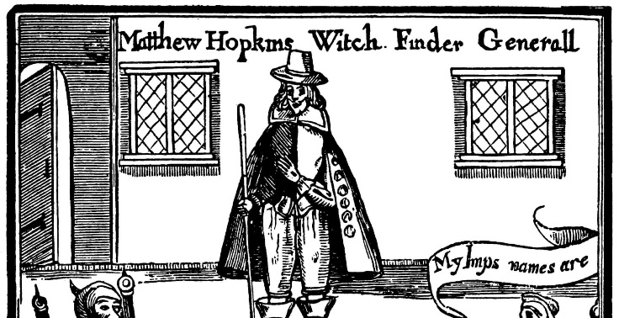
There were a number of identifying features of witches that Matthew Hopkins – The Witchfinder general, used as evidence that a person was a witch. Most of this came from King James’ book:

- Having a witch mark; this was often a large mole or wart.
- Typically, people accused of witchcraft were elderly women, but not exclusively.
- Having a familiar; an animal that was the representation of the Devil come to feed off the witch’s evil power via her witch mark.
- Missing church; people in league with the devil would not want to go into a church.
- Unintelligible muttering; if someone was muttering in a way that could not be understood and then something bad happened it might be thought that they were casting a spell.

The fact was that many people accused of witchcraft in this period were simply unfortunate people who happened to be alone and considered a little strange. When something bad happened in the village it was easy to assign blame to the village outsider. Matthew Hopkins used these attitudes to pin point women that he wanted to accuse.

- Why do you think outsiders were easy to accuse of witchcraft?
_________________________________________________________________________________________________________________________________________________________________________________________________________________________________

It wasn’t enough to simply identify a witch, in order to execute someone, it must be proven. These are some of the methods used by Matthew Hopkins to prove a person was a witch:

- Ducking; this was very similar to the Medieval Ordeal ‘Trial by Cold Water’. A person would be bound and then thrown into a local pond or lake. If they floated they were considered to be rejected by the purity of the water and must therefore be a witch. If they sank then they were being accepted into the purity of the water and therefore must be pure of spirit too.
- Examination of witch marks. If a needle could be used to pierce a mole or wart without hurting the person it was considered to be proof that it was indeed a witch mark. If it hurt then it was just a mole or wart. Matthew Hopkins was known for using a needed that would recede into the handle to give the appearance of piercing the flesh without hurting the person.
- Torturing the accused by forcing them to stay awake and unfed. They would be kept awake by being ‘walked’ up and down the room when they began to fall asleep. If any animals such as mice or even spiders entered the room when this was happening they could be considered evidence of familiars coming to feed. This however was not often necessary as many people would confess before this happened to make the torture stop.

- Why would someone confess to a crime like witchcraft?
_________________________________________________________________________________________________________________________________________________________________________________________________________________________________

The vast majority of Matthew Hopkins victims were women. They were also mainly over 50 years of age. This suggests that Hopkins did not victimise women because of some negative attitude towards them, but rather because they were easy targets. Old single women would have very little in terms of possessions and those without families would already be isolated in their communities. Matthew Hopkins perused witches during the witch craze, not because he wanted to persecute women, but more likely because he was highly paid for it. One village paid him £23 to them of their witches. This was in a time when the average weekly wage was 2p!

- Do you think Matthew Hopkins really believed in witches? Give reasons for your answer
_________________________________________________________________________________________________________________________________________________________________________________________________________________________________
The Growth of Highway Robbery

The eighteenth century saw the growth of a more mobile society. The development of industry, the sharp rise in population and the growth of towns, caused people to move around the country more frequently. However, better transport links and an increased volume of traffic also brought with it more opportunities for crime. Highway robber had always been present in the sixteenth and seventeenth centuries but it became much more common in the eighteenth century. Many roads secured reputations for being particularly unsafe due to an increased risk of being attacked by armed robbers. For several reasons this period became the age of the highwayman.

- Which of these reasons for the increase in highway robbery was the most important and why?

____________________________________________________________________________________________________________________________________________________________________________________
__________________________________________________________________________________________
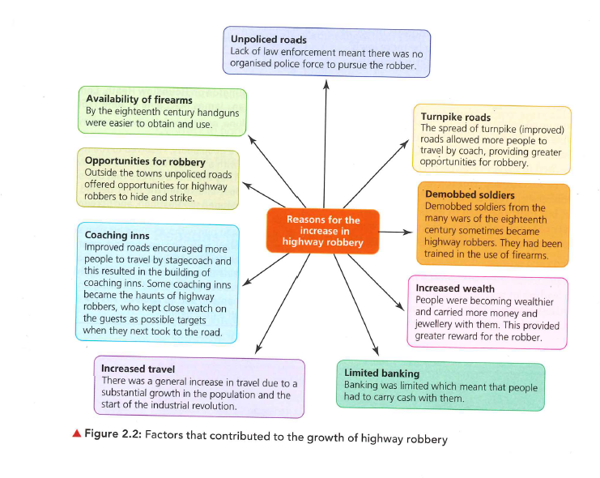

Highway Robbery caused great alarm, it involved stealing using violence or the threat of violence, and sometimes resulted in murder. There were two types of highway robber – the footpad and the highwayman.

Footpads attacked their victims on foot, and because they did not have a horse, they tended to specialise in robbing pedestrian travellers who could not escape as easily as mounted travellers. They lacked the glamourous image of the highwayman and were considered more lowly criminals, their attacks on the unsuspecting traveller could quite often be brutal.

Highwaymen were mounted robbers who, because they rode a horse, were able to attack stage coaches and travellers on horseback. Such travellers tended to be richer, and as the raid often resulted in bigger takings, highwaymen were considered to be socially superior to the lowly footpads. Many robberies involved the use of firearms. Some robbed alone, but most operated in pairs or in small groups. Private coaches and public stagecoaches were the most common targets, as well as postboys carrying the mail.

Case Study: Richard ‘Dick’ Turpin (1706 – 39)

Dick Turpin is probably the best remembered highwayman of the eighteenth century, his daring deeds were celebrated in the romantic novels of the nineteenth century. Historians have now shown that many of the glamourous stories attached to Turpin are more myth than historical fact. In reality, his career was violent and brutal.

Turpin was born in Essex in 1706 and trained as a butcher. In his teens he took to cattle stealing before joining a gang of violent house-breakers. During a raid on a house he threatened to throw a widow in the fire if she didn’t tell him where her money was hidden. When some of his gang were arrested and hanged, Turpin turned to highway robbery and carried out attacks on traveller. His crimes resulted in a reward of £100 for his capture, and he was forced to hide in a cave in Epping forest.

- Some highwaymen became local celebrities. Why do you think this was?
____________________________________________________________________________________________________________________________________________________________________________________
__________________________________________________________________________________________
_______________________________________________________________________________________________________________________________________
__________________________________________________________________________________________
_______________________________________________________________________________________________________________________________________
__________________________________________________________________________________________

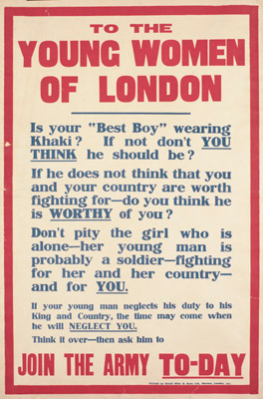
Conscientious Objectors
During the First World War, the government introduced a law known as conscription that said all men aged between 18 and 41 could be made to join the army. This was made compulsory in 1916,
Conscientious objectors were people who simply did not want to fight in World War One.

Conscientious objectors became known as ‘conchies’ or C.O's and they were a sign that not everybody was as enthusiastic about the war as the government would have liked
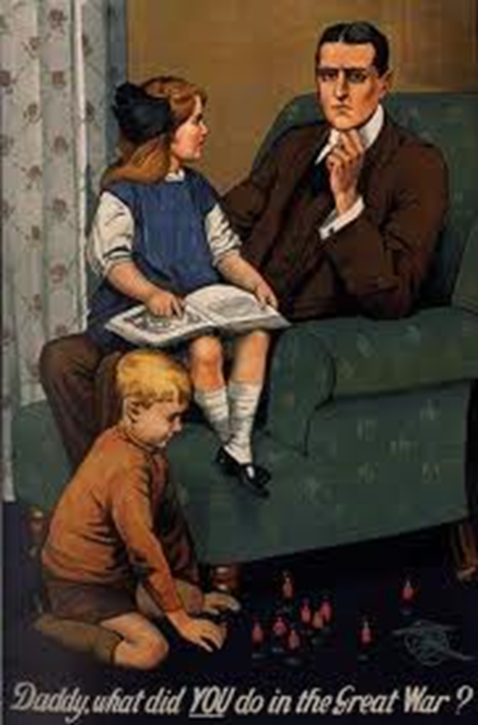
Some people refused to join the army, even under conscription. These conscientious objectors were against the war on moral or religious grounds. Some conscientious objectors agreed to work in hospital or act as stretcher bearers. Those who refused to go were put in prison.
A 'conscience clause' was added to the conscription law whereby those who had a "conscientious objection to bearing arms" were freed from military service. Those who claimed to be conscientious objectors had to face a tribunal to argue their case as to why they should not be called up to join the army.
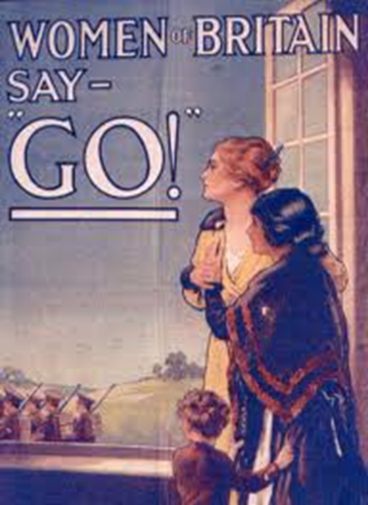
But the tribunals didn't use their powers with much judgement or sympathy. They rarely allowed the conscientious objectors to be exempt from the military. In many cases applications were turned down altogether, which meant that the men could still be called-up as ordinary soldiers without arguing their case. These unwilling people could be arrested and handed over to the military; if they disobeyed military orders they would be court-marshalled and sent to prison. 71 men died in prison due to poor treatment.
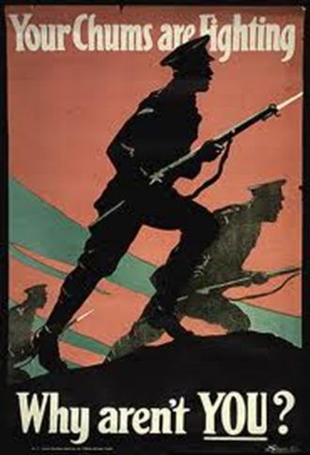
How were Conscientious Objectors treated?
Conscientious objectors were rejected from society, treated and seen as criminals. In the eyes of their country they failed to contribute and make a difference and were seen to be traitors.
Men were given white feathers by women, this was to make them feel like cowards. They were ridiculed by propaganda.

Pretend you are a Conscientious Objector. Write a speech for a military tribunal explaining why you should not go to war.
OR
Create a poster designed to encourage Conscientious Objector to join the war effort.

